

**Software Architecture Document (SAD)**

**EPDS v2 Future State Project**

##### Document Control Information

|  |  |
| --- | --- |
| **Document Name** | EPDS v2 Future State - Software Architecture Document |
| **Project Name** | EPDS v2 Future State |
| **Project Manager** | Craig J. Minarik & Lois A. Yager |
| **Document Author –**  **Application Architect** | Venugopal Yerubandi |
| **Domain Architect** | Joe Panici |
| **Information Architect** | Ninad Umrani |
| **Data Architect** | Dave Schaub  Ed Haun  Erwin Salazar |
| **Infrastructure Architect** | Greg Dunaway |
| **Info Security Architect** | Jeffrey B Dale |
| **IBM Lead** | Arti Pandit  Kim Eunsin  Jeremy Kohansimeh |
| **Development Leads** | Danny Ceralde  Jerry Adair  Ganesh Sethumadhavan |
| **Version** | 1.0 |
| **Status** | DRAFT |
| **Date Released** | Jan 2012 |
| **Electronic File Name** | EPDSv2FutureState-SAD-v1.docx |

# Approval of Final Document

*These signatories confirm that this document will serve as the Software Architecture Document for the Lean IT Project.*

|  |  |  |
| --- | --- | --- |
| **Name** | **Signature** | **Date** |
| *Project Manager* | Craig J. Minarik, Lois Yager, Lenore Ritzman | 03/22/2012 |
| *Delivery Manager* | Cheryl Brickey | 03/22/2012 |
| *Architects* | Joe Panici, Ninad Umrani, Greg Dunaway | 03/22/2012 |
| *IBM Lead* | Arti Pandit | 03/22/2012 |

**Document History**

|  |  |  |  |
| --- | --- | --- | --- |
| **Version** | **Date** | **Additions/Modifications** | **Prepared/Revised by** |
| 1.0 | 2/09/2012 | Initial draft | Venugopal Yerubandi |
| 1.0 | 2/16/2012 | Updates related to Golden Copy & Enclarity | Venugopal Yerubandi |
| 1.0 | 03/12/2012 | Updates based on Mason-Off-Site meetings with WLP & IBM | Venugopal Yerubandi |
| 1.0 | 03/22/2012 | SAD Review completed by Architects/IBM/Development Leads related to Aug/Sep 2012 delivery | Venugopal Yerubandi |

Table of Contents

1. Approval of Final Document 1
2. Introduction 7
   1. Strategic Capability Enablement: 7
   2. Structured Delivery in Capabilities 8
   3. High-Level Future State 10
   4. Definitions, Acronyms and Abbreviations 11
   5. Structure of this Document 12
   6. Risks and Issues 13
   7. Constraints 14
   8. Assumptions 15
   9. Dependencies 17
   10. Technical Considerations/Architectural Decisions 18
3. System Context 19
   1. Capability 1 – Aug 2012 Implementation 19
   2. Capability 2 – Jun 2013 Implementation 20
4. Application Architecture 21
   1. Major Components of Application Architecture 22
   2. Application Architecture Components Flow 24
   3. 3-Tier Architecture 25
   4. Overall Design Approach 26
   5. Overall Solution Approach 27
   6. Solution Component Framework 28
   7. Application Architecture Flow 29
   8. Use of IBM Initiate MDS Solution on AIX DB2 LUW Instance 30
   9. IBM Initiate MDS Framework 32
   10. Data flow through Initiate MDS (Regional 🡪 Golden) 35
   11. Solution Component Breakdown 38
   12. Capability 1 - Overview 39
   13. Capability 1 - Scope 39
   14. Capability 1 – Out of Scope 40
   15. Capability 1 – Conceptual Requirements 40
   16. Capability 1 – High-Level Data Migration Flow 41
   17. Data Extraction from Regional Provider Systems 42
   18. Enclarity Data sourcing from EDWARD/Enclarity process 43
   19. Reference Data Management (RDM) Synchronization Process 45
   20. Data Extraction - File/Folder Naming Convention 46
   21. Database (DB2 LUW on AIX) Enhancements 47
   22. Pre-processor Interface (File Sanity Checks) 48
   23. Regional Data Synchronization with Staging DB – Staging Phase 1 49
   24. Staging Data Transformations – Staging Phase 2 51
   25. Regional Data Extraction for Initiate Inbound Broker - Staging Phase 3 52
   26. Testing Strategy 54
   27. Capability 2 - Overview 55
   28. Capability 2 - Scope 55
   29. Capability 2 – Out of Scope 59
   30. Capability 2 – High-Level Data Flow 61
   31. Capability 2 - EPDS v2 User Interface 62
   32. Capability 2 – EPDS I (R6) Downstream Data Feeds 69
   33. Capability 2 – EPDS II (SSB) Downstream Data Feeds 69
   34. Capability 2 – WMS Downstream Data Feeds 70
   35. Capability 2 – WMS Future State West Downstream Data 70
   36. Regional Incoming Data Feeds & QCare Forward Data Synchronization 71
   37. Technology Platform 72
   38. Software Inventory Checklist 72
5. Information/Data Architecture 73
   1. Introduction 73
   2. Data Model 73
   3. Provider Data Categories for Demographics and Networks Data Model 90
   4. Demographics Logical Data Model 91
   5. Batch Data Integration Approach 92
   6. Logical Data Solution Components 93
   7. Some Data Integration Patterns at WellPoint 93
   8. Pattern Description 94
   9. Architectural Recommendation: Pattern 2–Common Provider File Format 95
   10. High Level Data Integration Approach 95
   11. Integration with IBM Initiate MDS 96
   12. Common Provider File Format (Excel) 97
   13. Initiate MDS Data Model Customizations 99
   14. Reference Data Management (RDM) 102
   15. Data Sourcing from Regional Systems 103
   16. EPDS v2.0 Enclarity Integration for Data Cleansing 104
6. Integration Architecture 107
   1. High-Level Data Integration Approach 109
   2. Integration with IBM Initiate Provider MDS 109
   3. IBM Initiate MDS Suite 110
   4. WellPoint / IBM Integration Components 112
   5. Use of Inbound Broker 113
   6. Use of WellPoint Custom Wrapper Services to invoke Initiate SDK API’s 113
   7. IBM Initiate Integration Summary 114
   8. Logging and Auditing 115
   9. Job Scheduling 117
7. Service Architecture 118
   1. Service Interaction Flow 118
   2. Integration View 119
8. Infrastructure Architecture 120
   1. Infrastructure Logical Topology - Development Environment 121
   2. Infrastructure Logical Topology - SIT Environment 122
   3. Infrastructure Logical Topology - Performance/Production Environment 123
   4. Infrastructure Components 124
   5. Informatica/Batch Unix/DB Server Information for EPDS v2 Environments 124
   6. Informatica Environment Details 125
   7. UNIX Server Details 125
   8. IBM DB2 LUW on AIX Server – Pure Scale Database Cluster Details 126
   9. IBM Hardware Sizing for Production HA & DR 127
   10. EPDS v2 Disaster Recovery Backup outside of Primary Data Center 128
   11. DR Data Flow 128
   12. Production HA & DR recommendation as per IBM 129
   13. Disaster Recovery Server Details 130
   14. Commercialization Landscape with Database Security 131
9. Commercialization Considerations 133
   1. Commercialization of EPDS v2 133
10. Appendix 137
    1. Credentialing 137
    2. Enclarity 139
    3. Central Region Facets – Inbound/Outbound Data Feeds 147
    4. CPF – CS90 Inbound/Outbound Data Feeds 147
    5. ACES – Inbound/Outbound Data Feeds 148

# Introduction

**Deliver a Consolidated Provider Data System for the Enterprise that will accommodate current and future Provider Demographic Data and Network Affiliation needs for all states and that will serve as a Centralized Source of Truth for Provider Data.**

## Strategic Capability Enablement:

* Having a central source for Provider Demographic information across all provider facing applications will enable data standardization and consistency
* Enables future vision of Provider services, i.e. Provider information Hub and Master Provider Profile.
* Consolidated provider data repository capability is an enabler of key strategic initiatives such as: Migrations, Payment innovation, Health Care Reform, Watson, Provider cost and Quality Transparency, Care Alerts, etc.
* Enables building a provider data product which can be utilized for future commercialization opportunities
* Enables a centralized/standardized data repository available for all downstream consumers of provider data
* Consolidated provider data will simplify the access to provider data reducing implementation cost of enterprise initiatives.
* Centralized Provider Maintenance will allow improved work flow for Provider Operation teams.
* Supply provider data to EDWard to support reporting and analytics with consistant data.
* Provide a file of providers to FEP allowing FEP to manage a single provider feed replacing feeds from several proivder systems
* Provide a file of providers to National IT in support of NASCO claims processing. A single file will be easer to manage than files from several provider systems and will enable the growth of NASCO proivders.

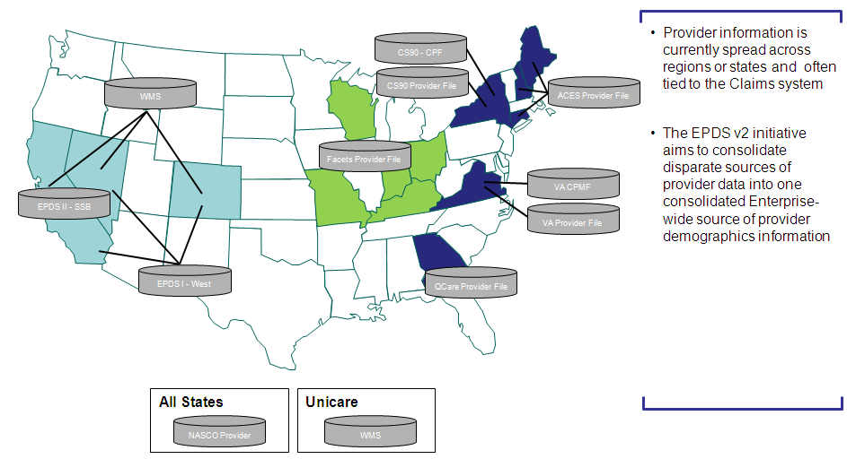

## Structured Delivery in Capabilities

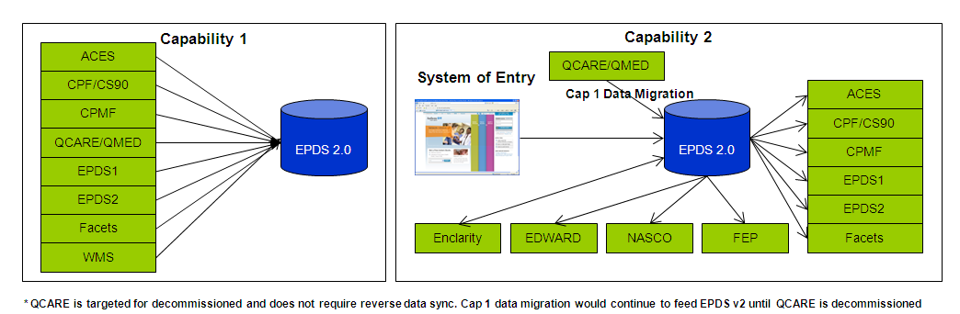

Standardized and consistant provider data will improve data quality for enterprise applications such as provider directories.

**When completed, EPDS v2.0 will be:**

* A centralized repository of standardized provider data for the enterprise that will accommodate current and future state provider demographic, contract, network, and affiliative relationship data.
* The single “source of truth” for provider data, which will enable significant business value for the provider domain and downstream consumers of provider data (i.e., reporting, warehouses, claims systems, strategic initiatives, etc.)

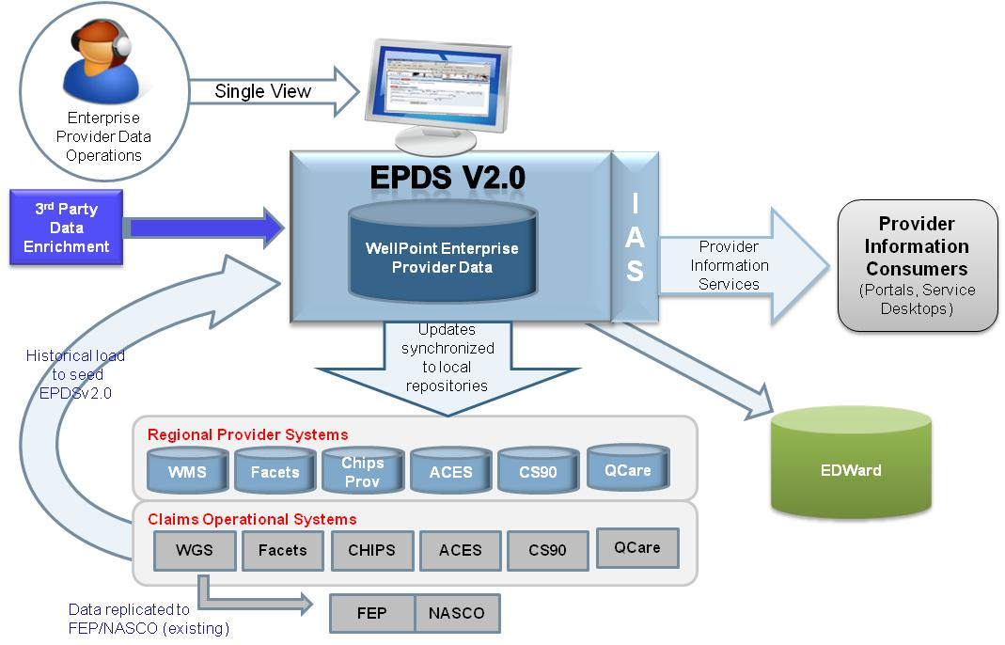

**Note: QCARE will continue to forward feed EPDS v2 until this system is decommissioned.**

**The objectives of the EPDS v2.0 Program as developed in the Project Charter:**

**Capability I - Centralized data repository -** Deliver a consolidated provider data system for the enterprise that will that will eventually enable current and future provider data and network affiliation needs for all states and that will serve as a centralized source of truth for provider data. This project scope is to build the central provider demographic repository; there will be no changes to downstream systems and the data in the repository will not be fed to the downstream systems as part of this initiative. Therefore, no downstream systems will be impacted by this project including claims and data warehouses or business impacts such as PDQI scores.

* Define current state/future state (EPDS v2.0) data model
* Migrate/transform data from provider legacy systems to EPDS v2.0
* Migrate/transform data in current state EPDS I (West) and EPDS II (SSB) to EPDS v2.0
* Design and build automated delta synchronization from legacy provider systems to EPDS v2.0
* Build GA provider data feed from EPDS v2.0 to NASCO

**Capability 2 - Source of Truth for Business to perform Provider Data Maintenance against EPDS v2.0**

* Build GA provider data feed from EPDS v2.0 to FEP Streamline
* Migrate West provider data from EPDS I and EPDS II (SSB) to WMS
* Enable WGS Claims system to use WMS for all West Claims processing (de-couple WGS from EPDS I and II for Claims system transaction processing)
* Decommission EPDS I and II and migrate downstream data consumers to either WMS or EPDSv2
* Design and build automated reverse-synchronization from EPDS v2.0 to legacy provider systems except QCARE since this system is targeted for decommission and would continue to forward feed EPDS v2 until system is retired
* Design and build Common User Interface for EPDS v2.0
* Design and build feed from EPDS v2.0 to EDWard
* Build the process to include Helathlink in EPDS v2.0. This will require a one-time load of the Healthlink providers and the back-sync process to the Helathlink provider database.

## High-Level Future State

EPDS v2 interaction with other Enterprise Systems related to Provider Data

NETWORX – Enterprise Pricing System but not all the regional systems have successfully migrated to this system

CONTRAX – Enterprise Contracting System to store all the Legal Documentation

Regional Pricing Systems – Regional Systems still use local pricing systems example Facets uses local instance of Pricer and NetworX systems

CACTUS – Enterprise Credentialing System aka Standard Cactus Platform (SCP) where all the Provider Credentialing Data is captured and managed. QCare and CPMF systems manage credentialing data locally in the current state

EDWARD – Enterprise Data Warehouse used for Analytics & Profiling activities for WLP

Provider Finder – Enterprise System with real-time provider finder capabilities (online and smartphone)

Future state EPDS v2 would be the single “Source of Truth” system for Provider Demographics & CAN (Contracts, Networks and Payment Innovation) Data and all the other systems should be sourcing this data from EPDS v2.



## Definitions, Acronyms and Abbreviations

* **ACES** – Anthem Consolidated East Systems. This is the claims and provider system for the North East (NE, ME, CT) region.
* **BTRD** – Business and Technical Requirements Document
* **CPMF** – Consolidated Provider Master File. This is the provider system for the Virginia region.
* **CS90/CPF** – Claim System of the 90s. The claims, membership and pricing processing system for NY
* **EDWard** – Enterprise Data Warehouse and Research Depot. EDWard is the enterprise-wide data warehouse that stores data from all regions and states across the corporation.
* **Enclarity** – Provider data cleansing vendor
* **EPDM** – Enterprise Provider Database Management. This business unit is comprised of provider database, provider credentialing and provider pricing and configuration.
* **EPDS I** – Enterprise Provider Data System I. This is the provider system for the West (CA, CO, NV) region. Includes SSB providers for CA.
* **EPDS II -** Enterprise Provider Data System II. This is the provider system for the SSB outside of CA
* **EPDSV2.0** – The future consolidated provider data system for the enterprise that will accommodate current and future provider data and network affiliation needs for all states
* **FACETS** –This is the provider system for the Central (MO, ME, IN, KY, OH) region.
* **FEP** - Federal Employee Program
* **HealthLink -** A WellPoint company that builds regional provider networks and makes them available by contract to payers of health benefits including insurers, third party administrators, union trust funds and employers.
* **ICD-10** –International Statistical Classification of Diseases and Related Health Problems 10th Revision is a diagnostic coding system implemented by the World Health Organization (WHO) in 1993 to replace ICD-9, which was developed by WHO in the 1970s.
* **ID** – Identification
* **IT** – Information Technology
* **NPI** – National Provider Identifier. A unique number assigned to identify a provider.
* **NASCO -** National Account Service Company. Claims system for National Accounts.
* **PDQI** –Provider Data Quality Index. Quality program represents the accuracy of the provider data provided to groups, members and other plans
* **Provider Data Operations –** Formerly known as EPDM. This business unit is comprised of provider database, provider credentialing and provider pricing and configuration.
* **WMS** - WellPoint Management System. This is the provider system for the Unicare plan.
* **Provider Systems** –means the following provider systems: CPMF, CS90, ACES, Facets, EPDS and QCARE.
* **Trizetto** - An information technology and services vendor focused on the healthcare industry, which supports some of WellPoint’s applications such as FACETS
* **ETL** - Extract, Transform and Load
* **FTP** - File Transfer Protocol
* **RDM** - Reference Data Management/Reference Data Manager tool
* **LZ** - Landing Zone – an area within the database that temporarily holds source data
* **WLM** - Work Load Manager – a scheduling tool
* **MDM –** Master Data Management
* **IBM Initiate Provider MDS –** IBM Master Data Solution (Identity Management, Match/Merge & Application Framework Layer)
* **HEDIS -** The Healthcare Effectiveness Data and Information Set (HEDIS) is a widely used set of performance measures in the managed care industry HEDIS is a tool used by more than 90 percent of America's health plans to measure performance on important dimensions of care and service. Altogether, HEDIS consists of 76 measures across 5 domains of care. Because so many plans collect HEDIS data, and because the measures are so specifically defined, HEDIS makes it possible to compare the performance of health plans on an "apples-to-apples" basis. Health plans also use HEDIS results themselves to see where they need to focus their improvement efforts.
* **TPA -** A Third Party Administrator (TPA) is an organization that processes insurance claims or certain aspects of employee benefit plans for a separate entity.

## Structure of this Document

* *System Context*
* *Application Architecture*
* *Information Architecture*
* *Integration Architecture*
* *Service Architecture*
* *Infrastructure Architecture*

## Risks and Issues

1. Transforming Disparate Legacy Provider Data Models into a single Standardized Future State Data Model.
2. Ensuring that business requirements for Current and Future State Provider Data needs are accurately articulated and captured.
3. Impacts to the Claims Adjudication / Membership / Product Systems
4. Enclarity Data Cleansing – Implications of not cleansing regional provider data using Enclarity Data would be on overall quality of provider data loaded into EPDS v2 Initiate MDS instance. Business need to provide Enterprise Provider Data Cleansing Rules to be implemented and consider not approving regional specific cleansing rules.
5. Provider Credentialing – Establishing connectivity between EPDS v2 and Enterprise Credentialing System (Cactus) so that Provider Demographics/Networks Data can be kept synchronized from EPDS v2 to Cactus and Credentialing Data sourcing from Cactus to EPDS v2 for read-only use.
6. Address Standardization – Implications of not standardizing regional address records using Informatica IDQ (Standardization as per USPS format) would lead to data mismatches within match merge process as Address plays a critical role in consuming Enclarity Data and within Provider Credentialing System (Cactus) for linking provider relationships.
7. The variation and complexity of the provider data in each of our regional systems is a potential risk to the consolidation of provider data into a single source repository.
8. Align with other Enterprise Initiatives impacting Provider Data including impacted systems to avoid duplication of work
9. The foundational project Infrastructure Repository Build (EPDS v2.0 Cap1) has aggressive timelines that may impact the project plan
10. Provider data integrity issues due to inaccurate forward-synching of the EPDS v2.0 data updates to the provider legacy systems may have repercussions to claims, membership, directories and other downstream processes
11. Provider data integrity issues due to inaccurate forward-synching of the EPDS v2.0 data updates to the provider legacy systems may increase the cost, effort and number of resources dedicated to the data entry in EPDS v2.0
12. Provider data integrity issues due to inaccurate forward-synching of the EPDS v2.0 data updates to the provider legacy systems may result to going over the Enclarity contractual limit on the number of records that can be cleansed, which will incur WellPoint cost for each additional record over threshold
13. Provider data integrity issues due to inaccurate forward-synching of the EPDS v2.0 data updates to the provider legacy systems may result in penalties (i.e. financial penalties from Worker’s Compensation audits) or regulatory non-compliance (i.e. MTM , BCBSA audits, Office of Inspector General and Office of Personnel Management audits)
14. Updates to the provider legacy systems (i.e. changes in fields, functionality, business rules etc.) may impact the scope and timeline of this initiative.
15. Availability of resources may impact the scope and timeline of this initiative.
16. Availability of funding may impact the scope and timeline of this initiative.

## Constraints

* The GA claims migration to WGS and other provider initiatives may utilize some of the same resource required to migrate providers to EPDS v2.0
* Coordination of external resources including vendors
* EPDS v2.0 implementation dates may be constrained by the independent provider legacy system release management time lines.
* EPDS v2.0 implementation dates may be constrained by the implementation dates of other concurrent provider domain initiatives
* The ability to deliver quality business requirements, design, and testing within appropriate budget and timeline may be constrained by the skill level and availability of business and IT resources
* The volume of EPDS v2.0 updates which can be forward-synched to each provider legacy system may be constrained by each system’s infrastructure
* Vendor support will be constrained by the availability of vendor resources and terms negotiated in the contract with WellPoint
* The successful execution and delivery of the project is constrained by the availability of project funding.
* The completion of the project is constrained by company reorganization initiatives.
* The completion of the project will be constrained by resources shared by this project with the dependency project Infrastructure Repository Build (EPDS v2.0 Cap 1) and other provider domain initiatives
* The completion of the project will be constrained by the availability of environments to support development, testing and training efforts.

The standardization of business processes and procedures may be constrained by region-specific business rules, which should be maintained in order to support region-specific business requirements.

## Assumptions

* WellPoint system owners of all systems targeted for the project will support the implementation in terms of availability of SME, QA and release management resources
* The one time load and synchronization of provider data to EPDS V2.0 will not adversely impact the performance, data integrity and functionality of the legacy provider systems
* The one time load and synchronization of provider data to EPDSV2.0 will not adversely impact claims processing, membership assignment, directory display and other downstream systems which interface with the provider systems
* The one time load and synchronization of provider data to EPDSV2.0 will not adversely impact the data integrity of EDWard data
* Infrastructure Repository Build (EPDS v2.0 Cap1) project will be successfully completed by 3rd quarter 2012.
* Dedicated development environments will be available to support the development efforts for EPDS v2.0
* QCARE data load to EPDS v2.0 will occur during the foundational project Infrastructure Repository Build (EPDS v2.0 Cap1)
* QCARE will be decommissioned by June 2014.
* The remediation of the QCARE extracts, reports and feeds (i.e. AIM Feed, PDF feeds to the association, ESI feed, standard GA PE&C monthly, quarterly and annual reports, GEO Studies and Disruption Analysis report etc.), will be taken care of by the initiative which will decommission QCARE by June 2014.
* EPDS v2.0 will continue to feed QCARE data to FEP, NASCO and EDWard
* The IP28 feed from FACETS to WMS will be covered under the forward-synch of data from EPDSv2.0 to WMS.
* The CS90, CPMF, FACETS, WMS, ACES and HealthLink ANITA legacy systems will be available to build the forward-synch process from EPDS v2.0 to these systems.
* FEP, NASCO, EDWard, Enclarity will be available to build the provider data feed process from EPDS v2.0 to these systems/processes.
* The Provider Centralized Maintenance project (PV ID 21535) will not build a forward-synch process to synch data from EPDS v2.0 to QCARE.
* WellPoint system owners from the provider legacy systems targeted to implement will support the implementation in terms of availability of SME, QA and release management resources.
* There will be sufficient vendor resources available to support the project
* There will be sufficient project funding to complete the project.
* Dedicated development environments will be available to support the development efforts for EPDS v2.0
* Dedicated testing environments will be available to support the appropriate quality and regression testing for EPDS v2.0
* Dedicated training environments will be available to support the appropriate user training for EPDS v2.0
* Dedicated reporting environments will be available to support the reporting requirements for EPDS v2.0
* Training will be provided in order for the users to understand the reporting data model/universe, and learn how to use the tools and processes for EPDSv2.0 provider data reporting
* The time it takes to return search results in EPDS v2.0 will take no more than the time it takes to return the same amount of provider data in the provider legacy systems
* The time it takes to save and submit data in EPDS v2.0 will take no more than the time it takes to save and submit the same amount of provider data in provider legacy systems
* The data entry process in EPDS v2.0 will take no more than the time it takes to enter the same amount of provider data in provider legacy systems
* Any dual maintenance being performed across provider legacy systems will be eliminated once EPDS v2.0 becomes the single point of data entry, However, updates in provider legacy systems will be allowed in exception scenarios where data integrity is compromised
* The forward-synching of the EPDS v2.0 data updates to the provider legacy systems will not adversely impact the current performance, data integrity and functionality of the provider legacy systems
* The forward-synching of the EPDS v2.0 data updates to the provider legacy systems will not adversely impact current claims processing, membership assignment, directory display and other downstream systems which interface with the provider legacy systems
* The forward-synching of the EPDS v2.0 data updates to the provider legacy systems will not adversely impact the current integrity of EDWard data.
* The current contractual limit on the number of records that WellPoint can send to Enclarity for cleansing (as outlined in the signed SOW) will not get impacted as a result of consolidating the Enclarity provider legacy systems processes into EPDS v2.0
* The current quality of correction/augmentation data being sent by Enclarity will not get impacted as a result of consolidating the Enclarity provider legacy systems processes into EPDS v2.0
* This initiative will not have any impact to building provider networks as WellPoint enters the Exchange market for the year 2014.
* All new SSB business contracts successfully negotiated will not be in scope for this initiative and may have to go through the change request process.
* The initiative will not require ICD-10 compliance.

## Dependencies

Accurate merging of duplicate records will depend on the business definition of single provider /duplicate provider

Accurate merging of duplicate records will depend on the accuracy by which Enclarity assigns the Enclarity ID to “duplicate” records.

Accurate synchronization of provider legacy system data to EPDSV2.0 will depend on the accuracy of the data mapping between each provider legacy system data model against EPDSV2.0 data model

* This initiative is dependent on the subject matter expertise and availability of the IT and business associates from provider operations (i.e. Provider Data Operations, Provider Engagement and Contracting etc.)  and from service operations units which use  provider data
* This initiative is dependent on the availability of the appropriate business, IT and vendor resources
* The ability to successfully perform the appropriate quality and regression testing for EPDS v2.0 is dependent on the availability of a dedicated testing environment for EPDSv2.0 and legacy provider systems
* The ability to successfully perform the appropriate training for EPDS v2.0 is dependent on the availability of a dedicated training environment for EPDSv2.0 and legacy provider systems
* The initiative is dependent on the Capability 2 Project (21535) for build out of the inquiry screens. This work is required to support testing and help meet the scope requirements.

## Technical Considerations/Architectural Decisions

**Refer to the Architecture Decision Document for Technical Guidelines and Architecture Principles related to EPDS v2 Project Implementation:**

NEED to Attach the Architecture Decisions Word Document

# System Context

## Capability 1 – Aug 2012 Implementation

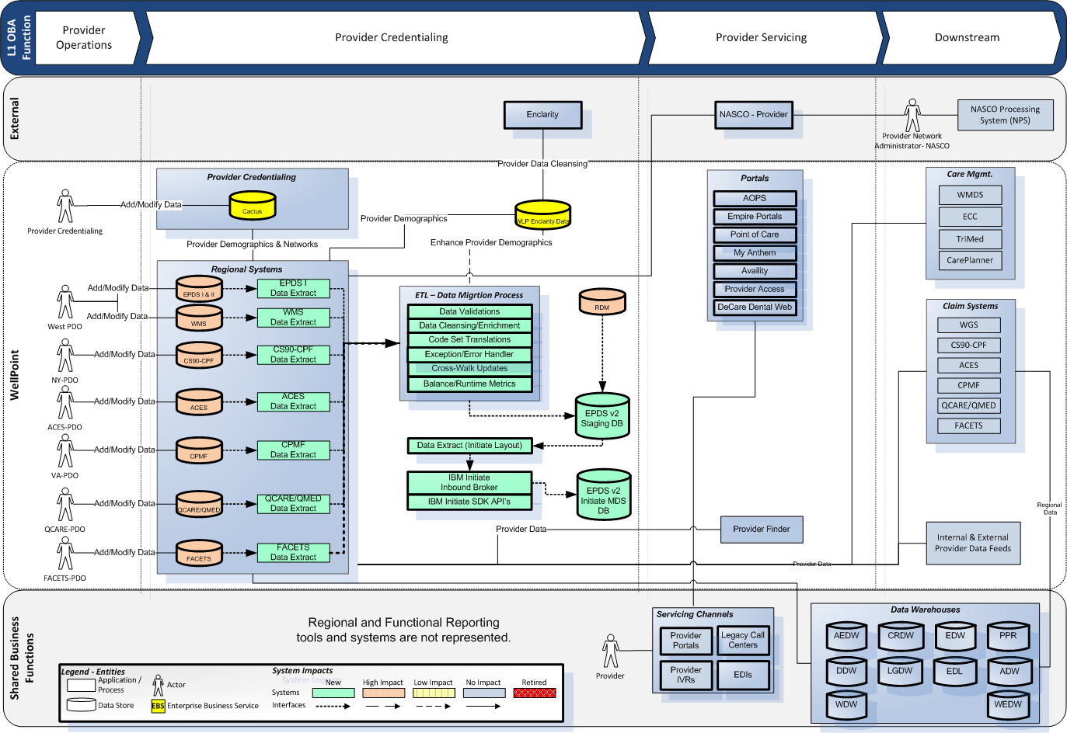

## Capability 2 – Jun 2013 Implementation

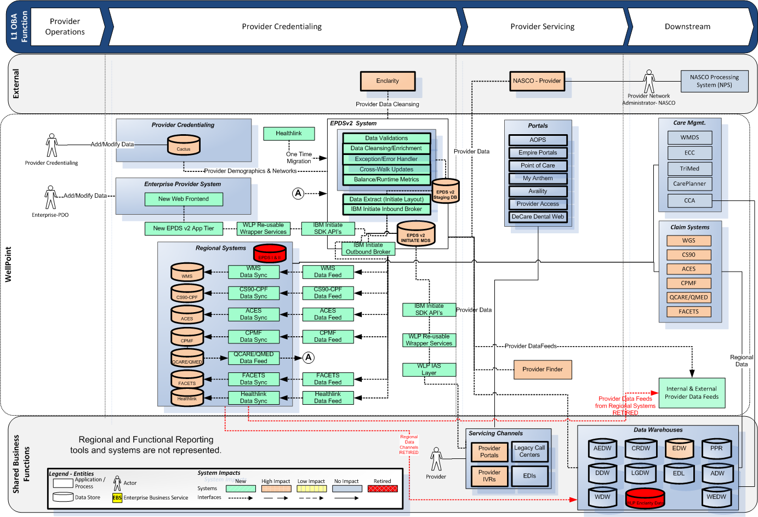

# Application Architecture

Deliver a Consolidated Provider Data System for the Enterprise that will accommodate current and future Provider Data and Affiliation needs for all states and that will serve as a Centralized Source of Truth for Provider Data.

The overall implementation of EPDS v2 is split into two broad capabilities with capability 1 to establish the New EPDS v2 provider repository and capability 2 to make EPDS v2 Source of Truth for provider data. Provider duplication & match/merge becomes challenging due to the multiple flavors of provider data currently managed within WLP regional provider systems and some systems internally feed provider data in support of business activities.

IBM Initiate Provider is a leading industry solution for rapid integration and leverage built-in duplicate elimination, match merge and application framework integration components. IBM Initiate Provider offers options to facilitate communication with downstream systems and external reference data sets. The product offering is pre-configured to load, manage, and quickly integrate provider information with clinical and administrative applications. The flexible data model supports providers as individuals or as organizations.

IBM Initiate Provider creates a master virtual repository of provider information by integrating with trusted data sources, from internal systems like ACES, CS90, FACETS, EPDS I, EPDS II, QCARE, CPMF and third party reference data sources. Using a gold standard probabilistic algorithm, the solution uniquely generates a single trusted view of a provider from these source systems, whether that provider is an individual (doctor, nurse, home health worker) or an organization (clinic, lab, practice location).

Primary reasons for using IBM Initiate Provider MDS technology

* Out of Box Provider Demographics Data Model which can be extended as WLP requirements
* Provider Registry approach to register all the provider data snapshot currently stored in each of the WLP regional systems
* Probabilistic Matching Algorithm to internally link duplicate providers
* Merging capabilities to create a Golden Copy of provider data
* Leverage pre-built application framework components such as Initiate Inbound/Outbound Brokers and Initiate Java API’s to communicate with Initiate Provider MDS engine

## Major Components of Application Architecture

Major components of EPDS v2 Application Architecture are

* New EPDS v2 Development, System Testing, Performance, UAT, Training and Production (High Availability/Disaster Recovery) Environments
* Regional Data Extraction methodology using Common Provider Data Format without applying any Data Filtering/Merging within each regional system
* Enclarity Data
  + Leverage Enclarity Data from EDWARD/ENCLARITY process by receiving Data Files with Augmented/Cleansed data including 50 state provider file from WLP Bridge Server
  + Receive EDWARD/ENCLARITY cross-reference data from EDWARD
  + Create Enclarity Data Repository within EPDS v2 Staging Database
  + Keep the Enclarity Data synchronized with EPDS v2 Enclarity Staging Repository
* Code Set Data from Enterprise Reference Data Management (RDM) Tool
  + Get the Regional and Enterprise Code Set Translations from RDM System
  + Create RDM Data Repository within EPDS v2 Staging Database
  + Keep the RDM Data synchronized with EPDS v2 RDM Data Repository
* Staging Database Operations
  + Staging the Regional Data Snapshot
  + Data Validations to check the provider data integrity
  + Code Set Translation between Regional and Enterprise Values using RDM Data
  + Data Cleansing & Enrichment using Enclarity Data
  + Address Standardization using Enterprise Standard Informatica IDQ process
  + Cross-Reference Management
  + Use of EDWARD/Enclarity Cross-Reference File with Regional Provider IDs to Enclarity ID
  + Provider Data Recycling
  + Data Extraction as per IBM Initiate Requirements to push data into Initiate Provider MDS engine
* Integration with Initiate Provider MDS
  + Extending Initiate Provider MDS Data Model with WLP Customizations to store all WLP Provider Data Elements from WLP Regional Provider Systems and align with future Provider Innovation Concepts
  + Use of Initiate Application Framework Components
    - Inbound Broker – Preferred for handling large data volume through System Migrations/Consolidation Projects
    - Outbound Broker/Event Notification – Preferred for Outbound Data Publishing requirements
    - Java SDK API’s – Preferred for Low Level Coupling with minimal touch points
    - eSOA Web Services
* New EPDS v2 User Interface to be used by Business for Data Maintenance Operations
* Connectivity with Enclarity (Batch/Real-Time)
* Reverse Data Synchronization from EPDS v2 to Regional Systems CS90, ACES, FACETS, CPMF, EPDS I, EPDS II and Healthlink Systems except QCARE (QCARE will continue to forward feed EPDS v2 with data change to keep EPDS v2 synchronized with regional data changes)
* Downstream Data connectivity with EDWARD, FEP, NASCO and eventually with Enterprise Credentialing System (CACTUS)
* Commercialization capabilities to manage Public Vs Private data
* Establishing Operational Reporting Database to support downstream consumer requirements of internal and external vendors/systems by keeping the data synchronized from EPDS v2 MDS database

## Application Architecture Components Flow



## 3-Tier Architecture

EPDS v2 would be implemented in 3-Tier Architecture

* Web – New EPDS v2 User Web Interface to be used by the business users
* Application – Web Sphere Application Server will be used to deploy web presentation-tier components and re-usable services to invoke IBM Initiate SDK API’s to communicate with database server
* Database – IBM DB2 LUW on AIX Database Server on which IBM Initiate Provider MDS components would be deployed.
* Database – EPDS v2 Staging and Operational Reporting Databases would be deployed to support Staging Data Transformation activities for inbound data and Operational Reporting database for outbound data for downstream data consumers



## Overall Design Approach

* Abstract the Provider Operational System from the Claim Systems (This model is being effectively used in VA-CPMF/CHIPS and NY-CPF/CS90 markets)
  + Provides ability to define an Enterprise Data Model in IBM Initiate MDS platform
  + Provides ability to load the repository prior to Claims migrations
* Capabilities will be designed and implemented in structured phases
  + Initial focus is on loading the provider demographics, contracts and networks (CAN)
  + Subsequent phases will deliver the operational functions
    - Universal Frontend
    - Provider Data Synchronization to the Backend Systems
    - Supporting QCare forward data synchronization
    - Supporting other automated feeds from regional systems like Dental Feed from Facets, Rental Networks Feeds from WMS etc.
    - Establishing connectivity with EDWARD, Enclarity, FEP and NASCO
    - Establishing connectivity with CACTUS (Provider Credentialing System)
    - Establishing connectivity with Provider Finder and other systems
    - Operational Reporting (Adhoc and Automated)

## Overall Solution Approach

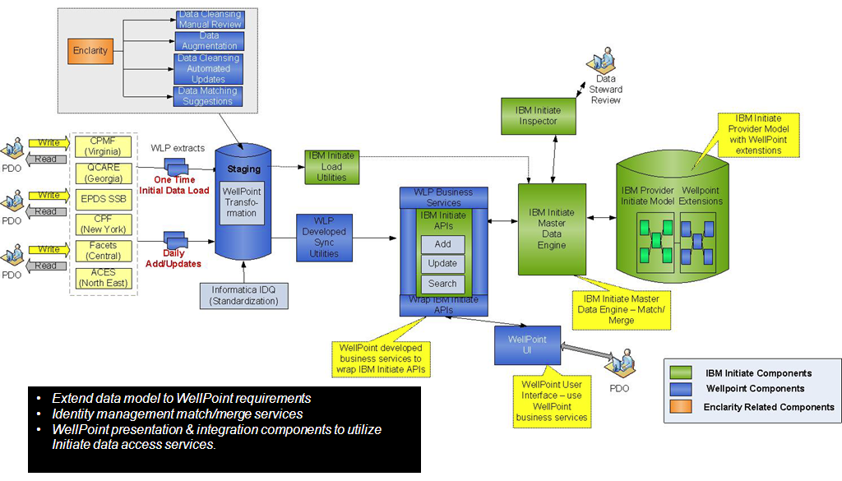

**Note: QCare will continue to feed EPDS v2 until this system is retired with NO reverse data sync.**

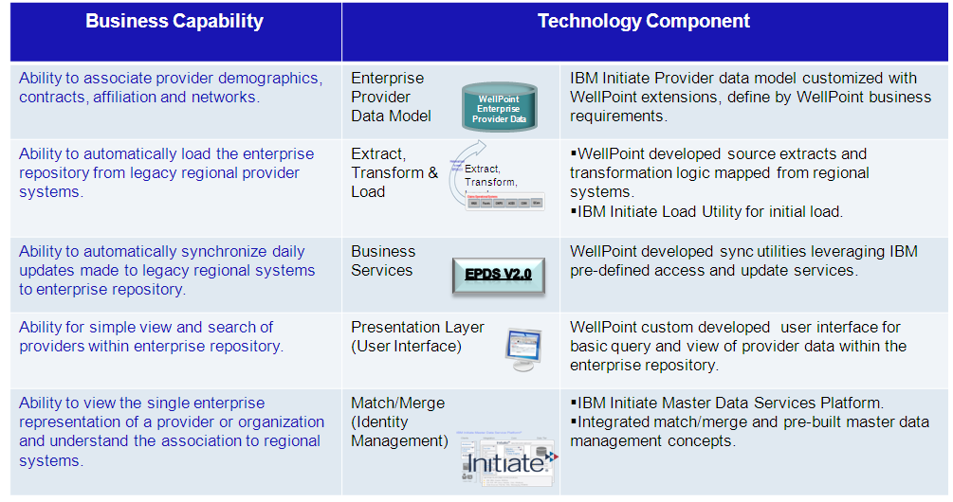

## Solution Component Framework

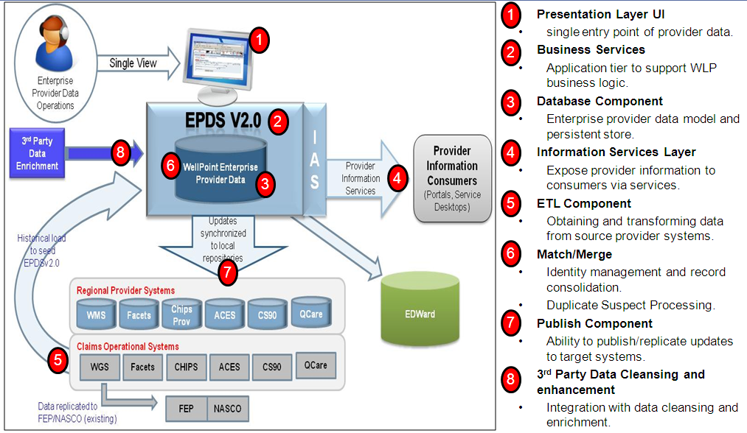

**EPDS v2 Component Strategy:**

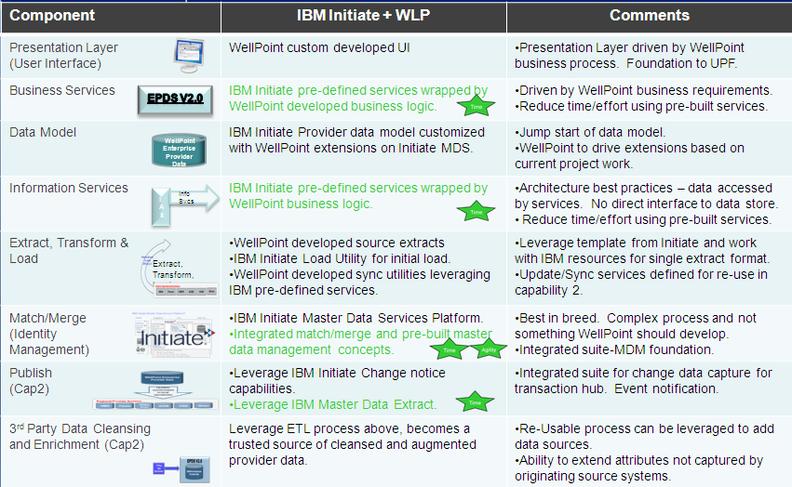

## Application Architecture Flow



## Use of IBM Initiate MDS Solution on AIX DB2 LUW Instance

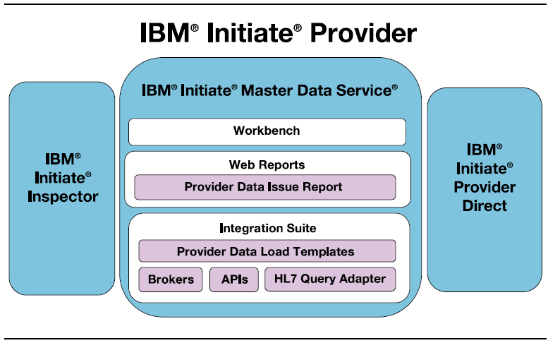

* Deliver results in accelerated time by taking advantage of IBM’s healthcare information management experience
* Reduce the cost and complexity of implementation services by eliminating time to design data models and integration toolsets
* Manage the creation of new providers from a single location with an easy to use wizard tool
* Achieve a predictable result with the accuracy, performance, scale and ease of implementation you need now, while providing flexibility to expand as business priorities evolve and change
* Establish a foundation for strategic information sharing initiatives to complement the systems you have in place today

**Core Functionality:**

* **Provider Data Model:**
  + Pre-built provider demographics data model.
  + Includes support for individuals and organizations.
  + Agility to customize via extensions.
* **Master Data Engine:**
  + Industry leading match engine to generate trusted single view.
  + Ability to generate unique enterprise id and track to sources.
  + Ability to store and view source system attributes.
* **Data Access Services:**
  + Pre-built data services supporting best architecture practices.
  + Ability to customize via extensions.
  + Re-usable for business logic and information services.

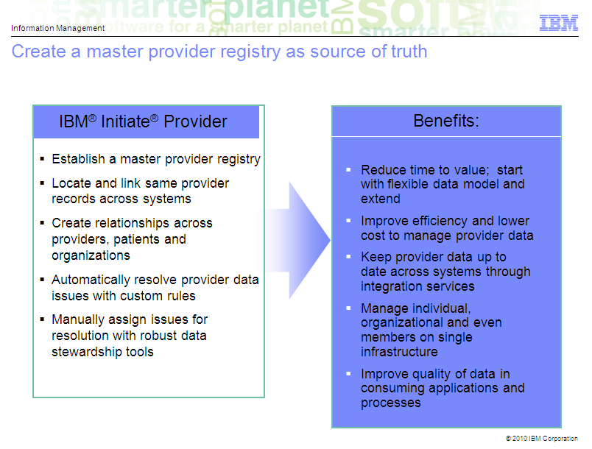

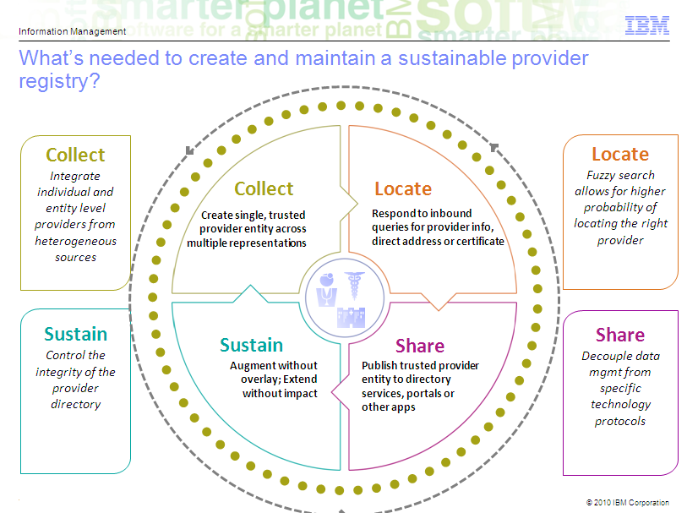

## IBM Initiate MDS Framework

* **WLP Customizations to the Initiate Provider MDS Data Model**
* **Composite Views Vs Golden Record**
  + **Composite View -** represents your defined “complete picture” of a member
  + **Golden Record –** One Physical Set of Merged Provider Data
  + **Registry Approach –** Regional Data Snapshots of Provider Data is retained by linking the duplicate providers internally using which Composite View can be generated or merged into a Hub Owned Record aka Golden Record
* **IBM Frameworks**
  + Initiate Inbound Broker
  + Initiate SDK
  + Initiate eSOA
  + Initiate Outbound Broker

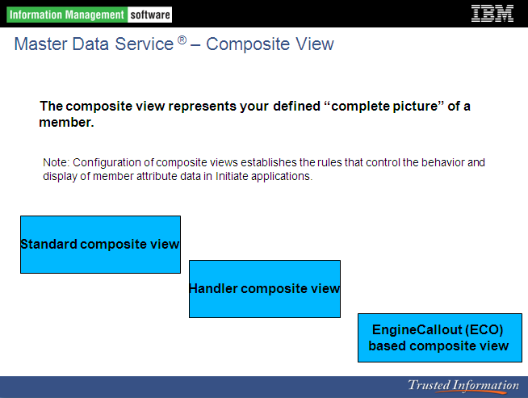

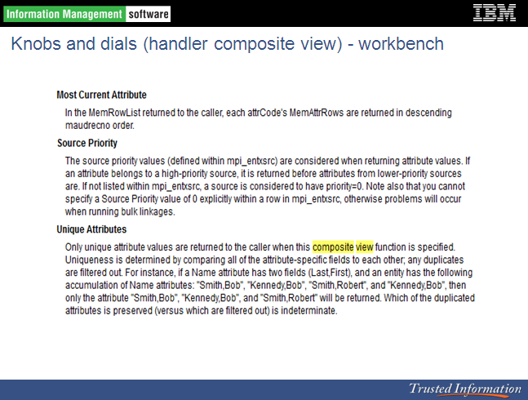

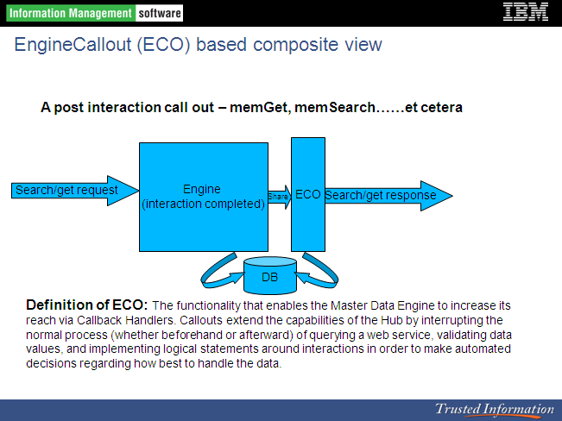

**Single MDS Instance Vs MDS Instance with additional DB2 ODS**

* Single Initiate Provider MDS Instance (PREFERRED) to be used to store ALL the Provider Demographics and CAN Data including any New Payment Innovation Provider Concepts. Administration of Master Data within MDS like Network Data Configuration etc.
* Use of MDS Instance to only store data related Provider Identity Management with Demographics and Networks Data and additional DB2 ODS for storing all the Provider Data. This approach leads to a FUZZY implementation to first hit MDS for identifying provider(s) followed by additional trips to get provider data from DBS ODS. Provider Data Duplication in MDS and DB2 ODS instance is another concern.

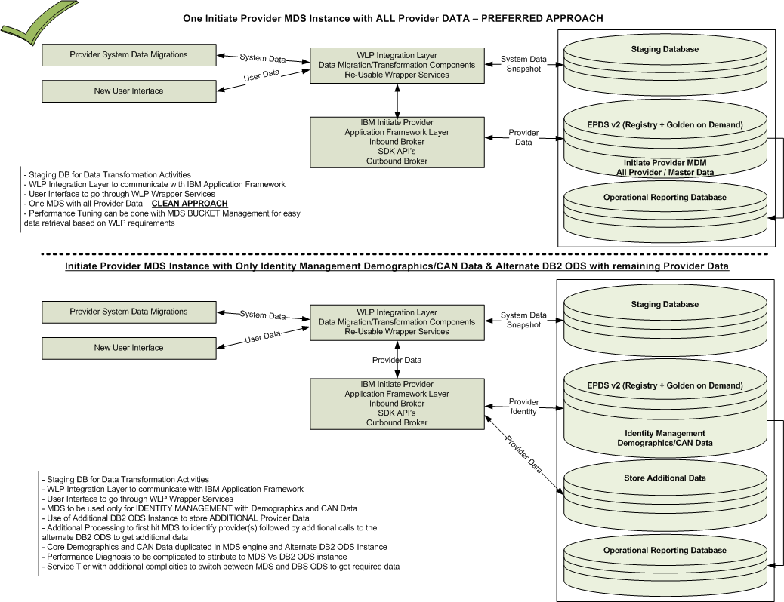

## Data flow through Initiate MDS (Regional 🡪 Golden)

The diagram below depicts the high-level data flow from regional systems into Initiate Provider MDS with a registry style approach leading to a golden copy creation to be used by Capability 2.

Within WLP Provider Systems feed each other to support business requirements example Central Region Providers (Facets), North East Providers (ACES) and Virginia Providers (CPMF) are fed into WMS system to support West business activities.

Provider Data is DUPLICATED by feeding data from one system to another system and also within each system Provider Data is duplicated to establish Provider ID based on Provider’s preferences around Location specific services. Every Provider minimum will have a Practice and Remit Location in each system. Based on the EPDS v2 Data Model some level of provider data merging operation need to be performed to roll-up provider specific specialty’s, tax ids, group affiliations, addresses etc.



**Current Options to establish Golden Copy of Provider Data**

* **Registry Style** **–** Provider Data from Regional Sources would be registered at the regional provider id level as data gets migrated from each regional system. MDS would internally link duplicate providers with appropriate EID value to track the providers uniquely
* **Registry + Golden Record** **–** This option physically registers the Golden Data using the Registry Data through a Automated Merging Process that would be implemented and triggered prior to rolling out EPDS v2 User Interface with maintenance functions to business users
* **Registry + Golden On-Demand –** This option has been selected currently to proceed with establishing Golden Data On Demand meaning regional provider data would be kept in the registry style approach and below mentioned approaches would be used
  + **Composite View** would be used to present the Golden View of data to the end user requests by pulling the data from registry data sets. Composite view is a Virtual View of data that generates the Enterprise Data Elements as and when user requests for a specific provider data through UI Provider Search, Search Results and Details view pages using WLP Wrappers & Initiate Java API Layer
  + **On-Demand Golden** would be registered when user performs a data maintenance operation through EPDS v2 UI and MDS would then apply Merging Configurations (Configurable and through Exit Point Scripting) using data from registry data sets and business approved merge criteria. Anytime new delta changes updated to the registry data set can cause golden copy to be outdated but overall merging solution would address these scenarios and keep the data refreshed without causing any data issues to the end users.

Initially Registry with Golden on Demand approach would be enforced through Cap 1 implementation and more performance testing would be done to gauge the impacts to the business SLA due to additional overhead that would be triggered with merging logic. Based on the outcome of performance testing if required Registry with Golden Copy approach would be a feasible option which would make the golden copy available through a automated merge process.



## Solution Component Breakdown

Component Breakdown provides a view of high-level operations related to Capability 1 & 2 along with breakdown of major components from various systems.

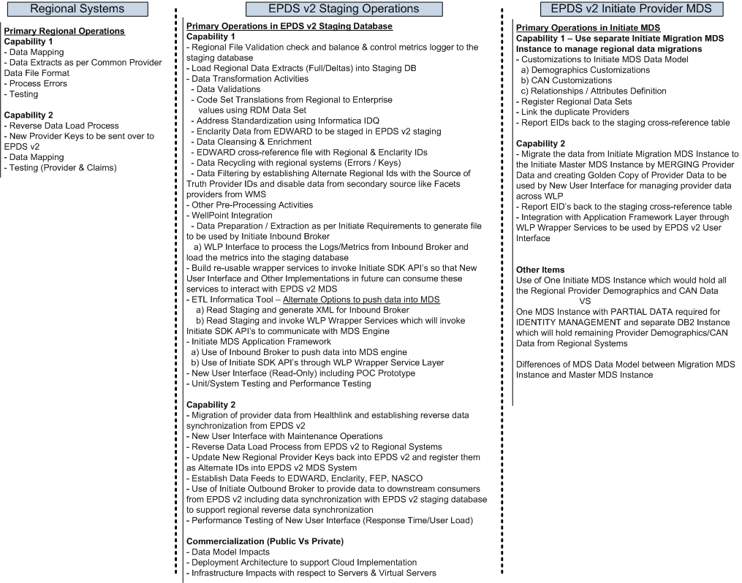

## Capability 1 - Overview

Deliver a consolidated provider data system for the enterprise that will that will eventually enable current and future provider data and network affiliation needs for all states and that will serve as a centralized source of truth for provider data. This project scope is to build the central provider demographic repository; there will be no changes to downstream systems and the data in the repository will not be fed to the downstream systems as part of this initiative. Therefore, no downstream systems will be impacted by this project including claims and data warehouses or business impacts such as PDQI scores.

* EPDS v2.0 data model must have the ability to accommodate current and future state provider affiliations
* Must have the ability to electronically extract, standardize, and load legacy provider system data into EPDS 2.0
* Must provide the ability to view provider data in EPDS 2.0 through a user interface
* Enterprise Provider Data Consolidation will simplify the implementaiton of key strategic initiatives such as: Payment innovation, Health Care Reform, Watson, Provider cost and Quality Transparency, Care Alerts, etc.
* Consolidated provider data will enable access to provider data for enterprise initiatives reducing implementation cost by reducing the number of interfaces required to retrieve provider demographic data. This can only be quantified the time an initiative is going through the discovery process.
* A central repository will enable standardized data for enterprise applications.

## Capability 1 - Scope

* Define current state/future state (EPDS v2.0) data model
* Map, Migrate, and implement/standardize data from other provider legacy systems to EPDS v2.0 Central Repository. Legacy system data migrations will include EPDS I, EPDS II, ACES, CPMF, QCare/QMed, FACETS, CPF (CS90), and WMS for Unicare Professional providers. Migrations will support providers from all lines of business.
* Evaluate archiving rules and implement where appropriate
* Evaluate provider data migration scope by defining type of providers, status (Active, Termed, contracted, non-contracted), and historical activity.
* Merge duplicate records within and across each legacy system where appropriate. Design and implement automated daily synchronization from legacy provider systems to EPDS v2.0 Design and implement a process for the daily synchronization conversion errors to be reported and worked by the region owning the data. Daily reconciliation reports must be part of the process to ensure all data is migrated from the source system to EPDS v2.0
* Design and implement a periodic reconciliation process that will capture, report and load any gaps in data between the source systems and EPDS v2.0
* Provide a way to view and report provider data residing in EPDS V2.0. Will provide business inquiry capability of provider data through a new user interface.
* Provide the Capability to audit changes to provider data whether the change was initiated through a batch process or a manual update.
* EPDS V2.0 must be able to store data that will enable the association of provider demographics with the credentialing profile to include but not limited to: Board Certification, Board Certification Name, Licensing, Education, Sanction, Certification Status, Accreditation, DEA, specialties, delegated data, Life Certifying, and credentialing status.
* EPDS v2.0 must be able to store data that will enable the association of provider demographics to price and contract information when required by claims or other downstream processes.
* EPDS V2.0 must be able to store data that will enable the association of provider demographics with the Provider Performance Profile which will include cost quality program participation and Score Card results managed in the Performance Provider Data Mart.
* EPDS v2.0 is required to support the Enclarity ID for Provider data cleansing and audit support for the association PDQI errors. The Enclarity ID must be visible on the inquiry screens.
* EPDS V2.0 needs to be able to support all current legacy system users with read only access.

## Capability 1 – Out of Scope

* Re-engineering of Provider Operations workflow and any workflow tools
* Data back sync to the legacy provider systems
* Creation of Single Directory File, retirement of paper directories and elimination of support fee for Ingenix
* The remediation of any current state extract, report, interface and I/O, RPCs from the following provider legacy systems:
  + ACES
  + CPMF
  + QCARE/QMED
  + FACETS
  + CS90
  + WMS
  + CACTUS
* The elimination of legacy provider IDs
* The decommissioning of any provider legacy systems
* Access databases/transparency databases being maintained outside of provider legacy systems
* The integration of EPDS v2.0 with claims system or other downstream systems.
* Healthlink Providers will not be loaded to EPDS v2.0
* Enclarity Data Cleansing in EPDS v2.0, Enclarity processes as part of the legacy systems will not be impacted.
* Building EPDS v2.0 to be the source of truth for provider demographic data
* NMS will not be impacted

## Capability 1 – Conceptual Requirements

* EPDS v2.0 data model must have the ability to accommodate current and future state provider affiliations
* Must have the ability to electronically extract, standardize, and load legacy provider system data into EPDS 2.0
* Must provide the ability to view provider data in EPDS 2.0 through a user interface

## Capability 1 – High-Level Data Migration Flow

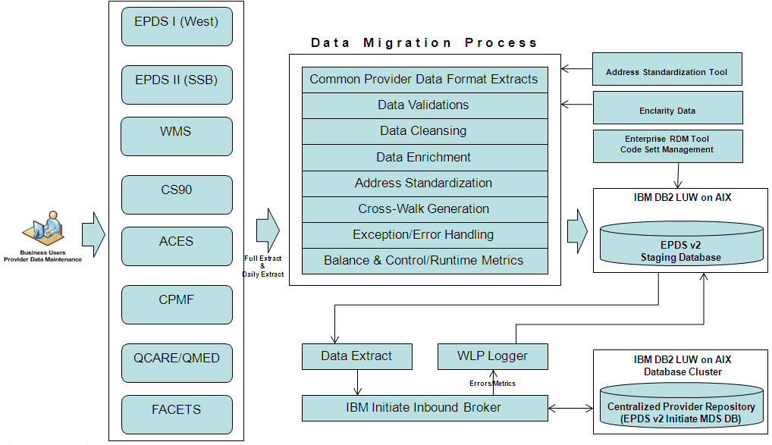

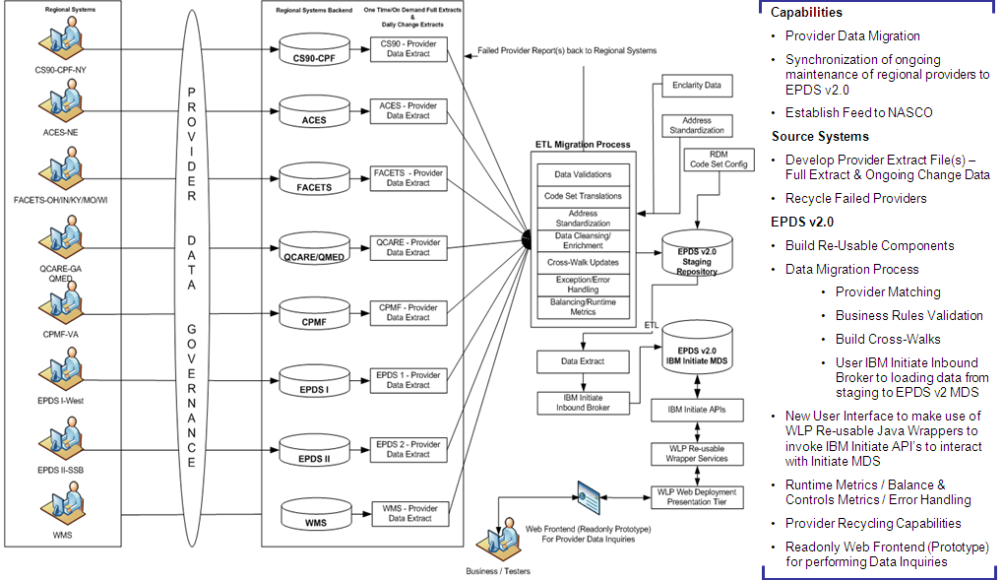

## Data Extraction from Regional Provider Systems

Regional Systems would be generating Provider Data Extracts in a Common Provider Data Format without applying any Data Filtering/Merging techniques and pushed into the WLP Bridge Server which would push the regional data files to the EPDS v2 Batch Server for further processing.

* **Full Data Extracts** – Multiple Provider Data Extract Files in the Common Provider Data File Format with each segment translated into a data file with Full Load of Provider Data
* **Delta Data Extracts** - Multiple Provider Data Extract Files in the Common Provider Data File Format with each segment translated into a data file with Delta (Change) Provider Data

**Note:** Regional Systems would also be sending a separate FILE with a list of FULL Provider Ids from each system which will be kept synchronized with the Master Cross-Reference Table within EPDS v2 System to closely TRACK DELETE operations at Provider Id Level.

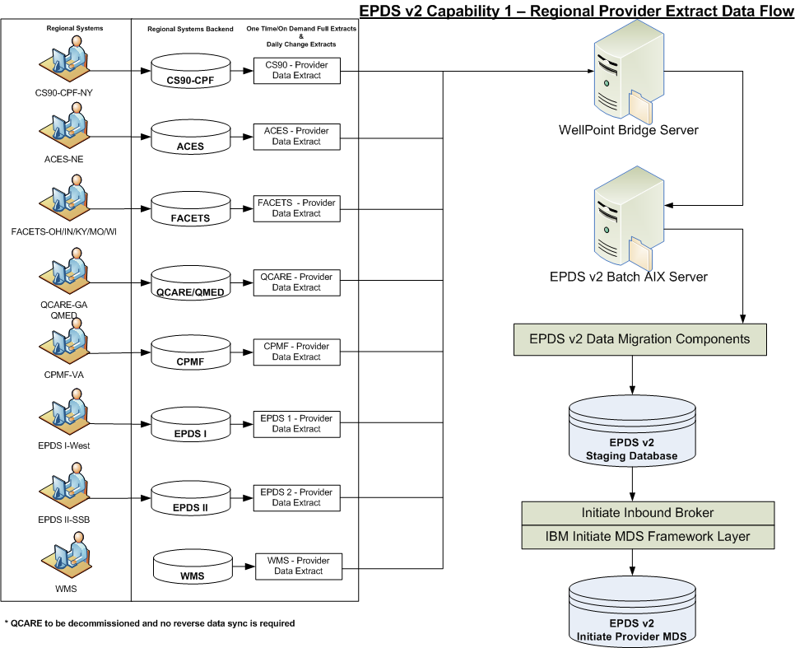

## Enclarity Data sourcing from EDWARD/Enclarity process

As a part of Cap 1 Implementation, Enclarity Data would be leveraged from the existing EDWARD/ENCLARITY process. In the current state EDWARD provides the WLP Provider Data to Enclarity on a monthly basis and Enclarity returns the Cleansed/Augmented data back to EDWARD systems which then routes the data to the regional systems. Files between EDWARD and ENCLARITY system are exchanged through the WLP Bridge Server. EPDS v2 would be leveraging the Cleansed/Augmented/50 state Provider File/EDWARD-Enclarity cross-reference data. Appropriate changes would be deployed to make WLP Bridge Server send Enclarity Data Files to EDWARD and EPDS v2 Systems in addition EDWARD would be sending the EDWARD/Enclarity cross-reference file to EPDS v2 System.

Leverage Enclarity Data currently EDWARD received and stage within EPDS v2 Staging Database through Capability 1 and establish direct connectivity with Enclarity through Capability 2 prior to decommissioning of EDWARD/Enclarity process. Also establish real-time connectivity with Enclarity through Capability 2 to be used by EPDS v2 implementations. Non WLP Providers would also be registered in the EPDS v2 as Enclarity Source to align with Commercialization initiative.

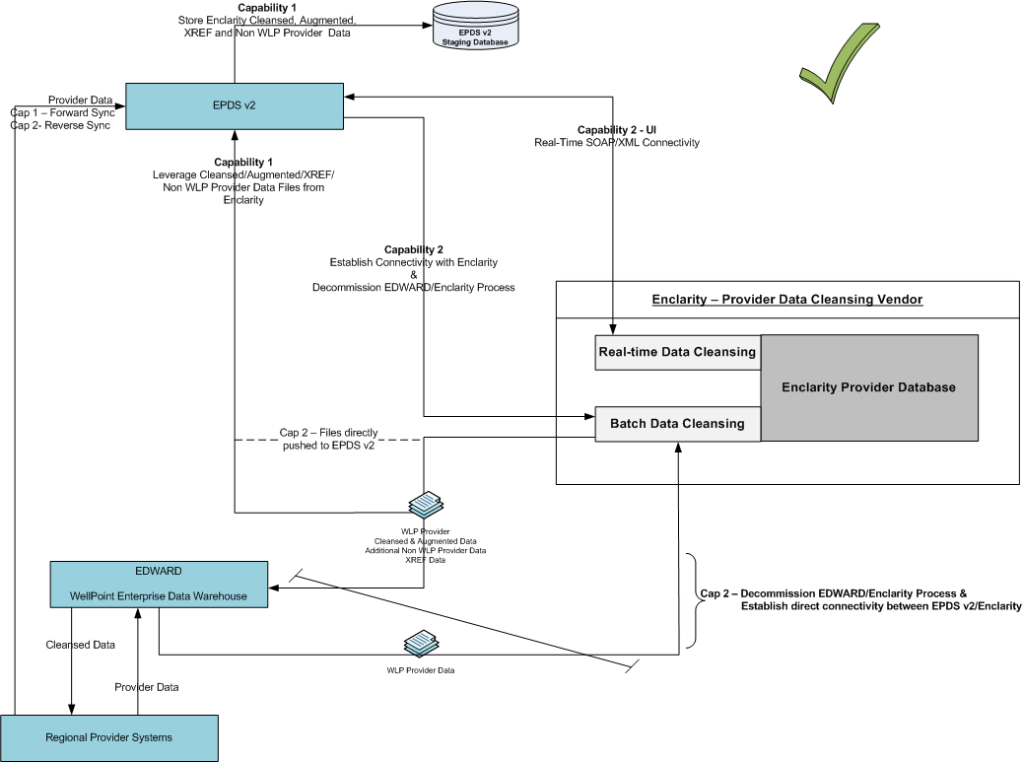

**Process 1:** EDWARD to send EDWARD/Enclarity cross-reference data file

**Process 2:** WLP Bridge Server to push all the Enclarity Data & XREF Files to EPDS v2 Batch Server

**Process 3:** Enclarity and EDWARD cross-reference data would then be kept tightly synchronized with the Staging Enclarity Data Repository for further use within EPDS v2 System.

**Process 4:** Separate process would be designed and implemented which would create a Data File as per Initiate Inbound Broker Format Requirement with Non WLP Provider Data as Enclarity Source so that these providers would then be processed through Initiate Inbound Broker in support of EPDS v2 Commercialization Initiative and these providers would also be readily available as Non Par Providers in support Regional Claims Adjudication Systems.

Triggering Auto-Emails with Runtime Metrics using environment detection logic to notify appropriate email distribution groups.



## Reference Data Management (RDM) Synchronization Process

Enterprise RDM System would be used to manage all the code set translations between Regional Provider Systems and EPDS v2 System. Major categories of Code Set transformations would be

* Provider Types
* Address Types
* Provider Status
* Specialty Codes
* Term Reason Codes for all the child data terminations
* Provider Relation Types

Data from RDM System would be made available at a frequent basis so that EPDS v2 System can consume these code set translations through Data Migration Components and EPDS v2 User Interface.

**New Synchronization** Process would be deployed with in EPDS v2 to process the incoming code sets data from RDM System and data would be tightly synchronized within EPDS v2 RDM Data Repository in the Staging Database.

Staging Data Transformation Process would perform the Code Set Translations through staging activities and any mismatches would be Hard Exceptioned and Recycled until the Data Issues are resolved.

EPDS v2 User Interface would also consume Code Set Data from EPDS v2 RDM Data Repository through WLP Java Wrappers deployed in the WAS Application Tier which would connect to the Staging Database using a DB Connection Pool User Account for interacting with the Staging DB.

Triggering Auto-Emails with Runtime Metrics using environment detection logic to notify appropriate email distribution groups.

## Data Extraction - File/Folder Naming Convention

Regional Systems Provider Data Extracts would be transferred in the WLP Bridge Server into their respective folders on EPDS v2 Project. Folders would be setup in the WLP Bridge and EPDS v2 Batch Servers for receiving files from regional DEV, SIT, PERF, UAT and PROD environments.

Common Provider Data File Format lists many Data Segments to source data from regional systems. Every Data Segment should be generated as a separate file with its header/trailer records.

Every Data File should have Environment Tag and Date Time Stamp for tracking purpose.

**epdsv2_facets_dev_segmentname_datetimestamp.txt (Sample File Name)**

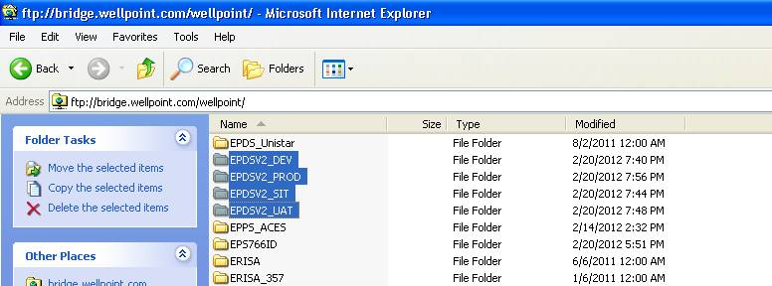

**Under each EPDS v2 environment directory, a sub-folder for each region will be used to stage file extracts:**

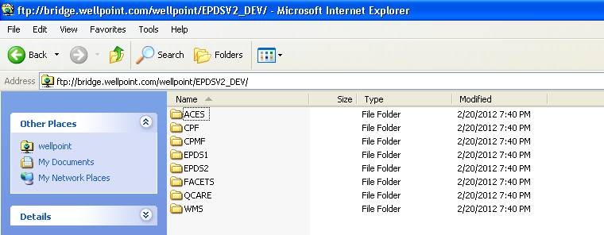

## Database (DB2 LUW on AIX) Enhancements

EPDS v2 would be using IBM DB2 LUW on AIX Server(s) as the Database Tier for managing Enterprise Provider Data across WellPoint. Initiate Provider MDM SE v10 requires dedicated database server for managing provider data within Initiate MDM System so that all the resources are accessible to MDM.

Below is the landscape of the Database Tier

First Instance of DB2 LUW on AIX

* Initiate MDM Database would be used to deploy out-of-box Initiate Provider Data Model after which New Customizations would be implemented to accommodate WLP Business Requirements for managing Provider Demographics, Contracts & Networks and Payment Innovation Data. **Production/Performance/UAT would be using pureScale Database Clustering Technology where as other environments would be using standalone dedicated DB Server.**

Second Instance of DB2 LUW on AIX would be used for managing Custom Data Requirements

* Staging Database would be deployed for managing
  + Common Provider Data Segments Repository with additional house-keeping columns used to keep the data synchronized from the regional provider data extracts in Common Provider Data File Segments. Each Segment from the Common Provider Data File Format is mapped to a specific table in this repository
  + RDM Repository for managing Regional/Enterprise Code Set Values from RDM System
  + Enclarity Data Repository including Edward/Enclarity cross-reference data
  + Common Error/Exceptions/Metrics Repository would be created to log errors/exceptions and balance & control/runtime metrics from the automated components
  + User Interface related application tables like User Access/Permissions configured for accessing EPDS v2 system
* Operational Reporting Database would be deployed for managing
  + Data from Initiate MDS Database would be kept synchronized through Initiate Event Notification capabilities with Operational Reporting Database with Parent/Child Data in support of downstream data consumers. EDWARD, NASCO, FEP, ENCLARITY and Reverse Data Synchronization with all the WLP Regional Provider Systems would be consuming data from this database.

**High-Level Database Tier View:**



## Pre-processor Interface (File Sanity Checks)

Pre-processor Interface will perform basic file sanity checks to make sure

* All the expected files from the regional system are present in the expected directory
* File is present in the correct environment directory to avoid contributing to a data issues
* complete data set is received
* Header and Trailer records exist correctly and strip off Header and Trailer for every file before these files are moved to a working directory for further processing through next data migration component
* Metrics are collected and logged them into the common repository. Some metrics are
  + File Name
  + Source System Name
  + Target System Name
  + Segment Name
  + Environment Name
  + Date Time Stamp
  + File Size
  + Number of Records
  + Header Info
  + Trailer Info
* Triggering Auto-Emails with Runtime Metrics using environment detection logic to notify appropriate email distribution groups



## Regional Data Synchronization with Staging DB – Staging Phase 1

Regional data files would be kept tightly synchronized with EPDS v2 staging database using Informatica ETL process

* Each regional file extract is mapped to a specific table in the staging database except the Master Provider File with list of Full Provider Ids along with Regional Source that would be part of Full and Delta process
* Master Provider File with list of Full Provider Ids along with Regional Source would be kept synchronized with Master Cross-Reference Table within EPDS v2 Staging DB (Master XREF table will have Regional Provider Id, Source, Enclarity ID, MDS EID, MDS MEMRECNO, Active Indicator, Date Time Stamp)
* ETL process refreshes the data in the staging tables
* Some Translations would be done while data is refreshed in the corresponding tables
  + Regional code set translations to the enterprise values while retaining the regional values. RDM Code Set data would be pre-existing through a separate process.
  + Use of IDQ call to perform address standardization while retaining the regional and scrubbed address records along with a indicator to know if address scrubbing was recommended by IDQ process

Staging Tables would only stage the latest regional data snapshot from the regional systems without maintaining any auditing data. Data Auditing should be leveraged from the Source (Regional System) and Target (EPDS v2 MDS built-in audit process).

Day 1 Regional Data Extracts will have FULL load of Provider Data. Day 2 onward Regional Data Extracts will have changes tracked at the Regional Provider Id level but COMPLETE data snapshot tied to a Provider Id would be part of the extract irrespective of what data changed for that provider. Data Integrity within regional data extracts would be enforced by the regional data extraction components.

Unique Key need to be generated for every segment using MD5 algorithm which takes custom unique key values and assigns a Unique Key that can be stored and recreated by invoking the algorithm with the same values. EDWARD and Provider Finder Systems currently use MD5 algorithm to generate unique keys.

Staging Repository consists of several database tables mapped to the data segments from the Common Provider Data File Format with an exception that these tables have additional housekeeping columns. Example all the segments that carry address data elements would have place holders in the corresponding table to store regional address data values along with separate columns to store scrubbed address elements from IDQ process along with scrubbed address indicator. Provider Profile Segment has an additional Process Indicator column (P-Process, C-Complete, E-Error & H-Exception) to be used by the remaining migration components to only pickup parent provider records with Process status for channeling data through next transformation phase.

Triggering Auto-Emails with Runtime Metrics using environment detection logic to notify appropriate email distribution groups

Master Data from the Regional Systems should be kept synchronized within the staging repository prior to channeling into MDS engine.



## Staging Data Transformations – Staging Phase 2

Primary operations of this process is to perform

* Data Cleansing / Enrichments using Enclarity Repository within Staging Database as per Business Approvals
* Data Validations
  + Invoke Re-Usable Java Data Validation Components from ETL process to tag providers with Hard and Soft Exceptions
    - Some exceptions would apply the validation rules locally without hitting staging database server
    - Some exceptions would need to perform validation rules by hitting against the staging database server to get the final outcome
  + Some Data Validations would need to be implemented within Database Server which will apply the validation criteria against the Mass Data Volume to check the referential integrity of the data. Example checking if Tax Id is valid or missing remit or primary address records or missing group affiliation relation etc.
* Data Filtering as per business approvals especially with respect to handling Term/Duplicate Data
* Updates to the Cross-Reference tables
* Error/Runtime metrics logging to the staging common repository
* Triggering Auto-Emails with Runtime Metrics using environment detection logic to notify appropriate email distribution groups

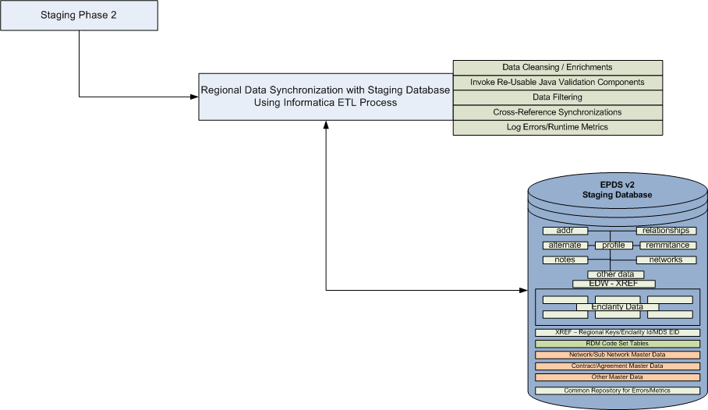

## Regional Data Extraction for Initiate Inbound Broker - Staging Phase 3

Primary operations of this process is to

* Regional Data Extraction from Staging Database
  + Generate One File per Regional System by listing data as per Initiate MDS Formatting requirements by listing complete data for each provider in the form of segments similar to common provider data file format. **All the DELETE Operations happening at Regional Provider ID level would be listed towards the end of the each file so that Inbound Broker can perform special process to DISABLE data tied to these Provider Id’s.**
  + Separate File would be generated with Non WLP Providers registered as Enclarity Source to support commercialization initiative and provide non-par providers to the regional claims systems as required
* Trigger automated script to move the regional Initiate MDS extracts to the corresponding locations for inbound broker to pickup and process further
* Multiple Inbound Brokers would be processing the data simultaneously to load regional data into Initiate Migration MDS Instance using REGISTRY APPROACH by registering the Regional Data Set and cross-linking the duplicate providers automatically using MDS matching algorithm. Multiple Brokers would be setup based on the Server Capacity which will be determined in the Performance Environment to take advantage of H/W resources as much as possible through Cap 1 data migration process. The multi-broker setup would be scaled down by factoring the User Interface load through Cap 2 as some incoming data channels may continue to use the registry approach to push data into MDS engine
* Check if all the Inbound Brokers have completed successfully and in the event of error appropriate inbound broker would be re-triggered to restart from point of failure
* Trigger Custom Java Interface which will collect the Inbound Broker Metrics from the Inbound Broker Logs and synchronize them in the staging common repository
* Trigger Custom Automated Script to extract MDS EID’s for Regional Providers and update the Staging Cross-Reference Table with MDS EID values for tracking providers between staging database and MDS instance. This information may also be required by EDWARD system for cross-linking the regional providers to the corresponding EID (Enterprise ID) assigned within Initiate Provider
* Master Data from the regional systems would also need to be kept synchronized with MDS engine like master Network Definition Information and Agreement/Contract Pointer Details that would be used to relate to the appropriate pricing profile elements like Rate Sheets and Fee Schedules
* Triggering Auto-Emails with Runtime Metrics using environment detection logic to notify appropriate email distribution groups



## Testing Strategy

EPDS v2 components be tested in the following environments

* + Development
  + System Testing (SIT)
  + Performance Testing
    1. MDM Matching Rules Tuning
    2. MDM Merging Configurations and Exit Point Scripting with WLP Customizations to implement the Merging Rules
    3. Data Migration Load Testing to setup multi-brokers based on h/w resources/capacity
    4. User Interface Load Testing to test the Response Time & Overall System Health within App-Tier, MDS Hub Tier and Database Tier

**Note:** Any tweaking/tuning of MDS Matching Rules and Merging Rules by IBM within Performance Environment at frequent intervals should be broadcasted to the Development and System Test Environments so that new configurations within MDS can be re-tested. In some situations data within MDS should be rebuilt to re-apply the new configurations so that algorithm re-links the providers within each environment.



## Capability 2 - Overview

Deliver a consolidated provider data system for the enterprise that will accommodate current and future provider data and network affiliation needs for all states and that will serve as a centralized source of truth for provider data.

Feeds from EPDS v2.0 will be built to support FEP, NASCO, and EDWard.

* Data entry for all provider data will be centralized in EPDS v2.0
* Business processes will be standardized where appropriate in order to support both the system and manual procedures involved with centrally maintaining provider data in EPDS v2.0
* Provider data updates in EPDS v2.0 will be synched to the appropriate provider legacy systems except QCare
* EPDS I and EPDS II will be decommissioned and all its associated interfaces (i.e. extracts, I/Os, RPCs, batch jobs etc.) will be remediated appropriately
* WGS claims system will redirect its provider claims interface from EPDS I and EPDS II to WMS for all claims processing
* Users will have data available which will help them prevent data entry of duplicate providers in EPDS v2.0; they will have tools to merge duplicate records which have been erroneously entered in the system
* Current NASCO, FEP, EDWard, IP28 and Enclarity provider data feeds will be decommissioned and consolidated into EPDS v2.0

## Capability 2 - Scope

* The following markets are in scope for this project:
* West region (CA Commercial, CO, NV)
* North East Region (ME, NH, CT)
* Central Region (IN, KY, OH, WI, MO)
* SSB (IN, KS, WV, TX, SC, MA, CA)
* VA
* GA
* NY
* HealthLink (IL, MO, IN, KY, TN, OH, and AR)
* Unicare
* The following provider systems are in scope for this project:
* EPDS I,
* EPDS II
* ACES (Provider)
* CPF
* FACETS (Provider)
* CPMF
* HealthLink ANITA
* WMS
* FEP
* NASCO
* Design and build a common user interface and screens for EPDS v2.0 to enable searching, viewing and management (i.e. add, update, terminate) of provider data. Any EPDS I and EPDS II functionality, which aligns with the Enterprise model, will be retained
* Migrate and implement/standardize data from HealthLink ANITA to EPDS v2.0
* Design and build a daily provider data synchronization process from EPDS v2.0 to each provider legacy system. The process will include implementing detailed data and record mapping, and transformation rules to ensure that EPDS v2.0 records are successfully synched to the data and record structure of each provider legacy systems EXCEPT QCARE. QCare would forward feed EPDS v2 until this system is retired with no need for reverse data synchronization
* Design and build a process for EPDSv2.0 to feed provider data to each provider legacy system to support new business’ Claims Unit testing. The new businesses will focus around:
  + ASO
  + Fully Insured
  + HMO
* Design and build a process for the daily synchronization conversion errors to be reported and worked by the region owning the data. Daily reconciliation reports must be part of the process to ensure all data is synched from the EPDS v2.0 to the provider legacy systems
* Provider legacy systems will be changed to read-only for all data stored in EPDS v2.0. Define an exception process to allow for urgent provider data changes (i.e. to support claims processing)
* Decommission EPDS I and EPDS II provider systems and remediate all associated interfaces, reports, extract files, feeds, RPCs and I/Os as appropriate
* Design and build a solution to enable WGS Claims system to use WMS for all Claims processing; decommission WGS Claims from using EPDS I and EPDS II for Claims system transaction processing. All EPDS I and EPDS II data (including WMS and NMS Institutional, and QCARE MedAdvantage records) should be available in WMS for WGS claims processing
* Using the merge rules/edits/criteria defined in the dependency project Infrastructure Repository Build (EPDS v2.0 Cap 1) to merge duplicate records:
* Design and build on-line functionality and/or edits, which will enable the user to identify potential duplicate records during the search and data entry process, and provide the information needed for the user to take the appropriate action.
* Provide user the on-line tools to merge duplicate records which have been erroneously entered in EPDS v2.0
* Design and build a provider data feed from EPDS v2.0 to FEP streamline, and decommission current provider data feeds from provider legacy systems to FEP streamline where appropriate
* Design and build a provider data feed from EPDS v2.0 to National IT to support the data feeds to NASCO, and decommission current provider data feeds from provider legacy systems to National IT where appropriate. QCARE feed will be prioritized in order to support the initiative to decommission QCARE
* Design and build a provider data feed from EPDS v2.0 to EDWard, and decommission current provider data feeds from provider legacy systems to EDWard where appropriate. QCARE feed will be prioritized in order to support the initiative to decommission QCARE
* ** Design and build a provider data feed from EPDS v2.0 to WMS, to support FACETS central host process and decommission current IP28 provider data feeds from FACETS to WMS where appropriate
* **Design and build an Enclarity process to cleanse the data in EPDS v2.0. All current Enclarity functionality which is documented in the approved Phase 1 and Phase 2 BTRD, together with any approved change requests, and which aligns with the Enterprise model must be retained. Decommission the Enclarity cleansing processes in each provider legacy systems where appropriate. Any Enclarity processes/business rules/reports/extracts/jobs required to support the initiative to decommission QCARE will be prioritized
* Design and build provider audit history reporting for the maintenance of a provider record in EPDS v2.0. Audit history will include, but is not limited to the following data: date/time when updates were made, value of the field before the update, value of the field after the update and the ID of the user or process which performed the update
* Design and build provider data migration, archiving and retention processes in EPDS v2.0
* **Design and build a functionality which allows users to temporarily save records into their queues, manage their queues and reassign the saved records. All current EPDS I and EPDS II functionality related to this requirement, which aligns with the Enterprise model must be retained and enhanced where appropriate, to support current and future business requirements
* **Design and build a business rules engine functionality, which allows users to add, update, view and search business rules. All current EPDS I and EPDS II business rules functionality, which aligns with the Enterprise model must be retained and enhanced where appropriate, to support current and future business requirements
* ** Design and build a process to perform systematic mass import, mass add and mass updates to EPDSv2.0 data from both internal and external partners
* ** Support all business functions of existing downstream consumers which use provider data:

Examples:

* Provider Directory
* eBusiness
* Utilization Management
* Health care management, e.g. Case Management
* Membership
* Customer Service
* Enrollment
* G&A
* Information Management
* Provider Network Contracts
* Claims and Checkwrite
* Express Scripts Incorporated (ESI)
* American Imaging Management (AIM)
* Other
* Design and execute a standardized business process, which will support both the system and manual procedures involved with centrally maintaining provider data in EPDSv2.0
* **Conduct the appropriate quality testing, regression testing and business checkout to ensure that the IT and business requirements are met, and that downstream systems are not adversely impacted by the initiative. Build and provide the appropriate environments to support the testing and business checkout efforts
* Conduct the appropriate performance and stress testing to ensure that performance, system availability, and other non-functional requirements are met. Build and provide the appropriate environments to support the performance and stress testing efforts
* Build EPDS v2.0 security access according to user’s role and function and provide users the appropriate access
* Develop and execute a training plan which includes but is not limited to the following:
* Design the training and delivery approach
* Design and develop the appropriate training outline and training materials according to users’ specific roles, functions and system access
* Build the appropriate tools, training data and training environments to support the training efforts
* Plan and coordinate the schedule, venue and other training logistics
* Evaluate training effectiveness and apply evaluation results to improve future training efforts
* Ensure due diligence and complete analysis is completed for the following requirement components, in order to understand impacts of EPDS v2.0, and to ensure user and technical requirements are met:
* Functionality
* Usability
* Reliability
* System Performance
* Supportability
* Security
* Business Rules
* Training
* Reassess the hardware infrastructure which was put in place in the Infrastructure Repository Build (EPDS v2.0 Capability1) to ensure that it meets the current and future system and performance requirements of Provider Centralized Maintenance (EPDS v2.0 Capability2), which includes but is not limited to:
* number of concurrent users,
* downstream transaction volume,
* memory and data storage capacity,
* response time, system performance and availability
* Design and build data back-up and disaster recovery processes. Update current WLP Business Continuity and Disaster Recovery plans to add EPDS v2.0
* ** Design and build a process and environment for reporting and extracting provider data, which includes the development of the appropriate data schema and query tools where appropriate
* **Design and build a process and environment to systematically generate correspondences to providers. The functionality will include features such as, the ability to create correspondence templates containing free-form text and placeholders to display provider data. It will include the creation of new standard correspondence templates and migration of existing correspondence templates
* Develop service level agreements (SLAs) for IT to provide the performance, reliability and system availability requirements of EPDS v2.0
* Develop an issue resolution and escalation process to report, prioritize, resolve and track production issues related to EPDS v2.0

** These are scope items which may not have been part of the Discovery Estimates and will be taken through Planning. Following Planning Gating Process, level of efforts (LOE) for these items may have to go through the change request process

## Capability 2 – Out of Scope

* The decommissioning of the following provider legacy systems
* QCARE (Provider),
* ACES (Provider),
* CPF,
* FACETS (Provider),
* CPMF and
* WMS
* HealthLink – ANITA provider system
* The remediation of legacy provider system extracts, report, RPCs, I/Os and batch jobs, (except for FEP, NASCO, EDWard, IP28 and Enclarity) for the following provider legacy systems
* QCARE (Provider),
* ACES (Provider),
* CPF,
* FACETS (Provider),
* CPMF and
* WMS
* HealthLink – ANITA provider system
* The decommissioning, remediation, migration or forward-synching of provider data stored in the following systems:
* NMS – National Management System
* Cactus and other credentialing databases used by Enterprise credentialing and Anthem Credentialing Services Inc (ACSI)
* Dental System
* Pharmacy System
* Vision and Life Systems
* Transparency databases, Microsoft Access databases and other ancillary databases stored outside of the provider legacy systems
* ePact system, Lotus Notes and other tools used to request provider data updates
* The building of a forward-synch process to synch data from EPDS v2.0 to QCARE.
* The elimination of the legacy system IDs from the provider systems
* The creation of single directory file, retirement of paper directories and elimination of support fee for directory vendors
* Initiatives outside of the EPDS v2.0 Provider centralized maintenance project (PV ID 021535)
* Infrastructure Repository Build (EPDS v2.0 Cap1) – PV ID 21129
* Enterprise NetworX GA – PV ID19886
* Enterprise NetworX NY – PV ID 20874
* Enterprise NetworX NE – PV ID 20875
* Enterprise NetworX Central Region – PV ID 20876
* Enterprise NetworX West – PV ID 20877
* Enterprise NetworX APC – PV ID 20912
* Enterprise Modeler Analytics – PV ID 20911
* Contraxx Project – PV ID 20913
* ClaimsXten Project – PV ID 20824
* EPDS GA/WMS Migration – PV ID 20292
* Enterprise Provider Pricing System – PV ID 20293
* Enclarity – PV ID 20311
* ICD-10 Remediation Project

## Capability 2 – High-Level Data Flow

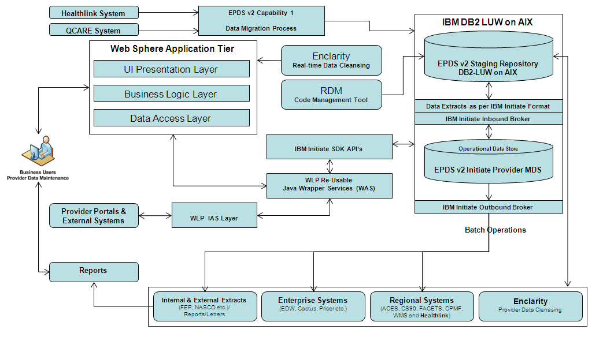

**Major Components**

* **New EPDS v2 User Interface –** New web based UI would be rolled out so that business users can perform provider data maintenance using standardized enterprise workflows/rules.
* **Reference Data Management (RDM) –** Use of Enterprise RDM tool to perform code set translations between regional and enterprise code set values.
* **Healthlink System Integration –** One time provider data migration to EPDS v2.
* **Reverse Data Synchronization –** To support regional business activities such as claims & downstream data feeds, provider data from EPDS v2 would be kept synchronized with ACES, CS90, FACETS, WMS, EPDS I, EPDS II, CPMF and Healthlink Systems EXCEPT QCARE. QCARE will forward feed EPDS v2 through CAP 1 until this system is retired with no reverse data sync.
* **Downstream Data Feeds –** Establish connectivity with NASCO, FEP and EDWARD. In future with CACTUS (Enterprise Credentialing System).
* **Enclarity –** Establish real-time and batch connectivity with Enclarity for performing provider data cleansing activities.
* **Portals/External Systems –** Align interface with Provider Portals and External Systems using WLP IAS Layer which would invoke EPDS v2 re-usable wrapper services for communicating with EPDS v2 Initiate MDS through Initiate SDK API layer.
* **Reporting –** Support EPDS v2 business reporting.

## Capability 2 - EPDS v2 User Interface

EPDS v2 User Interface will be a Web based GUI with application tier components to be deployed in the Web Sphere application server which would be communicating through WLP Java Wrappers and Initiate Java API Layer to interact with MDS database server.

Enterprise Provider Data maintenance work flow to be derived by consolidating the regional provider data maintenance workflows from

* ACES
* CS90
* CPMF
* EPDS R6 – Current state uses Web GUI
* EPDS SSB – Current state uses Web GUI
* FACETS – Current state uses Web GUI (GP00-Provider Intranet Application)
* HEALTHLINK
* QCARE
* WMS

Business should standardize on how provider data maintenance would be performed towards

* Terming Provider and related data
* Determining Provider Status
* Managing Provider Address Relationships example Professional Provider Address records should be found at the Group Level
* Managing Solo Practitioners
* Managing Group Affiliations for Professional Providers – Always linking these providers to a corresponding Group including Solo Providers
* Managing Par and Non Par Data in support regional claims adjudication systems
* Managing association of Specialty and Tax information

**Major Components of the EPDS v2 User Interface**

* Application tables related to User Interface Implementation would be stored in the EPDS v2 staging database
* User Login Process
  + Login Page will be using Site Minder/LDAP authentication as first step and then check against the staging user tables to check the User access to various modules within EPDS v2 System
  + Forgot Password / Create New Request process for New Users requiring access to the EPDS v2 System
  + System Availability/Application Version Information
* Home Page
  + Links to various Modules based on User Security
* Provider Search Functionality
  + Search Page with all the Search Parameters and User Preference to view Search Result Attributes
  + Search Results Page to display multiple providers as result
* Provider Details Functionality
  + - Details Page displaying the Enterprise View of a specific Provider with Specialty, Tax, Address, Relations (Group, IPA, Hospital & Covering), Credentialing and CAN Data
  + Maintenance Functions would be provided through links from the Details Page
    - Real-Time connectivity with Enclarity to perform data cleansing/enrichment functionality
    - Maintenance (Create/Update/Delete) of Specialty, Tax, Address, Relations (Group, IPA, Hospital & Covering), Credentialing and CAN Data
* Administration of
  + Network Data
  + Payment Innovation Data Concepts
  + Other Master Data
  + User Administration to grant access (read-only Vs read/write) to the Application Modules

User Interface

* Session Foot Print should be small to avoid HEAP issues in the Application-Tier Server
* Presentation-Tier would be rendering the page data
* Business Logic Layer would perform data validations and other transformations
* Data Access Layer would be invoking the WLP Java Wrappers to interact with MDS database
* Initiate Provider Java API’s are accessed through a Java Library which would be included into the WLP Wrapper Library that would be performing pre and post processing of data while interacting through Initiate API Layer
* WLP Java Library would then be used by EPDS UI App-Module to access all the methods for pushing and pulling data from/to MDS



**Sample Screens from EPDS R6:**

**Provider Search: Individual Provider**

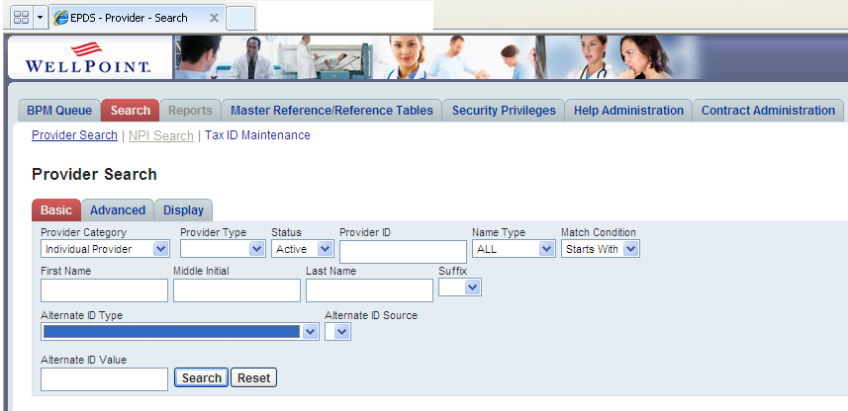  
**Provider Search: Organization**

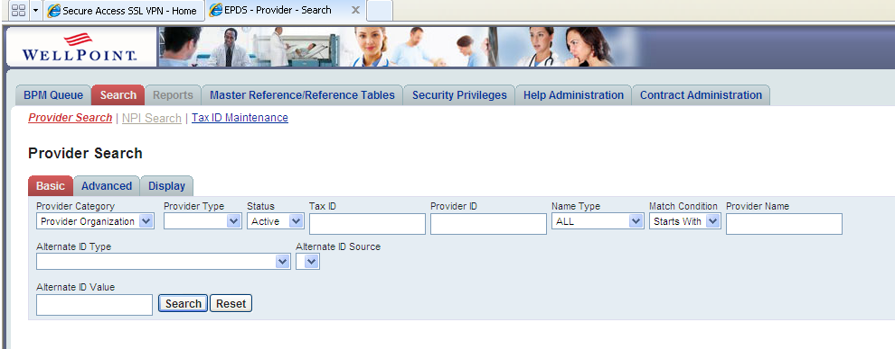

**Provider Search Results:**

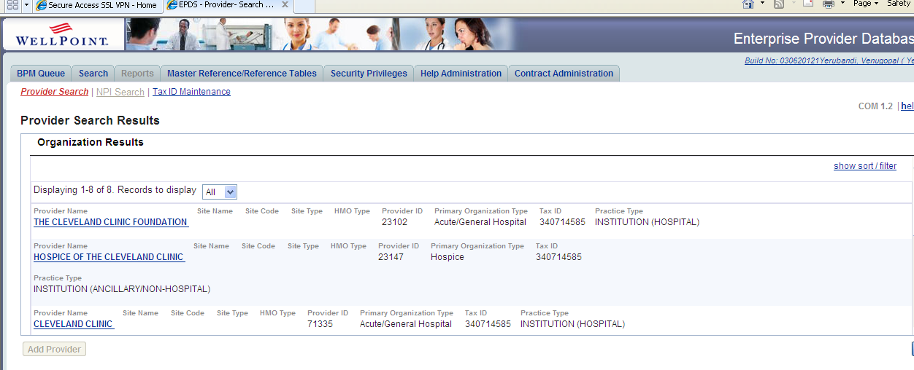

**Provider Details View:**

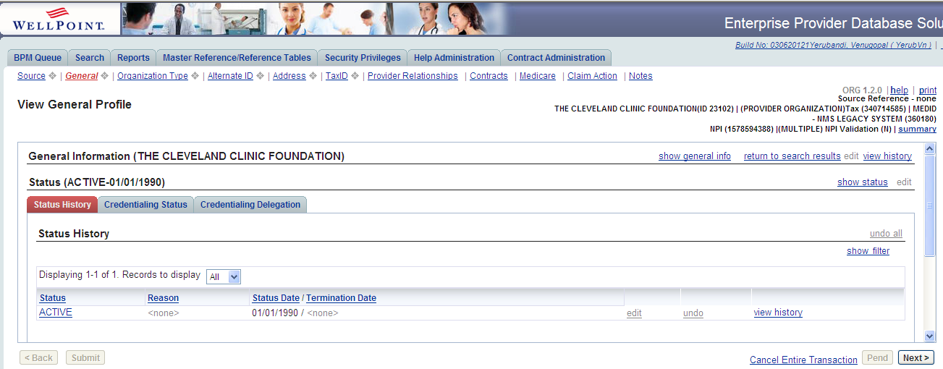

**Sample Screens from GP00-Provider Intranet Application used by Facets Business**

**Home Page:**

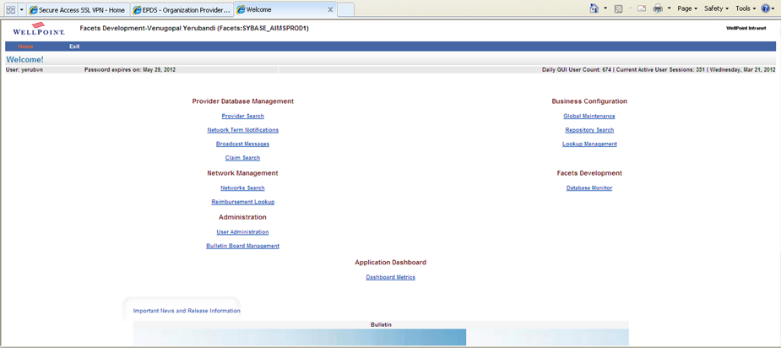

**Provider Search Page:**

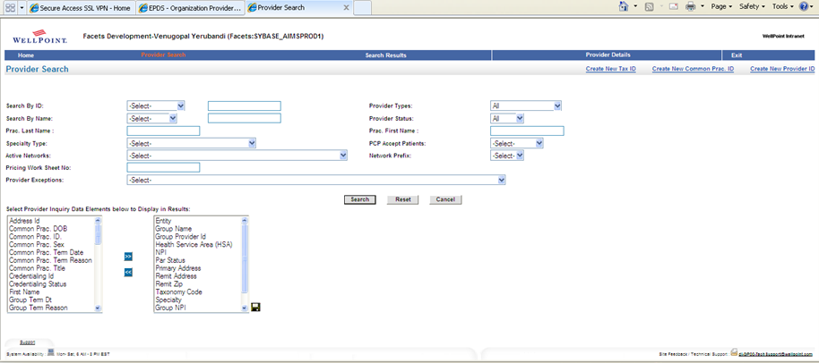

**Provider Search Results Page:**

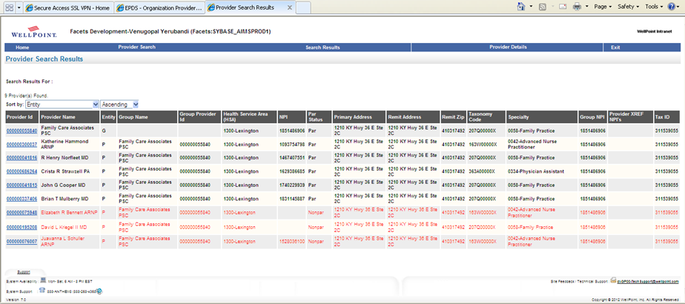

**Provider Details Page:**

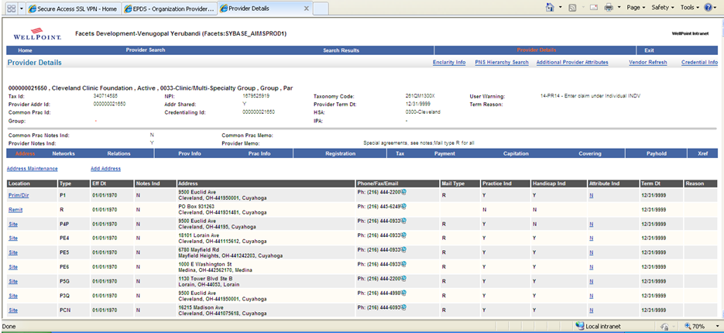

**New Tax Id:**

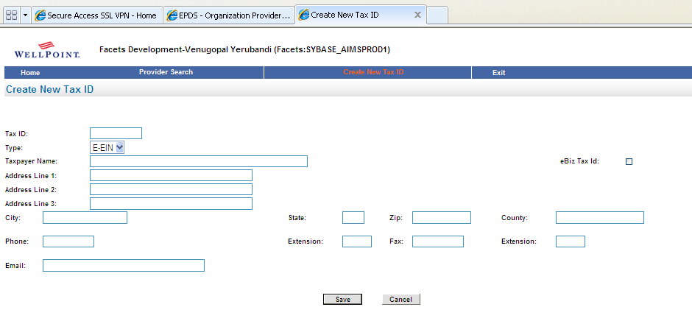**New Provider:**

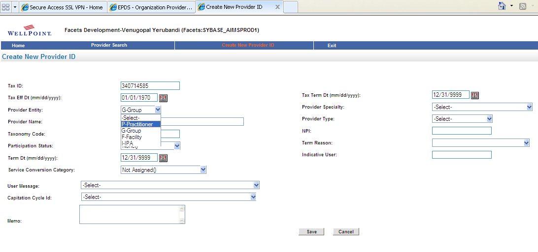

## Capability 2 – EPDS I (R6) Downstream Data Feeds

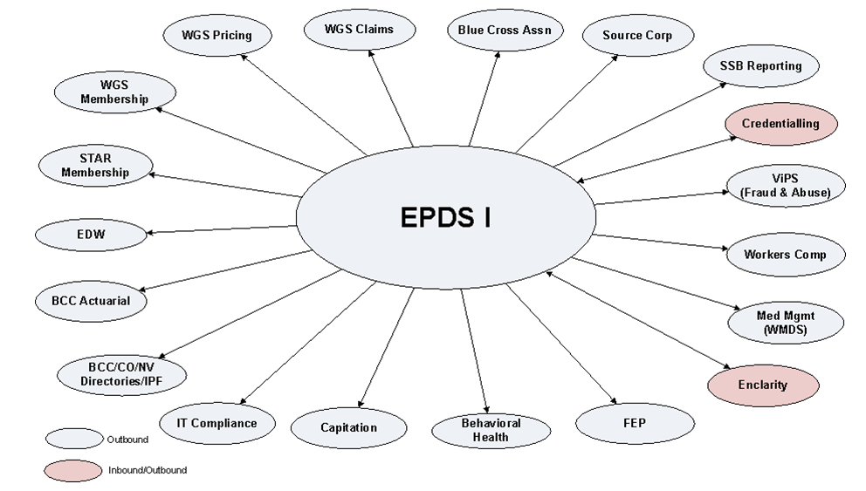

## Capability 2 – EPDS II (SSB) Downstream Data Feeds

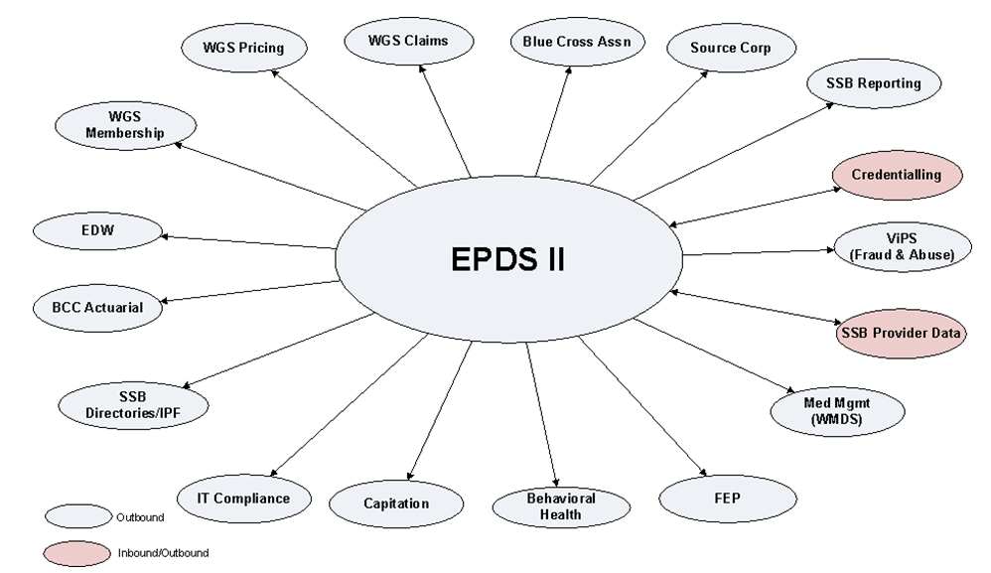

## Capability 2 – WMS Downstream Data Feeds

WMS – Inbound / Outbound Data Feeds would continue to exist in WMS system to support all West regional data requirements. The entire west related provider data would be made available from EPDS v2 to support West business activities around Provider Data. Due to the DECOMMISIONING of EPDS I and II, the downstream data feeds from EPDS I & II would be supported from WMS system.

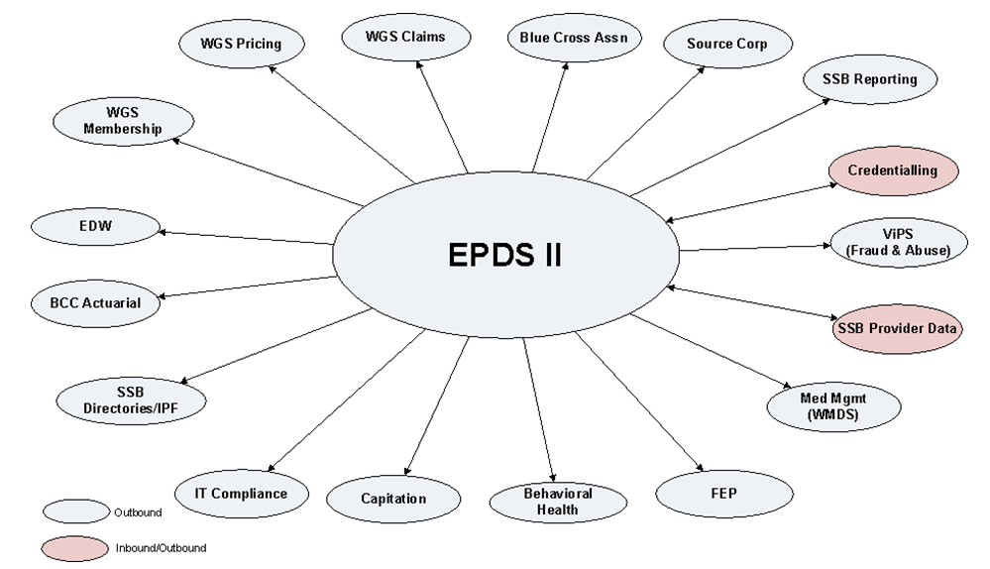

## Capability 2 – WMS Future State West Downstream Data

Downstream Data Feeds will be supported from WMS for all business requirements related to West region except some feeds like EDWARD, Enclarity, Cactus etc would be supported from EPDS v2

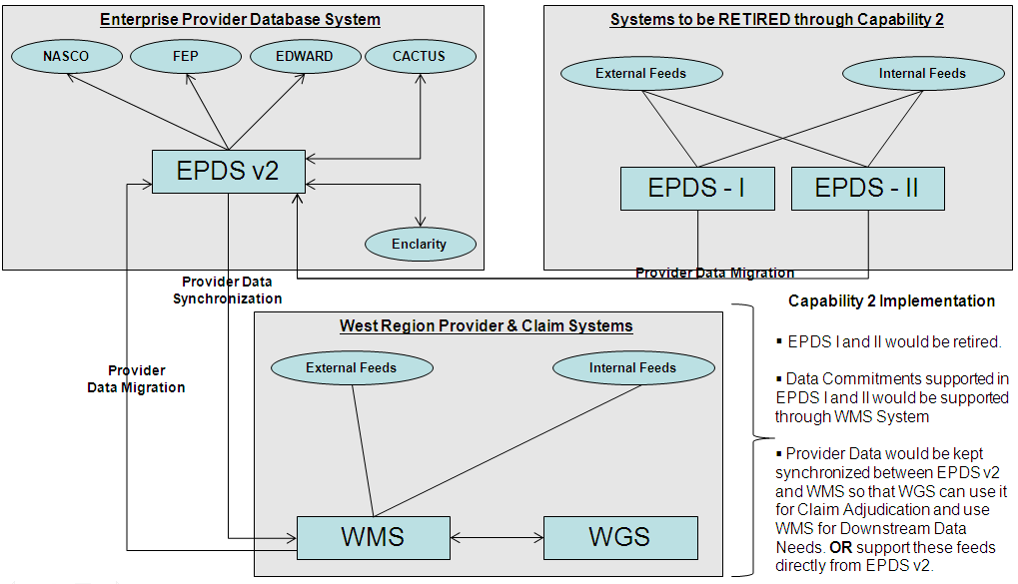

## Regional Incoming Data Feeds & QCare Forward Data Synchronization

Regional Incoming Data Feeds: All the INBOUND data feeds from the regional provider data systems should be moved over to the EPDS v2 System so that reverse data synchronization process would continue to make the corresponding data available to the regional systems.

* Facets
  + Dental Providers from WDS are currently processed through IP26 Interface
  + Credentialing Data from CACTUS is processed through IP24 interface
  + NPI Data from EDS is processed through IP25 interface
* ACES
  + Credentialing Data from CACTUS
* CS90
  + Credentialing Data from CACTUS
* WMS
  + Rental Data Feeds

**Note: Other Regional Systems Inbound Data Feeds analysis is under progress**

QCARE System will continue to forward feed EPDS v2 System until this system is decommissioned. Below mentioned are 2 approaches through which on-going delta changes from QCARE can be kept synchronized with EPDS v2 System

* Cap 1 Registry Style implementation can continue to keep the QCARE data synchronized with the QCARE Registry Data Sets through the use of Initiate Inbound Broker. Composite View to always provide end users with the latest data from the registry data sets even if golden copy old and golden copy would be synchronized when maintenance operation is triggered through EPDS v2 User Interface
* Java Interface to read QCARE DELTA’s from the staging database
  + perform search operation to identify the QCARE provider in EPDS v2
  + invoke WLP Migration Wrappers for pushing data into Initiate Provider MDS Golden Copy using Initiate Java API’s
  + update EID Cross-Reference Table in Staging Database

## Technology Platform

* 3 Tier Architecture (Client, Application & Database)
* J2EE with Web based Universal Frontend Interface
* Web Sphere Application Tier on AIX for real-time Operations
* IBM DB2 9.7 LUW on AIX 6.1
* IBM INITIATE 9.7 MDM Solution
* Java 1.6, JSF 2, AJAX, Hibernate 4.x & Spring Batch 3.1 Framework on AIX for Batch Operations
* Informatica 8.1 (ETL) for Data Transformations (provides IDQ for address standardization)
* IAS Integration Layer with Datapower – MQ 7.0
* Business Objects 4.0 for Reporting
* IBM Rational Clearcase 7.0 for Version Control System
* Other TSB Approved Tools
  + Reference Data Manager (RDM) for managing Enterprise wide Code Sets
  + Address Standardization Tool (IDQ/Trillium 11.5) for performing real-time address data validation
  + Enclarity to be used for Provider Data Cleansing (Real-time through Universal Frontend and Batch Mode)
  + HP LoadRunner 9.5 for Load Testing to gauge Performance & Response Time SLA’s
  + CA WILY/IBM Tivoli Monitoring
  + Internet Information Server (IIS) 6.0
  + LDAP/Siteminder 5.5 Authentication for EPDS v2.0 GUI access
  + Maven SLAM/DTO, Build Forge SLAM/DTO, Identity Manager (role based) and Prime Faces 3.x

## Software Inventory Checklist



# Information/Data Architecture

## Introduction

EPDS v2.0 will consolidate WellPoint Provider Demographics, Networks, Contracts and Affiliations data into a single enterprise repository which will serve as the system of entry and the source of truth for Provider data. The Information Architecture definition for EPDS v2.0 includes an enterprise Provider conceptual and logical data model, common/canonical data exchange formats, data standardization, data cleansing and batch data integration.

## Data Model

The EPDS v2.0 data model is an Enterprise standard data model for Provider Demographics, Network and Affiliation data within WellPoint. It is being built with guidance from key business teams including Provider Operations, Provider Engagement & Contracting and a Provider domain wide Data Governance team.

**Provider Type Classification**

Practitioner

Physician

Other Health Professional

Billing Type

UB

1500

Group

Institution

Ancillary

Servicing

Provider

Remit

Entity

Specialty

Hospital

Based Group

Group

Practice

Acute

General

Specialty

Facilities

UB

1500

Professional

Ancillary

Institutional

Ancillary

Ambulance

DME

Lab

PT

OT

ST

SNF

Dialysis

Hospice

Lithotripsy

HHA

Billing Type

Provider Type

Practitioner Type

Group Type

Institution Type

Ancillary Type

Dental

Group

Vision

Facility

Business

Entity

**Conceptual Data Model**

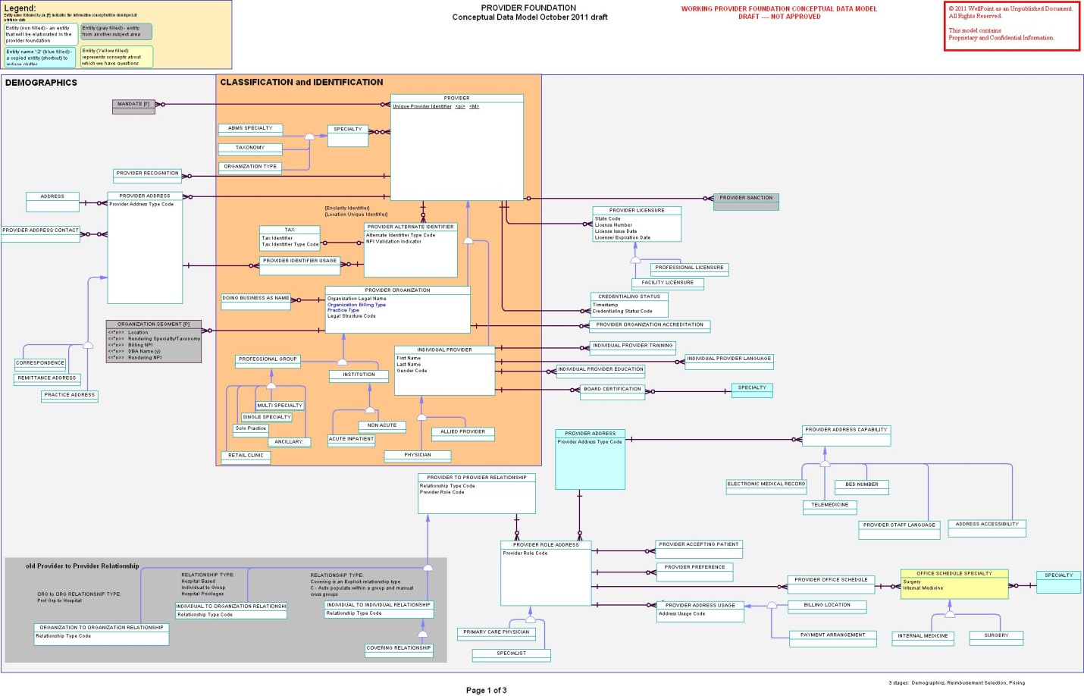

**EPDS v2.0 contains the following data concepts:**

|  |  |
| --- | --- |
| Entity | Description/Comments |
| PROVIDER | PROVIDER is an individual or organization who provides medical care goods and services to a consumer |
| ALTERNATE IDENTIFIER | ALTERNATE IDENTIFIER represents the values and types of an Internal or External assigned identifier for the Provider. Examples include but are not limited to, National Provider Identifier (NPI), Universal Provider Identifier Number (UPIN), Medicare Identifier etc |
| Individual Provider | INDIVIDUAL PROVIDER represents an individual who supplies or makes available medical care goods and services or directs the care for another person. Examples include medical doctor, nurse practitioner, licensed consulting psychologist, physical therapist, chiropractor, dentist, and optometrist. |
| PROVIDER Entity | PROVIDER ORGANIZATION represents a grouping or collection of providers into a structured organization that offer health care delivery services. Examples include but are not limited to the following: Institutional Providers such as (Hospital Facilities, Clinics, etc.), Professional Practice Providers, Acute Care Facilities, Pharmacy, Home Health Agency, Nursing Home, Intermediate Care Facility (ICF), Skilled Nursing Facility (SNF), etc. These Facilities are licensed to do business and provide the services defined in the Licensure for the Facility |
| Provider License | PROVIDER LICENSE represents the license(s) of a provider in the given area of specialization. This represents that that the provider has been legally licensed by a regulatory authorization to provide the services applicable under the area of specialization. Both facilities and professionals are typically licensed. |
| Office Staff Language | PROVIDER ADDRESS STAFF LANGUAGE represents the languages and proficiencies available by the staff |
| Education | PROVIDER EDUCATION represents the degrees and titles achieved at institutions of medical learning. |
| Credentialing Profile | Credentialing Profile of Provider (Credentialing status, Board Cert, Accreditation etc) |
| Individual Provider Language |  |
| PROFESSIONAL CREDENTIALS | PROFESSIONAL CREDENTIAL represents the various credential labels earned through education and training experiences of a health care professional e.g. MD, DO, |
| Provider Training | INDIVIDUAL PROVIDER TRAINING identifies the training a provider has obtained, e.g., residency, internship, etc. Note: 1. Training may be either in a standard specialty on not e.g. holistic medicine |
| Ethnicity |  |
| Clinical Orientation | Examples:- Behavioral Biological/Medical Cognitive Behavioral (Medical Social Work, MD, License Psychologist, ) Cognitive Psycho Dynamic Systems |
| Area of Expertise | Examples:- Attention Deficit Disorder (ADD/ADHD)  Adoption  Anxiety and Panic Disorders  Domestic Violence  Eating Disorders  Men's Issues  Geriatrics  Cognitive Behavioral Therapy (CBT) |
| Provider Address | Provider's Address Location |
| ADDRESS FEATURE | Examples are:- Wheel Chair Accessible Public Transportation availability (may be with a certain distance from location) |
| Business Entity | Represents a corporate Entity that may play the role of a managing/owning/billing or other type of entity. The business entity will have a relationship to one or more providers but is not considered to be a Provider |
| Provider Capability | types of capabilities may include: Language (written, spoken, translation and translator services)  In Office Services (RAD, LAB, Med) Office capabilities (Accessibility, Transportation etc) |
| Provider Contact Info | Contact Information related to a Provider or a Provider at an address (cell phone, internet url, e-mail address etc) |
| DBA Name | DOING BUSINESS AS NAME (DBA) represents a name a provider has chosen for their business at a location. It is separate from the legal name of the business. |
| FACILITY ATTRIBUTES | defines various characteristics of interest about a facility such as number of beds at the facility |
| MEDICAID PARTICIPATION | Providers Participation in Medicaid |
| Address | PROVIDER ADDRESS represents the addresses and the kinds of addresses for a provider e.g. practice, billing, mailing etc. Note: 1. Enclarity Flag.. practice, billing or both |
| Contact Info | Contact Info and it's relationship to a Provider, Address etc. Physical Telephone Number Uniform Resource Locator Text (URL) Fax Telephone Number Emergency Telephone Number Text Telephone Device Number (TTY) Electronic Mail Address Text (e-mail address) Text Telephone Device Number is a device used by individuals who may have deafness, other hearing difficulties, or speech disabilities. The Telecommunication Relay Service (TRS) is a free service that enables persons who are deaf, hard-of-hearing or speech-impaired to use their TDD or TTY to place calls to and receive calls from hearing people. It also enables hearing people to call TDD/TTY users. |
| Office Feature | Type of Technology (Telemedicine, EMR, automated appointment, EDI) Type of Feature (represents characteristics of interest about a provider at an address e.g., Interpreter Services, Translator Services, etc.) - possible duplicate for office languages Type of Office Service (Lab, EKG, XRAY, MRI) Add CAQH for services, accessibility e.g. ADA compliant (both address and office levels) |
| Tax | FEDERAL TAX represents the entity on 1099 reporting to the Federal Government |
| Remittance |  |
| Remittance Segment | REMITTANCE SEGMENT represents information necessary to pay a provider and the rendering provider's assignment to a remittance billing tax, address, and NPI. |
| Medicare Participation | MEDICARE PARTICIPATION indicates the kinds of Medicare Program benefit coverage options (Medicare Part A, B, C etc.) in which a provider has chosen to participate or not. Medicare Part A provides hospital or facilities coverage; Medicare Part B provides Medical coverage benefits; Medicare Part C (Medicare Advantage) provides benefits through private insurance plans. Medicare Part D provides pharmacy benefits. Medicare Participation v.s. our Medicare Advantage products  Participate? not necessary with our products but with CMS  Provider must be enrolled in CMS program and Medicaid before they can participate in our Medicare and Medicaid programs |
| PROVIDER NOTE | PROVIDER NOTE represents a storage area containing notes of interest concerning the provider written by those working with the provider... Contain say justification for a claim action.. Directory Note, Footnote |
| Accepting Patients | Indicates if a Provider is accepting new patients |
| Patient Preferences | represents the kinds of patients a practice prefers to treat at an address. Children  Adolescents  Adults  Senior Adults  Deaf and Hearing Impaired  Disabled  Low Age Range Value  High Age Range Value |
| PROVIDER OFFICE SCHEDULE | PROVIDER OFFICE SCHEDULE defines the schedule of availability for an office |
| Accreditation | PROVIDER ORGANIZATION ACCREDITATION represents the accreditation of a provider organization by a third party organization such as Joint Commission of Healthcare Organizations (JACHO). It represents a stamp of approval. Accreditation by a regulatory authority is usually call licensure. JACHO is usually a 3 year cycle and the accreditation is effective for the 3 years.    Professional education program accreditation is the process whereby a college or university professional program (e.g. counseling or psychology) voluntarily undergoes review by an accrediting body, such as the Council for the Accreditation of Counseling and Related Educational Programs (CACREP), the Council on Rehabilitation Education (CORE), or the American Psychological Association (APA). CACREP, CORE, and the APA are professional accrediting bodies that evaluate graduate education programs in professional counseling, rehabilitation counseling, counseling psychology respectively. The purpose of these accreditation bodies is to ensure that the graduates of these programs meet the standards developed by these professions and by the Council on Higher Education Accreditation (CHEA) which oversees all academic accreditation bodies. |
| CENTERS OF EXCELLENCE | PROVIDER ORGANIZATION CENTER OF EXCELLENCE represents facilities, typically hospitals, that have passed or exceeded a rigorous evaluation of their clinical data. This data provides insight into the facility's structure, processes, and outcome. Evaluations and reviews are conducted by medical professionals.     Note:  The Blue Cross and Blue Shield Association, in partnership with Anthem National Accounts and other Blue Plans, developed the national Blue Distinction Centers for Specialty Care    Example:  Cardiac Care  Bariatric Surgery Centers  Complex and Rare Cancer  Transplant  Spine Surgery  Knee and Hip Replacement    Blue Distinction defined and WellPoint can define our own centers of excellence.. |
| Recognition | PROVIDER RECOGNITION represents (external) the certifications received by a provider from various entities such as BTE (Bridges to Excellence) program certifications in e.g. back pain. NCQA specifies recognition certifications, CMS |
| PROVIDER RELATIONSHIP | PROVIDER PROVIDER RELATIONSHIP defines the relationship between a Provider Organization and one or more Providers (Individual Provider, Provider Organization Grouping or Provider Organization). A PPR can define a relationship between individuals as well e.g. covering relationship. |
| Provider Sanction |  |
| Provider Specialty | PROVIDER SPECIALTY represents the areas of medical specialization of a provider. These are areas of medical specialization recognized by the approved ABMS Specialty Boards. |
| Office Language | PROVIDER ADDRESS LANGUAGE identifies the languages available for communication. Valid Values: Spanish French Sign (ASL) |
| COVERING RELATIONSHIP | Need a ruling on rules and can we get this information; it drives payments    Is there additional information we wish to carry or did we want to represent Covering and Supervising as distinct relationship for a given reason? |
| PROVIDER PROGRAM | PROVIDER PROGRAM defines the cost/quality programs in which a provider participates. A program can be established for many reasons (example: to manage quality). Providers are selected for the program based on the program requirements.  QHIP  Blue Precision |
| Taxonomy |  |
| SUPERVISING RELATIONSHIP | SUPERVISING represents an oversight relationship between a physician and a healthcare professional. Is there additional information we wish to carry or did we want to represent Covering and Supervising as distinct relationship for a given reason? |
| Provider Network | Network is a grouping of Providers where the Providers have accepted terms to be part of the grouping. Need to account for association of a Provider to a Network at an address and for a given specialty |
| Tiered Network | A grouping of Providers created to support variation in benefits |
| Narrow Network | A subset of a Network which may include Providers with a specific profile |
| Provider Contract/Agreement | Identifies an agreement between a Provider or group of Providers and WellPoint. Need to account for association of a Provider to an agreement at an address |
| Provider Agreement Terms and Conditions | Terms and conditions such as number of days to submit claims |
| Service Codes | Contain specific procedure codes which are covered under CAP. They could also be used to designate specific procedure codes which are not covered under Capitation. |
| HMO Information | Membership Enrollment Capacity, Referral parameters (self refer, speedy direct etc), In Area Zip Codes |
| Business Entity | An entity that is a group of people organized for some profitable or charitable purpose. Business entities include organizations such as corporations, partnerships, charities, trusts, and other forms of organization. Business entities, just like individual persons, are subject to taxation and must file a tax return. Some business entities are exempt from federal income tax. These include non-profit charities, S-corporations, and partnerships. Business entities may be subject to state income tax, depending on the laws of the state or states where they conduct business.   See also the following more specific terms: corporations, s-corporations, partnerships, non-profit organizations, sole proprietors, trusts. As part of our discussion on business entity, I decided to do some quick research. Here’s what I found…can we/should we use this to help us better understand the Managing Business Entity concept…to better define what goes into that entity vs. a provider entity? See the yellow highlighted section below. I would also like the Provider Data Governance group weigh in on this concept and these definitions.  http://taxes.about.com/od/taxglossary/g/BusinessEntity.htm  Definition: A business entity is an entity that is a group of people organized for some profitable or charitable purpose. Business entities include organizations such as corporations, partnerships, charities, trusts, and other forms of organization. Business entities, just like individual persons, are subject to taxation and must file a tax return. Some business entities are exempt from federal income tax. These include non-profit charities, S-corporations, and partnerships. Business entities may be subject to state income tax, depending on the laws of the state or states where they conduct business.   See also the following more specific terms: corporations, s-corporations, partnerships, non-profit organizations, sole proprietors, trusts. |
| Grouping | GROUPING is a collection of provider entities that meet some business purpose; orderly grouping (of things or persons) considered as a unit; the result of arranging.   Note: 1. Purpose - , Medical; Provider Group Practice; Product delivery (Network); external collections of providers we wish influence e.g. ACO, PHO, etc. 2. Groupings may not render service |
| ACO |  |
| PCMH |  |
| AICU |  |
| Reporting Grouping |  |
| Bundle | Grouping of Providers in which one of the providers is an administrative provider. Wellpoint would contract with the administrative provider but the contract would cover the group |
| IPA | IPA: An organization comprised of individual physicians or physicians in small group practices that contract with managed care organizations on behalf of its member physicians to provide healthcare services. |
| PMG | PMG: An HMO organization type where all PCP individual providers at the site can be considered the PCP for all membership that visits the site. A member can see any PCP (instead of having to select a single one) at the site and the visit is covered under HMO rules. Membership is assigned at the site level, not to by individual PCPs. |
| Episode of Care | Hip Replacement etc |

**Core Provider Entities:**

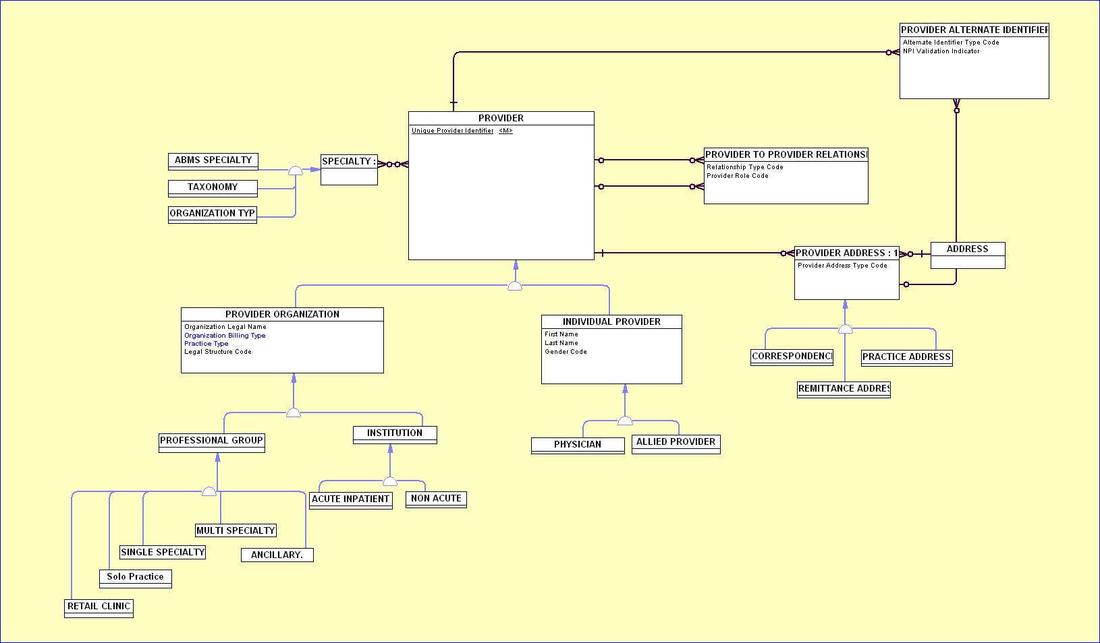

**Provider Characteristics (Individual Provider level information)**

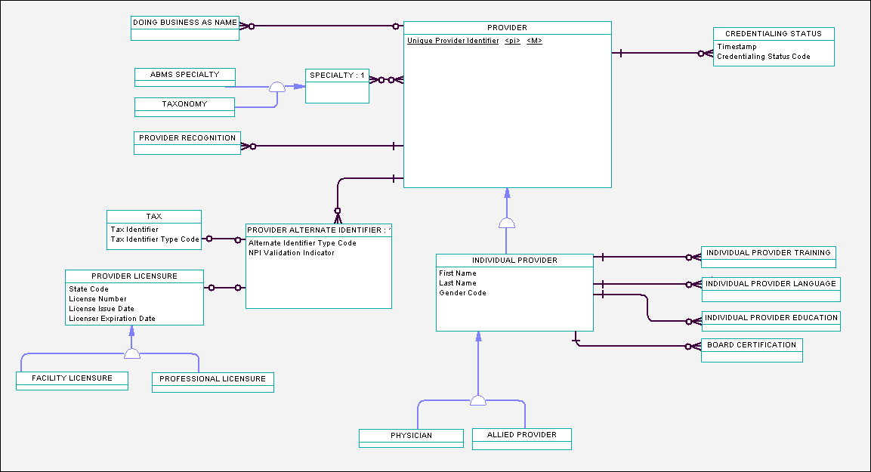

**Provider Characteristics (Provider Entity level information)**

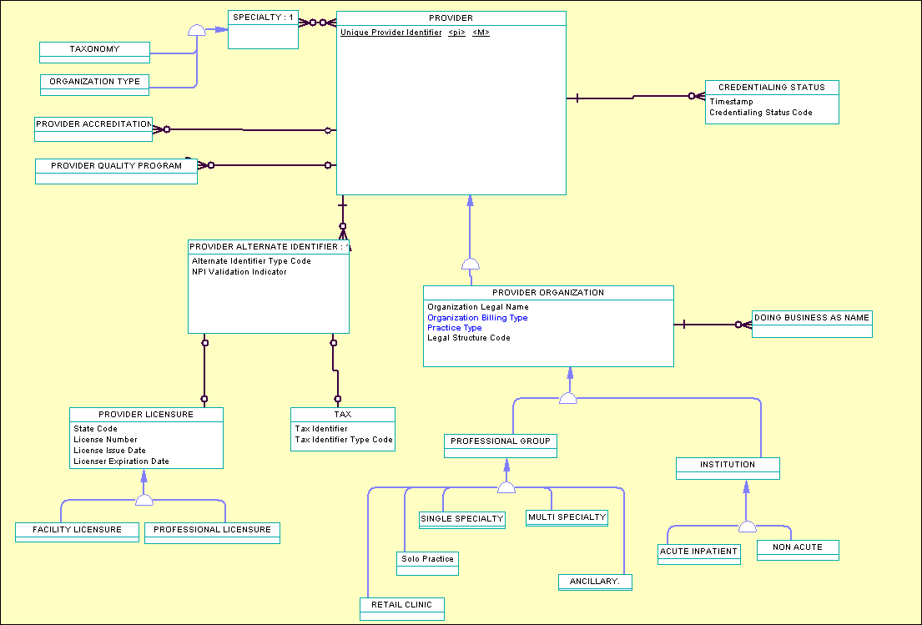

**Provider Address Level Information**

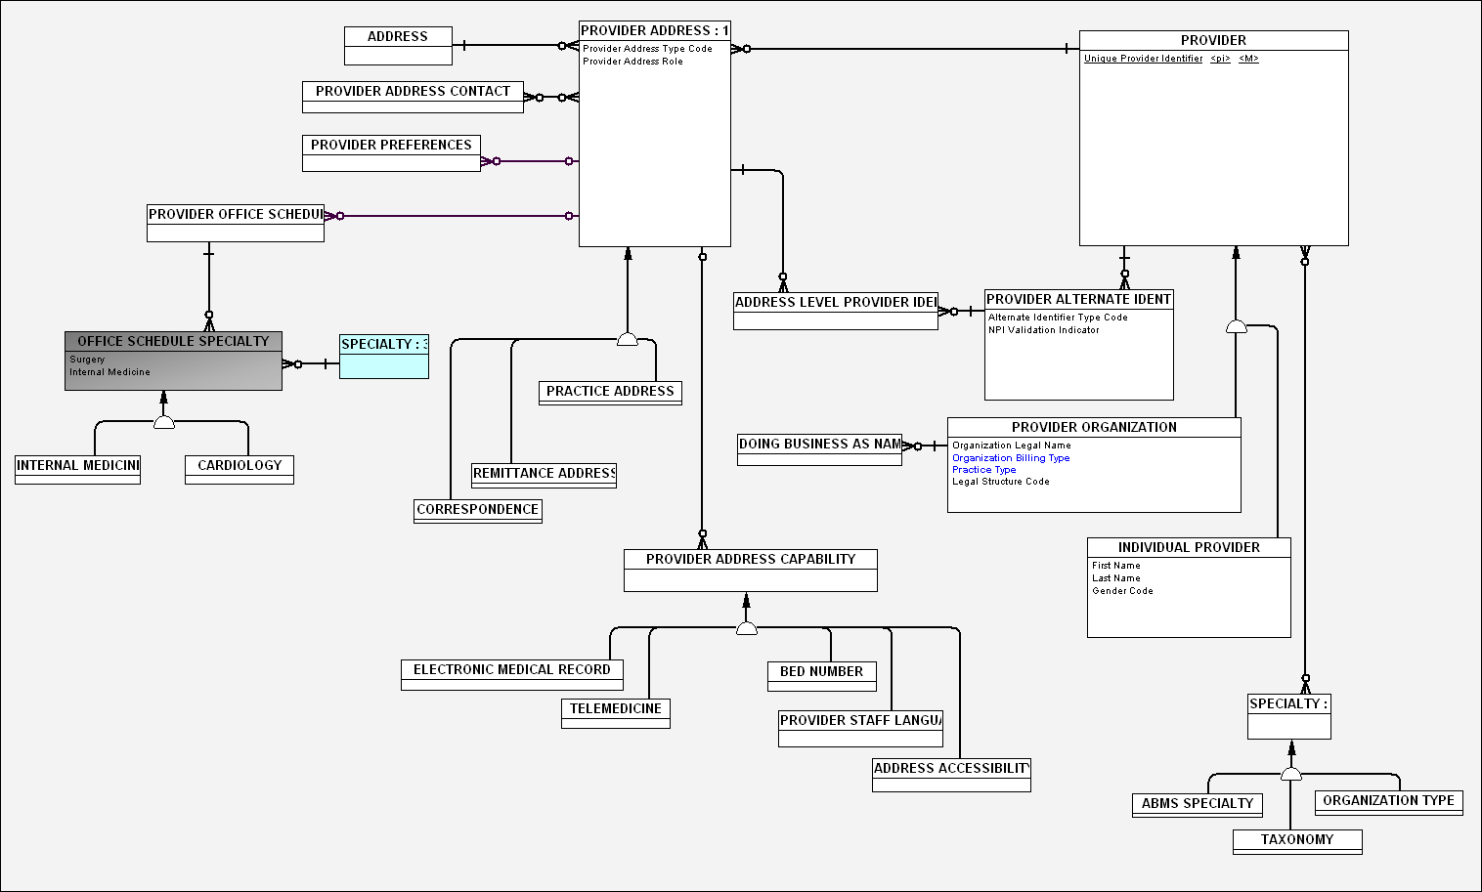

**Provider Relationships**

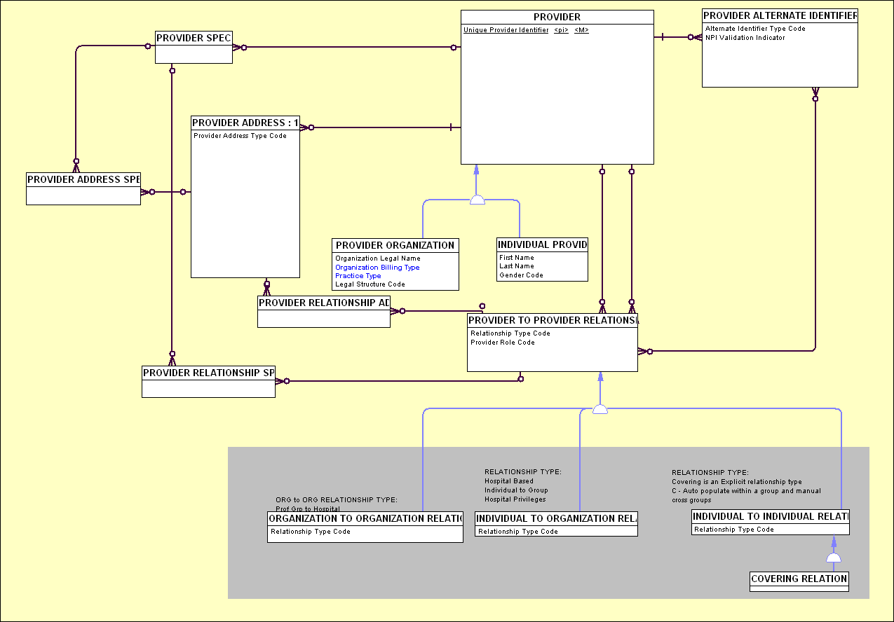

**Provider Identity***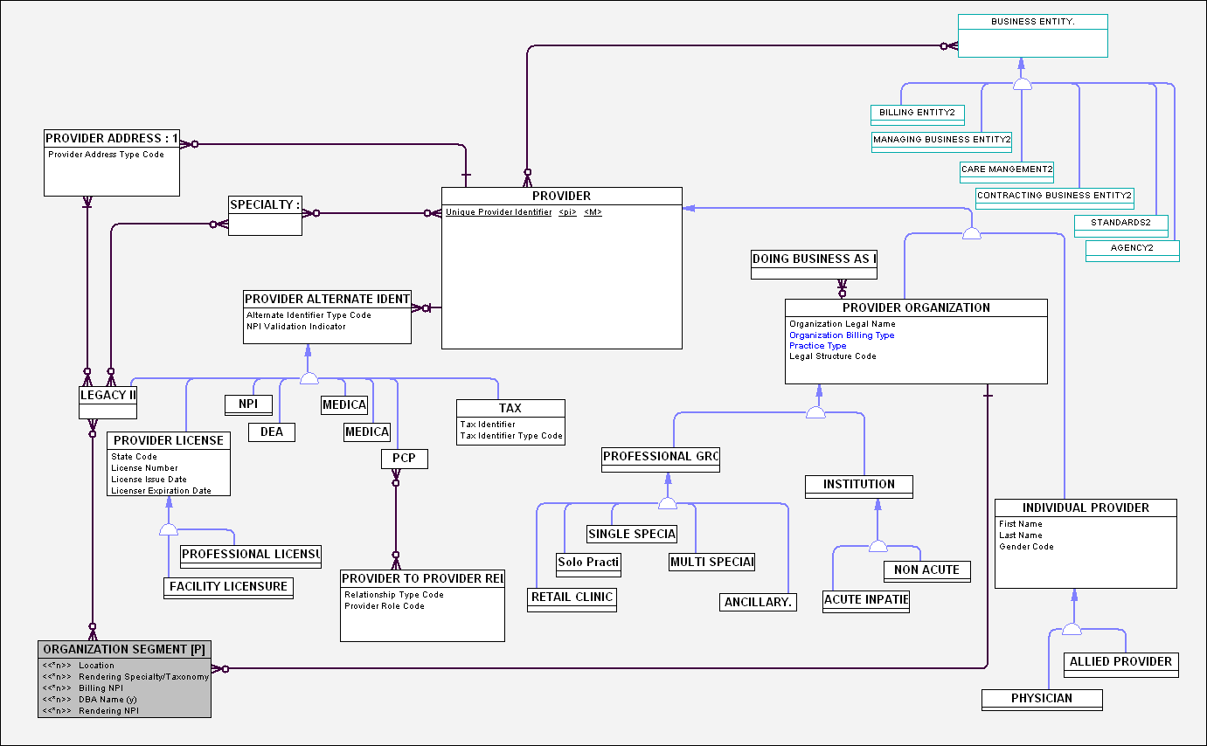*

## Provider Data Categories for Demographics and Networks Data Model

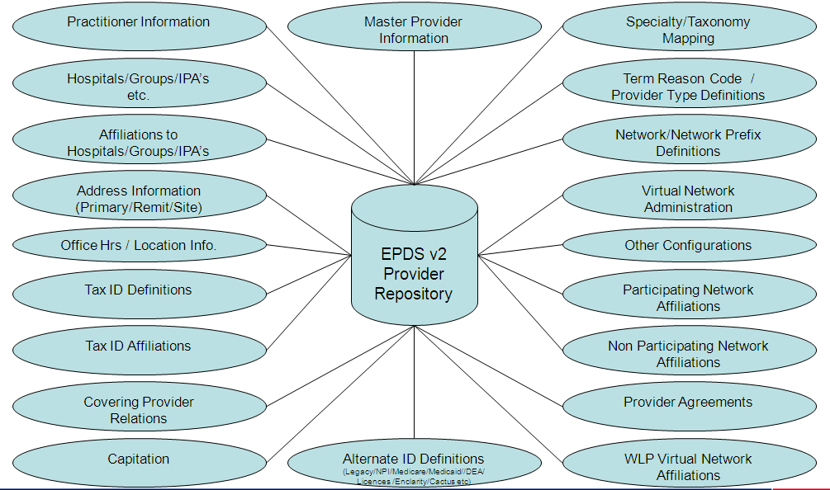

## Demographics Logical Data Model



## Batch Data Integration Approach

**Architectural Goals for EPDS v2 Data Integration**

* Build and leverage a common process to support data conversion as well as data synchronization.
* Use an enterprise standard data format to exchange data with EPDS in order to support loose coupling and reuse of data mapping and code
* Evaluate the use of enterprise standard tools and technologies for data integration. This includes codes management, data quality and ETL tools.
* Build a robust data integration approach that can be leveraged for future initiatives that may bring additional source systems on EPDS

## Logical Data Solution Components

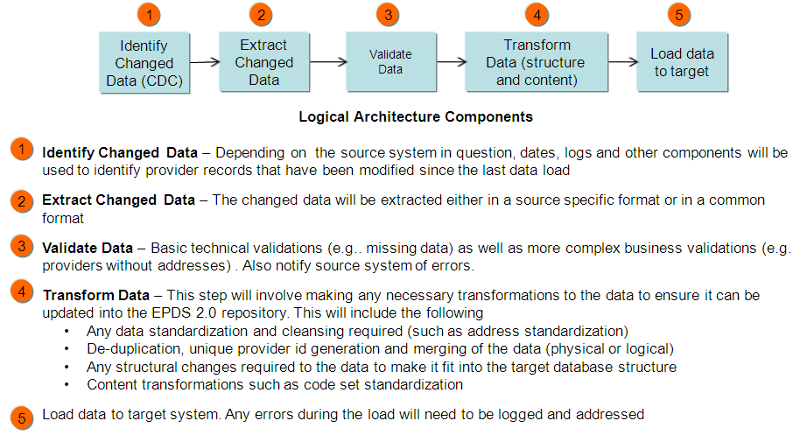

## Some Data Integration Patterns at WellPoint

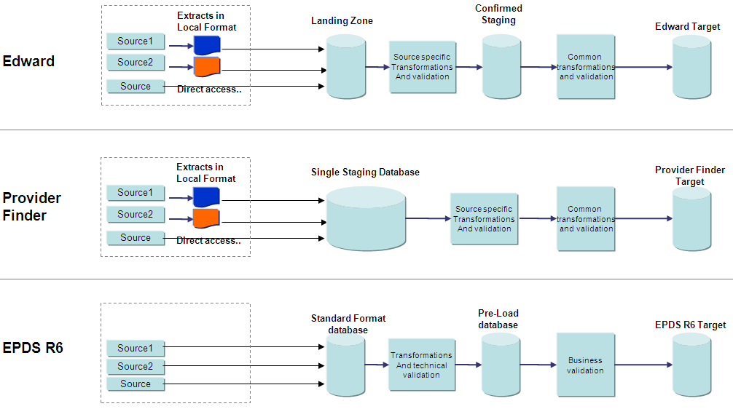

## Pattern Description

* Data from the regional source systems will be loaded into a staging database. The staging tables will reflect regional system data formats for each regional system. The staging database would be populated using regional data extracts. Data Transformation Operations are performed against the staging tables to perform Data Validation, Code Set Translations, Address Standardization, Cleansing and Enrichment as per business requirements.
* Data from the staging database tables will be transformed as per Initiate Inbound Broker Format so that Inbound Broker can push the data into Initiate Provider MDS Instance. Initiate MDS provides auditing capability through which data updates to the MDS can be tracked. Use of Inbound Broker not only reduces WLP Development Time but also provides restart/recovery capability to track the progress of the job and recover from the point of failure. Other alternative to use of inbound broker is to channel the data through WLP re-usable wrapper services which would interact with Initiate SDK API’s to push data into Initiate MDS instance.
* Match/Merge functionality would be performed within Initiate MDS solution. Enclarity ID should be used by the merging rules that can be configured within MDS engine. Registry approach is used to push the regional provider data snapshot so that Initiate MDS internally tracks the providers by linking the duplicate providers. Eventually either Composite View (Virtual) or Golden Copy (Physical) would be established to generate a Hub Owned Data Set.

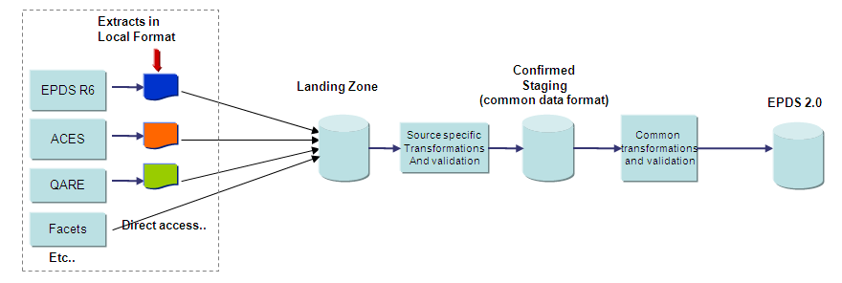

## Architectural Recommendation: Pattern 2–Common Provider File Format

The recommended data integration pattern is the common format approach. This pattern is recommended since it will help promote reuse, loose coupling and distribute the work more evenly between legacy and EPDS teams

* Legacy source systems would create extracts that adhere to one common layout. The layout will be informed by the structure of the EPDS 2.0 database. The extract files will organized around key the data concepts and could comprise of multiple data files
* The data extracts will be loaded to tables in a staging area. In addition, the staging area will contain tables related to validation and data transformation. The data cleansing, enrichment and address standardization activities would be performed against the staging database to improve the quality of the provider data.
* The data from the staging database would be channeled through WLP Custom Integration Layer where Java Interface/Wrapper Services will be used to invoke the IBM Initiate API’s for pushing the data into EPDS v2 Initiate MDS data store.

## High Level Data Integration Approach

QARE

EPDS R6

Facets

ACES

**Extracts in**

**Common Format**

**Staging Area**

**Staging Area High Level Requirements**

* Common Format tables need to mirror common format with one table per record type in the common format. Need to discuss how to handle header records in each file
* The Common Format tables need to include columns for source and standardized address as well as source and standardized code
* The Common Format tables need to account for an MD5 type key that can be used for traceability on staging records
* Need a set of validation/error reprocessing tables that will be used to notify source systems of errors
* Enclarity files will be loaded into the staging area
* RDM tables will need to be created in the staging area

Initiate

Database

**EPDS 2.0**

**Etc..**

Validate

Common

Format

Structures

Transformation

And validation

structures

Address

Standardization

Code

Standardization

Enclarity

Files

Edward/

Enclarity

**Data**

**File**

Initiate

Inbound

Broker

Initiate

MDS

**Inbound broker errors**

Java Validation

Components

RDM

Code

Structures

**Error notification**

Extract

Transform

## Integration with IBM Initiate MDS

1. Use of IBM Initiate Provider MDS out of box Provider Data Model
2. Extend IBM Initiate Provider Data Model by extending the Provider Data Model with WLP customization to capture all the WellPoint Provider Data Elements
3. Use of WLP Integration Layer where all the Regional Data Extracts would be loaded into the EPDS v2 Staging Database for Data Cleansing using Enclarity Cleansed/Augmented Data Files from EDWARD system. All the WLP specific data transformation will be done within Staging Database to improve the overall quality of provider data
4. Use of IBM Provider Initiate API Layer for interacting with Core Initiate MDS Platform
   1. IBM Initiate Inbound Broker for pushing data into Initiate MDS data store
   2. IBM initiate Outbound Broker for extracting data from Initiate MDS data store
   3. IBM Initiate API’s which can invoked through
      1. Java Interface pulling the data from the staging database and invoking WLP Java Wrappers which would invoke IBM Initiate API’s to interact with Initiate MDS system
      2. ETL tool to pull data from the staging database and invoke WLP Java Wrappers to channel data through Initiate API layer
5. Use of WellPoint IAS Layer to interact with EPDS Initiate MDS data store for real-time connectivity with internal & external applications/systems. IAS Services would be invoking EPDS Java Re-Usable Wrapper Services for data access from EPDS Initiate MDS data store. This approach would be used for systems ready to support PUB/SUB model.

## Common Provider File Format (Excel)

The EPDS v2.0 will use a Wellpoint common provider file format to exchange data. The common file format is created based on the logical data model and contains multiple segments containing related data grouped together.

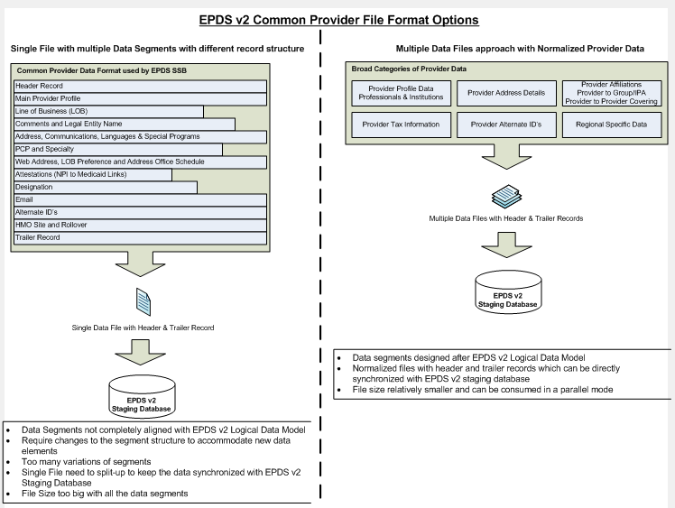



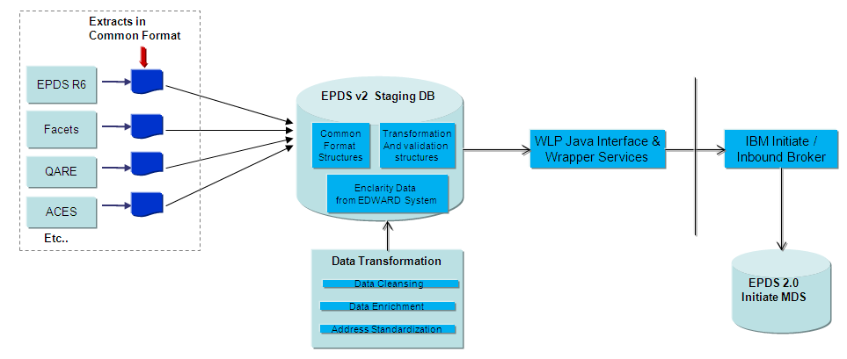

## Initiate MDS Data Model Customizations

Initiate Provider MDS comes with out-of-box Provider Data model which basic data attributes related to managing Provider Data for Professional and Organization type Providers. Additional WLP Customizations have been made to the Initiate MDS Data Model to accommodate all the custom Provider Demographics, CAN and Payment Innovation attributes from Enterprise Logical Data Model.

Additional Buckets would be deployed with appropriate hash values to support the User Data Retrieval based on the expected Provider Search Criteria’s from EPDS v2 User Interface.

Initiate Provider MDS Model should make considerations to store appropriate attributes in the MDS Segments to be able to track the regional provider data. Example by storing Tax Id and Specialty in all the segments would relate the provider data association to these business attributes using which enterprise provider data can be transformed into the regional view.

Initiate Provider MDS would also be

* tuned with the Matching Rules for Professional and Organization type Providers
* configured with Merging Configurations and Custom Merging Rules will be implemented with Exit Point Scripting which will be triggered to pull data for Composite View and to also establish the On-Demand Golden Copy

**Provider Model:**

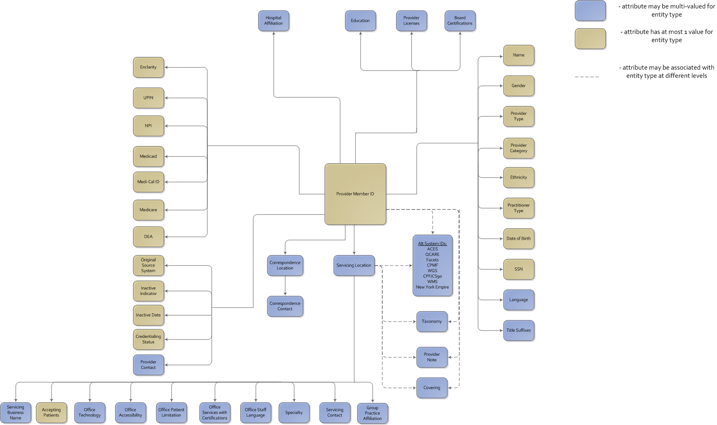

**Organization Data Model:**



## Reference Data Management (RDM)

The EPDS v2 system requires the definition of several reference lists. Some of these code sets will be required to support the user experience and others will support the population of the data repository. RDM tool will be used to track all the code sets used within regional provider systems and their corresponding enterprise code set values. The key reference data sets that will need to be defined and managed are:

* Provider Status
* Gender
* Address Types
* Specialty
* Specialty Category
* Provider Type
* Language
* Ethnicity
* Area of Expertise
* Plan
* Network

These reference lists, code hierarchies (specialty-specialty category-provider types) and the translation between the source system values and master reference values will be managed in RDM (Reference Data Manager) and will then be pushed out to the EPDS v2 staging database on a periodic basis.

Business data owners will need to assess and define the master reference lists to be used for the EPDS v2 System. IT will work with the business to facilitate this process.

## Data Sourcing from Regional Systems

Regional Provider Systems (EPDS I, EPDS II, ACES, CPMF, QCARE/QMED, FACETS, CPF, and WMS) would be generating the Data Extracts (Multiple Files from each system) in Common Provider Data Format to feed Provider Data to EPDS v2 System. Healthlink System is part of Capability 2 scope through which One Time Data Migration from Healthlink to EPDS v2 need to happen followed by Reverse Data Synchronization from EPDS v2 to Healthlink System.



## EPDS v2.0 Enclarity Integration for Data Cleansing

**Overview**

EPDS v2.0 will leverage Enclarity for data enrichment for Capability 1 and for Data Cleansing for Capability 2. The summary of the EPDS v2.0 – Enclarity interactions are:

**Capability 1**

* + EPDS 2.0 will not override cleansing rules applied by the Provider Source Systems
  + Data Enrichment – Data that is not maintained in source systems and may be useful will be augmented to the EPDS 2.0 data repository. The data enrichment proposals will be reviewed with the business before implementing.
  + Enclarity Id may be used as an input into the matching process to create a Wellpoint Enterprise Provider Id.
  + Enclarity Id will be loaded into EPDS 2.0 as an alternate id

**Capability 2**

* + EPDS 2.0 will directly interact with Enclarity. This will include a real-time validation and weekly/monthly file exchange.
  + EPDS 2.0 will apply Enclarity cleansing (this includes applying recommendations based on rules)
  + The rules around cleansing will have to be standardized as much as possible to ensure consistency of the data.

**Current State**

QARE

EPDS R6

ACES

Facets

**Etc..**

**Description**

* Provider business team maintains data on Provider Source Systems
* Provider Source Systems send data to Edward. Edward consolidates data and sends extract to Enclarity
* Enclarity send data feed back to Edward with the following components:-
  + Cleansing/Augmentation recommendations
  + Enclarity Id for each Wellpoint Provider Id Passed
  + 50 state Provider Select File
* Edward reads Enclarity files and reformats based on recommendations (some recommendations are for auto update and some manual). Edward then sends updated data files to the Source Systems
* Source Systems apply updates. Some updates are applied in an automated manner and some are manually reviewed by business SMEs before applying

**Provider Source**

**Systems**

Enclarity

Consolidate

Source

Data

Enclarity

Updated

Data

Apply

Rules

**Edward**



**Provider**

**Business**

**Users**

**Capability 1 Enclarity Interaction**

QARE

EPDS R6

ACES

Facets

**Etc..**

**Description**

* Provider business team maintains data on Provider Source Systems
* Existing Source System, Edward and Enclarity interfaces will function the same for Capability 1
* EPDS 2.0 will pull Enclarity files (all 3 sets of files) into it’s staging area
* The Enclarity Id will be used as one of the inputs into the matching process to generate the Wellpoint Enterprise Provider Id
* Data that is not maintained on the Provider Source Systems and is provided by Enclarity will be loaded as an enrichment into EPDS 2.0. No existing data will be overridden. Enrichment will be done based on business approval.

**Provider Source**

**Systems**

Enclarity

Consolidate

Source

Data

Apply

Rules

**Edward**

Pull

Enclarity

Files

EPDS 2.0

Database

Use Enclarity Id

for Matching

Process

Apply

Data

Enrichment

**EPDS 2.0**

Pull

Source

Files



**Provider**

**Business**

**Users**

Enclarity

Updated

Data

Full Select

File (50 States)

Cleansing

Recommendations

Manual/Auto

Updates

Data with Manual/Auto Updates Applied

**Capability 2 Enclarity Interaction**

WMS

ACES

Provider

Facets

(Provider)

**Etc..**

**Description**

* Provider business team maintains data on EPDS 2.0. As part of data updates, EPDS 2.0 will make a real time call to Enclarity to get data cleansing recommendations. These recommendations will be applied based on the rules defined by the business.
* EPDS 2.0 will periodically send a complete snapshot of Provider data to Enclarity
* Enclarity send data feed back to Edward with the following components:-
  + Cleansing/Augmentation recommendations
  + Enclarity Id for each Wellpoint Provider Id Passed
  + 50 state Provider Select File
* Enclarity recommendations will be applied to EPDS 2.0 based on rules defined by the business. This will include user review of the manual recommendations. In addition, data enrichment will be applied.
* EPDS 2.0 will send data feeds to the Provider Repositories that support claims processing as well as to Edward to support any downstream processes.

**Provider**

**Repositories**

Enclarity

Edward

EPDS 2.0

Database

**EPDS 2.0**

Apply

Cleansing

Rules

Extract

All Data

Periodically

Apply

Cleansing

Rules and

Enrichment

**Provider**

**Business**

**Users**

WGS

ACES

Facets

**Etc..**

**Claims**

**Systems**



Full Select

File (50 States)

Cleansing

Recommendations

Enclarity

Updated

Data

# Integration Architecture

This section will focus on the data integration aspects of the EPDS v2 system. It details the various data sources and the processes/steps that will be used to integrate all the data into the EPDS v2 Initiate MDS database. The following are the three major categories of Data Migration.

1. **Regional Provider Data Files –** Regional Systems would be generating the Provider Data Extract Files as per Common Provider Data Format and push the files into the WLP Bridge Server through which files would be pushed to the EPDS v2 Batch Server for further processing. Regional systems would be first generating the Full Sweep Provider Data Extracts **without** **Filtering/Merging** any providers followed by Daily Delta’s of Provider Data Extracts (Complete Provider Data Snapshot would be sent any time any data changes for a particular provider).
2. **Staging Database –** ETL tool or Java Implementation would be used to keep the regional data extract files with the EPDS v2 DB2 AIX Staging Database. Regional Data Snapshot (Full Data followed by Delta’s) would be maintained in the EPDS v2 Staging Database using the incoming Provider Data Extract Files from each of the regional system. Data Transformation Operations would be performed in the EPDS v2 Staging Database:
   1. Data Validations – WLP re-usable data validation components to be built so that same components can be leveraged by the Batch & Real-time implementations to avoid code duplication.
   2. Regional to Enterprise Code Set Translations using the RDM Code Set Values consisting of Regional to Enterprise mapping and vice-versa
   3. Address Standardization using Informatica IDQ process as per Business Approval – Regional Address and Scrubbed Address can be maintained in the staging but scrubbed address would be loaded into the EPDS v2 Initiate MDS Instance
   4. Enclarity Data (Leverage Enclarity Augmented/Cleansed Files from EDWARD for Capability 1 to consume in a Batch Mode and through Capability 2 establish direct connectivity with Enclarity Vendor and decommission EDWARD/Enclarity Process. EPDS v2 should also establish real-time provider data cleansing by directly hitting the Enclarity System in a real-time mode from either batch implementations or new user interface)
      1. Data Cleansing using Enclarity Data as per Business Approvals would be done but for Capability 1 business does not want data migration components to cleanse and wants each of the regional system to carry out cleansing through auto-update Vs manual review process
      2. Data Enrichment using Enclarity Data for Business Approved scenarios through which additional data can be sourced from the Enclarity Data that regional systems currently don’t capture and EPDS v2 Data Model has provision
3. **EPDS v2 Initiate Provider MDS –** Provider Data from the EPDS v2 staging database would be loaded into the EPDS v2 Initiate Provider MDS through below mentioned steps:
   1. **Provider Data Extract as per IBM Initiate MDS requirements** should be generated from the EPDS v2 staging database so that data can be channeled through IBM Initiate Application Framework components.
   2. **Use of IBM Initiate Application Framework Components –** Multiple options are available
      1. **Initiate Inbound Broker –** Data Files along with the configuration file can be processed using Inbound Broker to push the data into Initiate MDS instance. Inbound Broker has built-in restart/recovery process to track the progress of the load and can recover from the point of failure during errors. Inbound broker also provides the load process metrics which need to be processed using WLP Java Implementation to load the errors/metrics from the logs to a common repository in the database.
      2. **Initiate SDK eSOA -** WLP Integration Layer will have re-usable WLP Java Wrapper Business Services which would invoke appropriate Initiate SDK API’s to interact with Initiate MDS instance. These re-usable wrapper services will be consumed by EPDS v2 User Interface, IAS Services and Batch Implementations.
      3. **Initiate Outbound Broker –** To be used for feeding data from EPDS v2 to downstream data consumers. Outbound broker supports both real-time and batch extracts.

The following is a list of the various data files that will be processed and loaded into the EPDS v2 staging database.

|  |  |
| --- | --- |
| **Source** | **Type** |
| ACES | Text Files |
| FACETS | Text Files |
| CS90 | Text Files |
| WMS | Text Files |
| EPDS I | Text Files |
| EPDS II | Text Files |
| QCare | Text Files |
| CPMF | Text Files |
| Healthlink through Capability 2 | Text Files |

## High-Level Data Integration Approach

Data from the various sources will be processed through Informatica which is the WellPoint standard Extract, Transform, and Load (ETL) tool and loaded into EPDS v2 Staging Database. Staging Database is an IBM DB2 Instance where the regional data snapshot is stored temporarily until data transformation operations are complete prior to loading the data into EPDS v2 Initiate Provider MDS Instance.

Application Integration Flow below depicts the high-level integration of EPDS v2 Web User Frontend and External Applications like Provider Portals with EPDS v2 System.



## Integration with IBM Initiate Provider MDS

* Use of Initiate Inbound Broker to push data into Initiate MDS
* Use of Initiate SDK API’s to communicate with Initiate MDS
* Use of Initiate Outbound Broker for generating Outbound Data Feeds from EPDS v2

## IBM Initiate MDS Suite

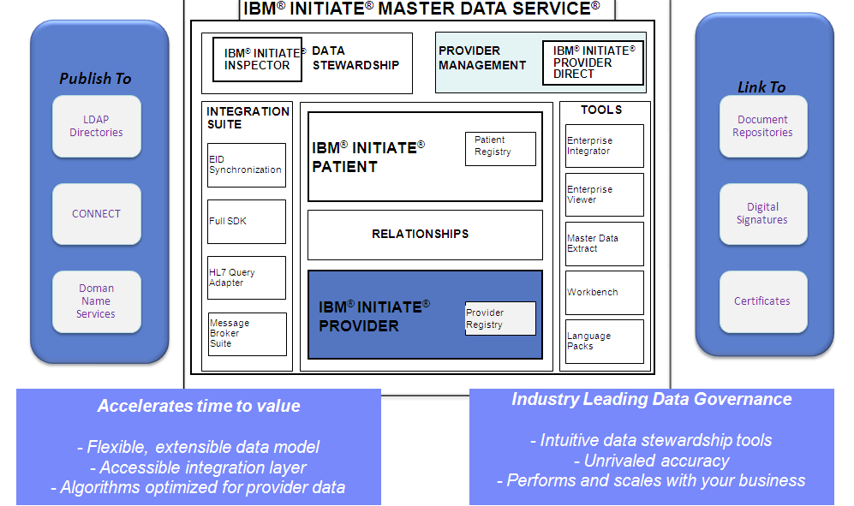

###### 

## WellPoint / IBM Integration Components

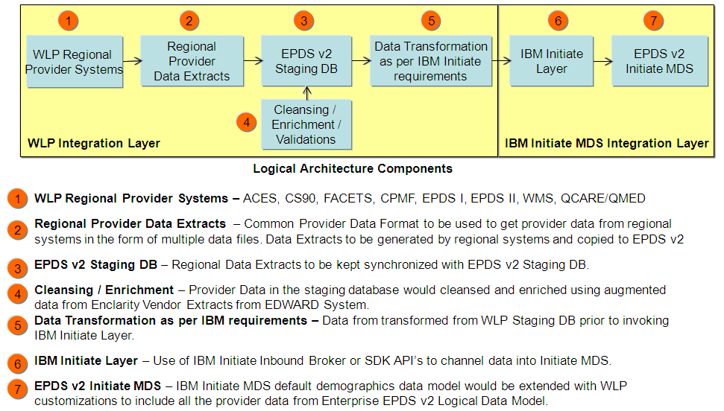



## Use of Inbound Broker

* Support the Large Data Files as per IBM Initiate Format requirements - Files will be generated from the WLP Staging Database
* Multiple Broker setup to load data simultaneously
* Restart/Recovery support to recover from the point of failure without having to start over from the beginning of the data file
* Broker to support New Data Segments / Modified Data Segments through a Configuration Mapping
* Return Files spit by Broker to be processed by WLP Java Interface to log the errors/metrics/exceptions in a common repository

## Use of WellPoint Custom Wrapper Services to invoke Initiate SDK API’s

* Custom Java Interface to read the Staging DB for picking the providers to be part of the load process
* Restart/Recovery to recover from the point of failure without having to start over has be designed and coded within Java Interface
* Java Interface to invoke WLP Java Wrappers which would transform the data into IBM specific objects and invoke IBM Initiate API's
* Java Interface to support Logging, Error and Exceptions against the common repository
* Use of Multi-Threaded approach to simultaneously load regional data into IBM Initiate MDS
* Java Wrappers to decoupled from the interface for re-usable options so that front-end and other batch-end implementations can invoke these services to communicate with IBM Initiate MDS
* External Systems wanting to interface with EPDS v2 would be done through WLP IAS Layer which will invoke the re-usable Java Wrappers to communicate with IBM Initiate MDS



## 

## IBM Initiate Integration Summary

* IBM Inbound Broker – First recommended option due to large data volume, built-in restart/recovery process, ability to use multi-broker setup to load data simultaneously, widely used by other clients and reduces the development effort for Capability 1 delivery. Inbound Broker would always keep the data synchronized with the Registry Data Sets and Composite View would pull the appropriate data elements from the registry data sets and On-Demand Golden Copy would be instantiated when UI performs data maintenance operations.
* IBM Initiate SDK API’s – This is the second best option but requires development of WLP Custom Java Interface and Re-usable Java Wrappers to invoke the Initiate SDK API’s. Restart/Recovery and Multi-Threading logic has to designed and implemented in the Java Interface which would be reading the data from the staging database and performing data transformation as per IBM Initiate requirements

## Logging and Auditing

At each step in the process (i.e. source to staging database and staging database to target) information about the load process will be logged and verified to ensure data integrity. Checks will be performed to ensure that the number of records that came in on the source files are the same as the number of records loaded into the target database. IBM Initiate MDS provides the Data Audit functionality so that business can check the before/after image of the data from an auditing standpoint. EPDS v2 Staging DB to maintain the regional data snapshot without tracking the historical data changes because business can use IBM Initiate Provider MDS audit functionality to track specific data changes.

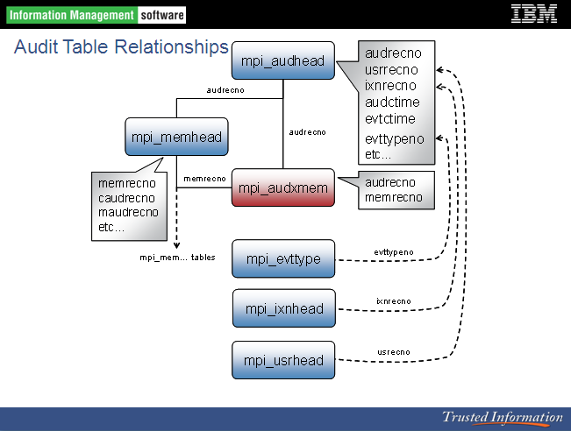

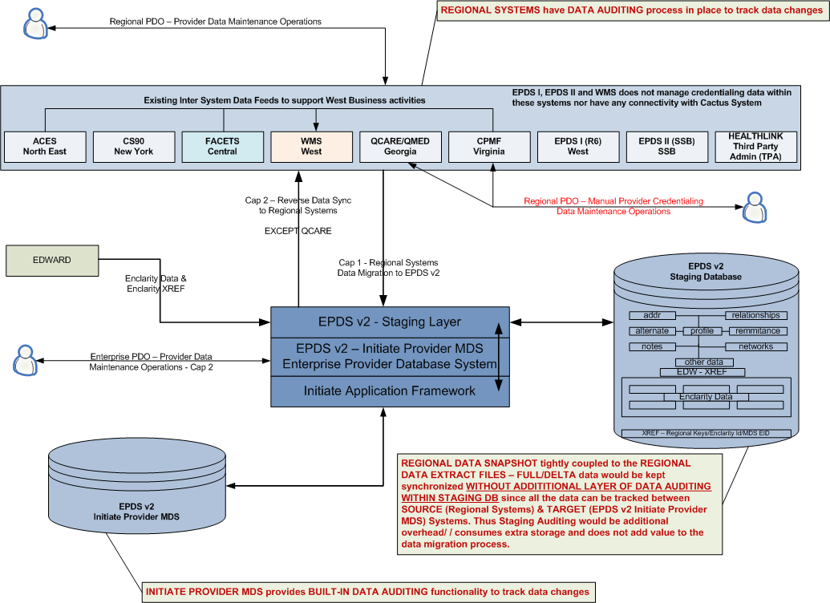

## Job Scheduling

All the data integration processes are batch jobs expected to run on a daily schedule. Scheduling of the Informatica workflows will be done using Workload Manager (WLM). WLM tool is designed to:

1. Manage begin to end processing flows.
2. Manage execution of parallel job processing.
3. Manage overall process sequence. (I.e. Jobs or processes those are dependent upon the completion of a preceding job or process.)
4. Manage job failure notification

# Service Architecture

WellPoint re-usable wrapper business services would be created to invoke Initiate SDK API’s for interacting with the Initiate Provider MDS instance.

External Systems/Applications (Portals etc) outside of EPDS v2 System would be going through WLP IAS Layer to invoke the re-usable wrapper business services for interacting with Initiate Provider MDS.

## Service Interaction Flow



## Integration View

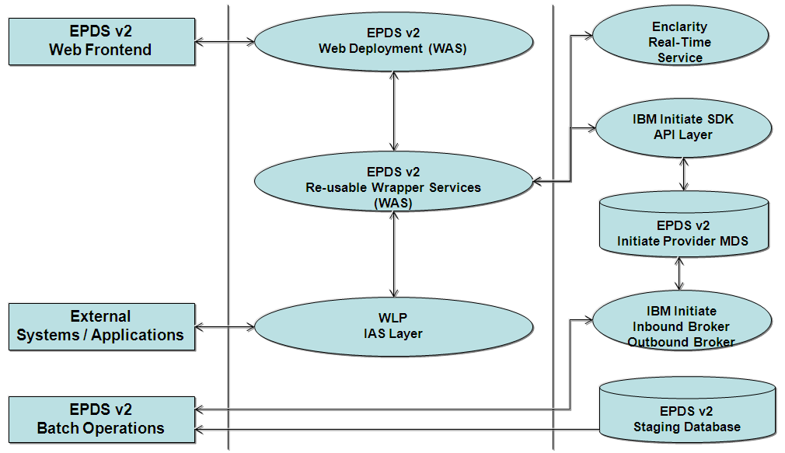

# Infrastructure Architecture

The diagram below depicts the overall physical/infrastructure view of the EPDS v2.

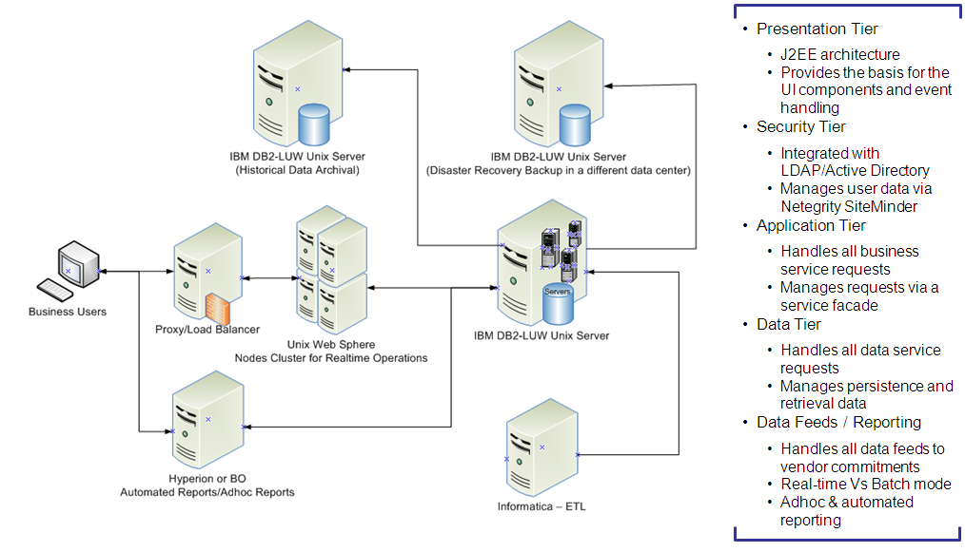

## Infrastructure Logical Topology - Development Environment



## Infrastructure Logical Topology - SIT Environment



## Infrastructure Logical Topology - Performance/Production Environment





## Infrastructure Components

The following are the various Infrastructure components involved in the EPDS v2 database architecture:

| **Purpose** | **Product** | **Version** | **WellPoint Standard** |
| --- | --- | --- | --- |
| File Pre-processing  Archival Processing  Scheduling and Workflow execution | Unix | AIX | Yes |
| ETL | Informatica | 8.6.1 | Yes |
| Relational Database | IBM DB2 LUW on AIX | 9.7 | Yes |
| Scheduling of the ETL Load Jobs & work flow execution | WLM | 3.1.0 | Yes |
| IBM Initiate Provider MDS | IBM | 9.7 | Yes |

## Informatica/Batch Unix/DB Server Information for EPDS v2 Environments

The following table describes the Informatica UNIX Server and DB2 LUW Server details for Development, System Test, Performance, UAT, Training and Production environments:

|  |  |  |  |
| --- | --- | --- | --- |
| **Region** | **Informatica Unix Servers** | **Batch UNIX Servers** | **DB2 LUW on AIX Database** |
| Development | TBD | TBD | TBD |
| SIT |  |  |  |
| Performance |  |  |  |
| UAT |  |  |  |
| Training |  |  |  |
| Production |  |  |  |

## Informatica Environment Details

|  |  |  |
| --- | --- | --- |
| **Region** | **Repository** | **Informatica Folder** |
| **DEV** |  |  |
| **SIT** |  |  |
| **Performance** |  |  |
| **UAT** |  |  |
| **Training** |  |  |
| **PROD** |  |  |

## UNIX Server Details

|  |  |  |
| --- | --- | --- |
| **Region** | **Unix Server Information** | **FTP Directory** |
| **Development** |  |  |
| **SIT** |  |  |
| **UAT** |  |  |
| **Production** |  |  |

## IBM DB2 LUW on AIX Server – Pure Scale Database Cluster Details

Designed for organizations that run online transaction processing (OLTP) applications on distributed systems, IBM® DB2® pureScale™ offers clustering technology that helps deliver high availability and exceptional scalability transparent to applications. DB2 pureScale is based on technology from IBM DB2 for z/OS® and is available as an option on IBM DB2 9.7 Enterprise Server Edition.

DB2 pureScale enables the database to continue processing through most unplanned outages and provides nearly unlimited capacity for any transactional workload. Scaling your system is simply a matter of connecting a new node and issuing two simple commands. The cluster-based, shared-disk architecture of DB2 pureScale also helps reduce costs through efficient use of system resources. With DB2 pureScale, organizations can scale their OLTP systems to meet the most demanding business needs, while controlling data management costs.

###### Scale up transparently without complex application tuning

* High Availability - Avoid downtime
* Support enhanced performance with a clustering architecture designed for scalability
* Simplify database management with streamlined installation and monitoring
* Smooth scaling is key to an outstanding customer experience

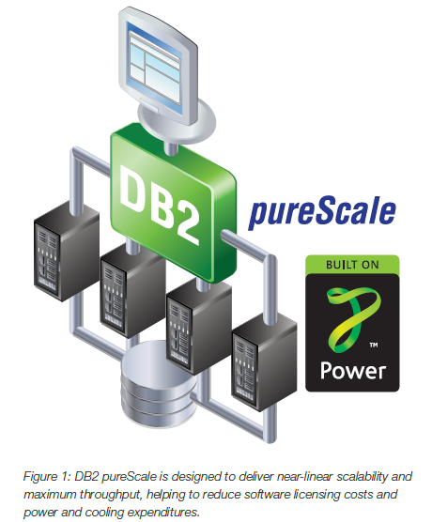

## IBM Hardware Sizing for Production HA & DR

Attached is the document provided by IBM with Hardware Sizing Recommendations for EPDS v2 System:



## EPDS v2 Disaster Recovery Backup outside of Primary Data Center

Disasters and security incidents may threaten the organization’s ability to carry out its mission as well as other operational functions. Advance planning and preparation will allow the organization to:

* Continue serving its Business
* Ensure the availability of EPDS v2 Data
* Minimize loss and facilitate recovery of core Information Technology and other business assets
* Preserve the organization’s public image and reputation within the community
* Prevent the disaster or incident from threatening the organization’s long-term stability and viability
* Heighten organizational awareness, allow for advance preparation, and workforce education and training
* Comply with applicable state and federal regulations

Components of this plan include:

* Disaster Recovery and Restoration
* Emergency Mode Operation
* Applications and Criticality Analysis
* Data Back-Up outside of Primary Data Center
* Security Incident Response
* Testing and Revision

**PureScale can be augmented with Q-Replication for an Active-Active DR solution.**

## DR Data Flow



## Production HA & DR recommendation as per IBM

## Disaster Recovery Server Details

The following are the details of Disaster Recovery Servers:

|  |  |  |
| --- | --- | --- |
| **Server Type** | **Server Details** | **Data Center** |
| Database Server | TBD | TBD |
| Batch Server | TBD | TBD |
| Informatica Server | TBD | TBD |
| Application Server | TBD | TBD |

## Commercialization Landscape with Database Security

Securing data requires a holistic and layered approach taking into consideration the broad range of threats. This is commonly referred to as *defence in depth*, a term adopted from military strategy. Defence in depth is a fundamental tenet for today’s information security. It requires a “security by design” approach, which espouses security as part of the core design of database environments, the supporting infrastructures and business practices around these environments. This means building robust security components directly into the database and data storage environments from day one to enforce data security best practices. Multiple layers of security, each layer of which plays an important part in securing the system and is reinforced by other layers, are the underpinnings of an environment in which data is secure. Together these provide the three ultimate objectives of security, commonly known as the CIA triad: confidentiality, integrity, and availability.

At a minimum, rolling out an effective data security plan should include the following steps:

* Data Classification
* User Classification
* Threat Identification
* Counter/Preventative Measures
* Testing
* Auditing
* Maintenance

Technology comprises interdependent components. Security must exist on each of these components at each layer in the environment to make a truly secure system. The IBM Data Server Security Blueprint focuses on the database tier and the underlying data level security. It assumes that the overall environment that the Data Server runs in is also being properly secured. Specifically, it assumes that the following security layers and processes *are already in place in the environment:*

* Network Security: Firewalls, Virtual Private Networks (VPN's), secure routers, intrusion detection systems, detecting network sniffers, and so on.
* Host Security: Securing the operating system, virus and malware protection, Web browser security, monitoring and logging activities of privileged system users, and so on.
* Physical Security: Effective badge access controlling who can physically access the machine(s) hosting the Data Server.
* Identity Management: Reliable systems and methods for identifying and authenticating enterprise users effectively.
* Business Controls: Rules, processes and practices governing access to assets and the use and management of data.

Data server security threats into four broad categories: Data Threats, Configuration Threats, Audit Threats, and Executable Threats.

* **Data Threats:** Threats against data are mechanisms whereby data can be accessed by users or processes that are not authorized to access such data. This is by far the largest category of threats, and is usually the first that come to mind. These threats can be aimed directly at the tables in the database, or through more indirect means such as by looking at the log files or directly at the table space files on the operating system.
* **Configuration Threats:** Threats against configuration mechanisms whereby the database or database manager configuration files can be tampered with. Since they control critical aspects of your data server – such as how and where authentication is performed – it is critical that the database configuration files are protected as securely as the data itself.
* **Audit Threats:** Threats against the audit facility are mechanisms whereby the audit configuration, audit logs, or archive logs can be tampered with. In many cases, audit records are the only way to determine what has happened in the past and the only form of evidence to detect misuse; it is critical that they be able to withstand tampering.
* **Executable Threats:** Threats against executables are mechanisms whereby database manager executable files can be tampered with. This includes executable spoofing, denial-of-service attacks and Trojan horse attacks.

Security at levels is a key factor for implementing the concepts of Public Vs Private data concepts:

* Database
* Application Tier
* Unix Server
* Cloud Deployment

**Common Data**

* + Information that can be shared amongst multiple organizations. In the context of commercialization, common data is different than public data by means of requiring payment for access to the data.

**Public Data**

* + Information that is available to all users with no security measures necessary as far as reading or accessing the data.

**Proprietary Data**

* + Data that is owned by an individual or organization, which is deemed important enough that it gives a competitive advantage to that individual or organization.

**Multi-tenancy Architecture**

* + Refers to a principle in software architecture where a single instance of the software runs on a server, serving multiple client organizations (tenants). With a multitenant architecture, a software application is designed to virtually partition its data and configuration, and each client organization works with a customized virtual application instance.

**Multi-instance Architecture**

* + Separate software instances (or hardware systems) are set up for different client organizations.

# Commercialization Considerations

## Commercialization of EPDS v2

Commercialization enables building a provider data product which can be utilized for future commercialization opportunities outside of WellPoint domain.

* Problem to solve to define what is private vs. public data
* The solution needs to accommodate the solution being used as SAAS or a purchased product
* Customers need ability to view provider data both public and their allowed private data
* Customers need ability to update their private data
* Customers cannot update public data
* Customers need the ability to assign role-based, individual access - both view and update - to private data

**Commercialization Implementation Options are:**

* Create two physically separate databases (public vs. private) joined by the application layer
* Single physical database with role based views – Fine Grain Security
* Data and application replication - the customer gets the application and data to place in their environment. Public data updates are provided for the customer to place into

**Commercialization Assumptions:**

* Public data will be maintained by company owning the product
* In general, Demographics is primarily public and CAN is primarily private

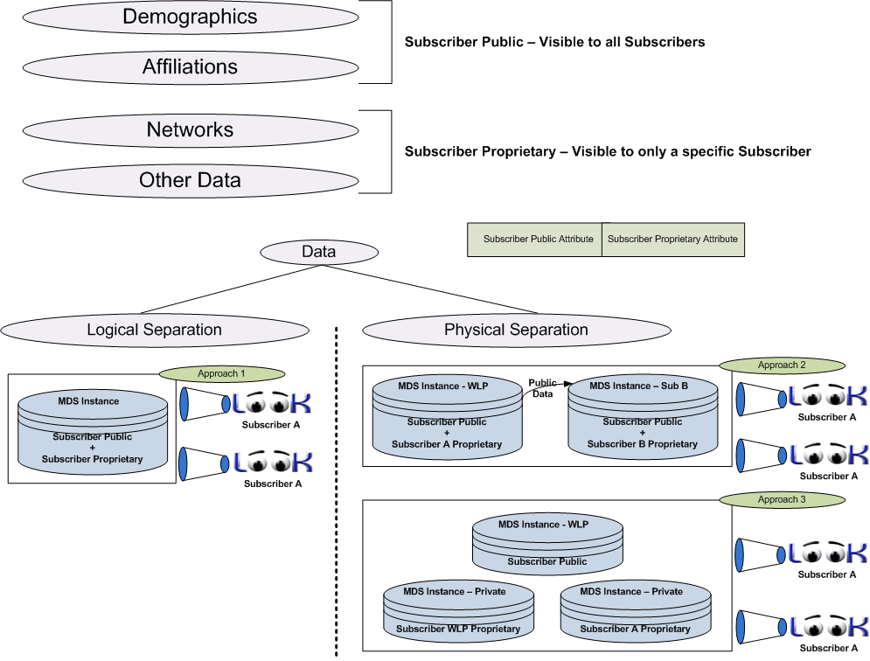

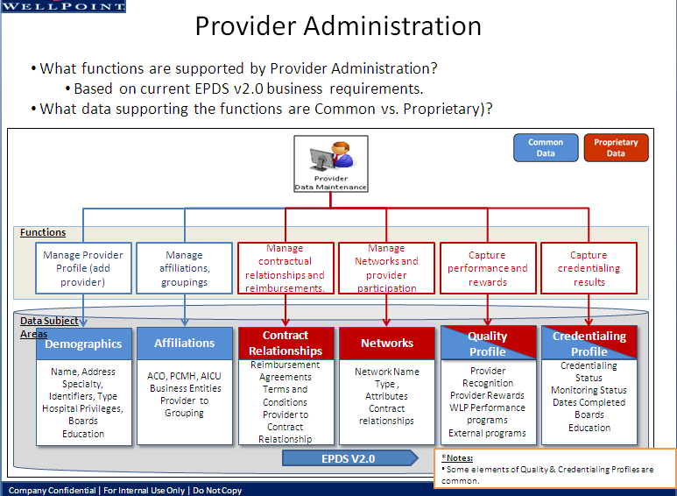

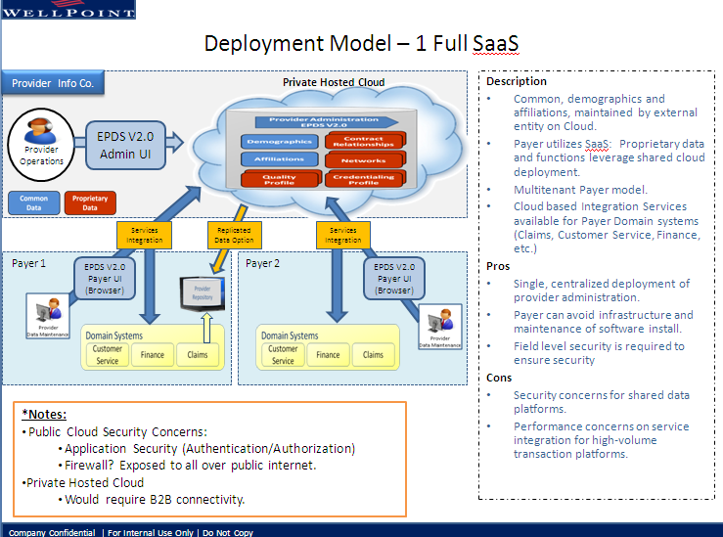

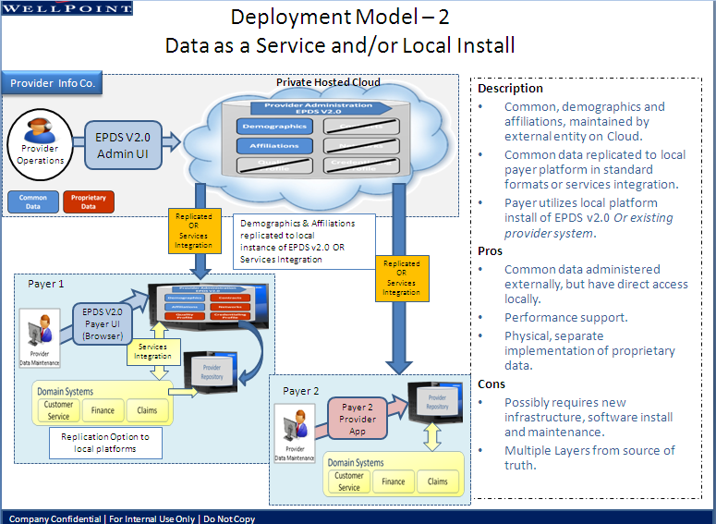

# Appendix

## Credentialing

Provider credentialing data is very critical to EPDS v2 and in the current state CACTUS is WLP Enterprise Credentialing System aka SCP (Standard Cactus Platform) where all the credentialing data is managed. Currently CACTUS is not part of EPDS v2 Cap 1 and Cap 2 project scope but is very critical system to establish direct connectivity with EPDS v2.

Strategically provider demographics data should be fed from EPDS v2 to CACTUS where provider demographics and networks data should be automatically kept synchronized within CACTUS after which credentialing business can manage credentialing data. CACTUS should feed credentialing data to EPDS v2 so that credentialing data within EPDS v2 can be used in a read-only mode.

As per EPDS v2 project all the credentialing data within each regional system needs to be sourced and loaded within EPDS v2 system to consume in a read-only mode. QCare and CPMF currently manage credentialing data manually and have not migrated to CACTUS. QCare is targeted to retire and will continue to forward feed EPDS v2 until its retirement with no reverse data synchronization from EPDS v2 system.

In order to support reverse data synchronization for CPMF, EPDS v2 User Interface has to provide business capabilities to manage Virginia Credentialing Data within EPDS v2 which forces implementing credentialing functionality within EPDS v2 otherwise business needs to manage credentialing data within CPMF system.

Ideally if business wants to integrate credentialing functionality within EPDS v2 as a long term goal then credentialing functionality including data needs to be sourced directly from CACTUS system.



**Architectural Recommendation for Credentialing Data:**

1. Do not source Credentialing Data from FACETS, ACES and CS90 as these systems are not Source of Truth for Credentialing Data and receive data directly from CACTUS System
2. Establish connectivity with Enterprise Credentialing System (CACTUS)
   * Send Provider Demographics and Networks Data from EPDS v2 to CACTUS so that CACTUS uses this data in a read-only mode and is managed within EPDS v2 (Source of Truth System for Provider Demographics & Networks Data)
   * Receive Credentialing Data from CACTUS to consume data in a read-only mode

Business should address the current GAPS in EPDS v2 project related to Credentialing Data so that EPDS v2 Cap 2 would not run into a situation forcing to provide credentialing data maintenance to Virginia Business (CPMF).

QCARE would not require reverse data synchronization and would forward feed EDPS v2 since Cap 1 until QCARE is decommissioned permanently. Business should address how Credentialing Data from QCARE would be migrated to CACTUS prior to decommissioning this system.

## Enclarity

Provider Data Cleansing using Cleansed/Augmented Data from Enclarity Vendor

* Delivery of most current data
* Improve Quality of Provider Data
* Increase Auto Claims Adjudication
* Accurate Provider Directories Data
* Multi Data Sources for cleaner Provider Data

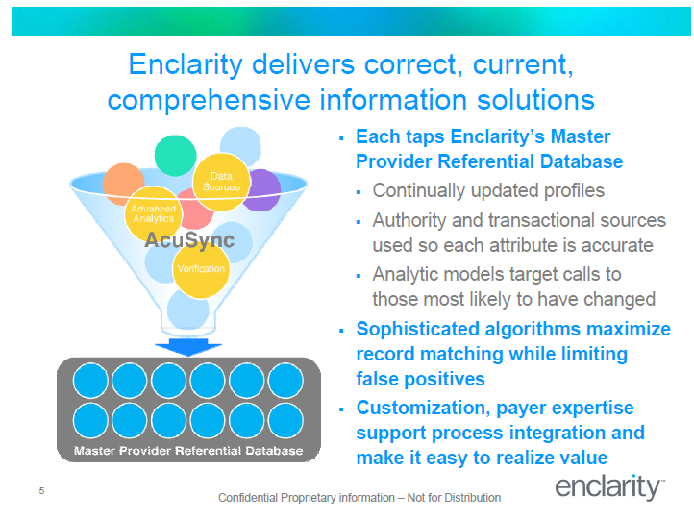

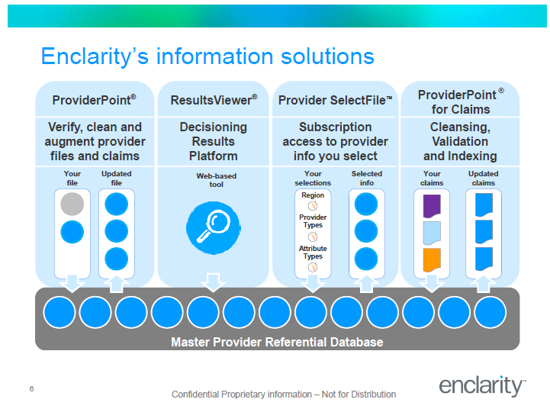

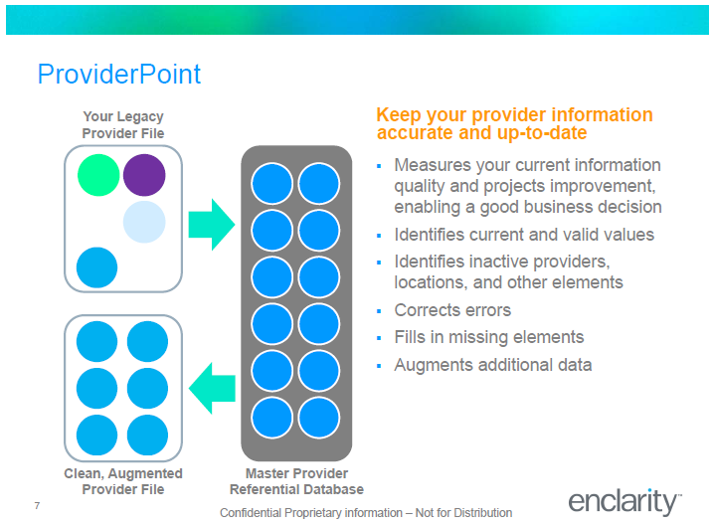

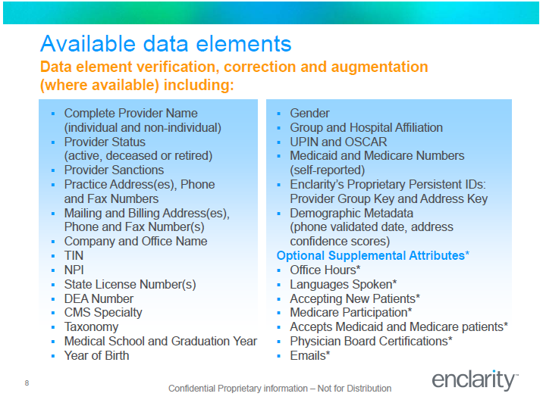

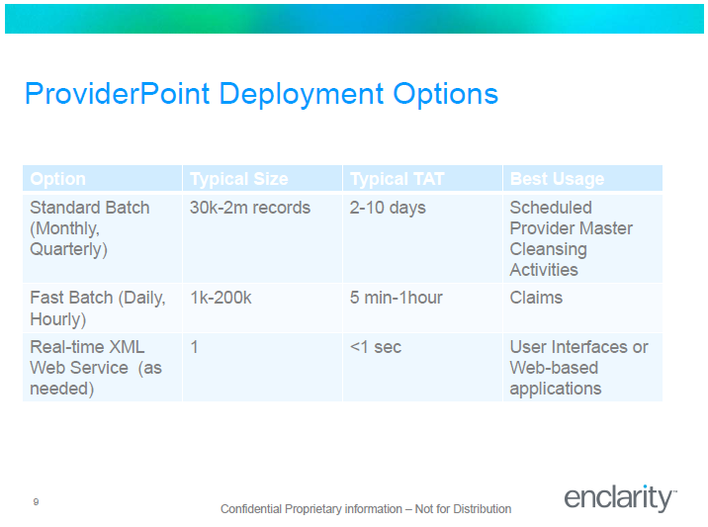

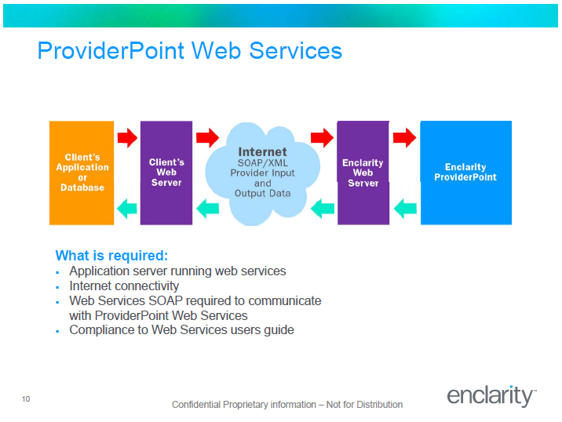

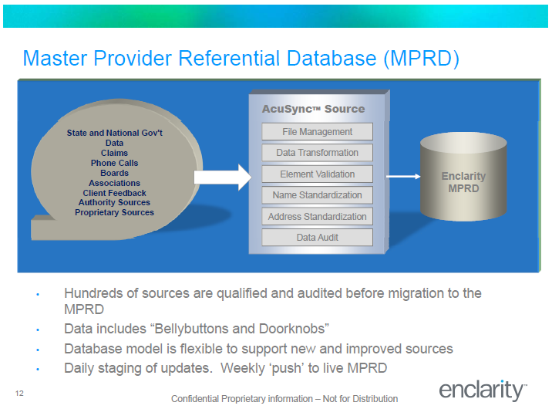

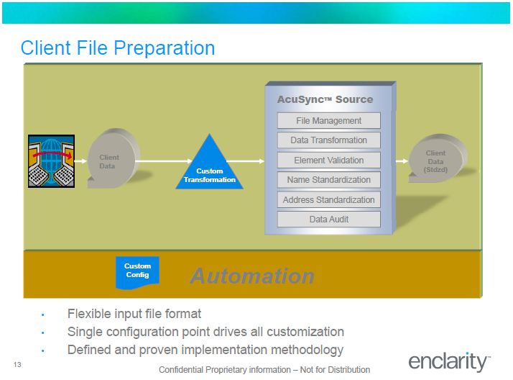

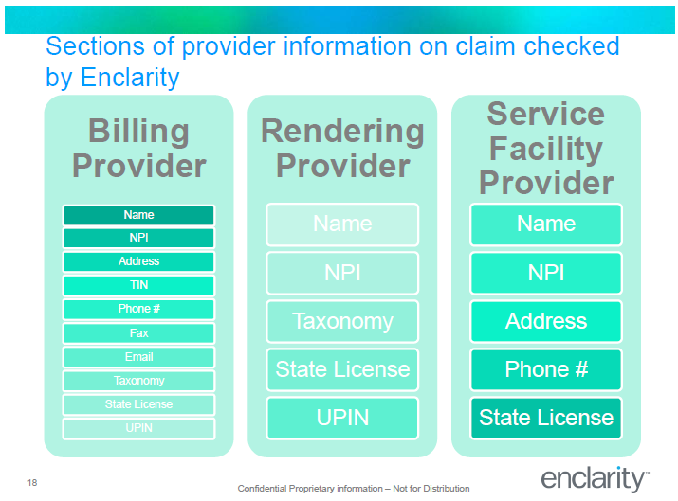

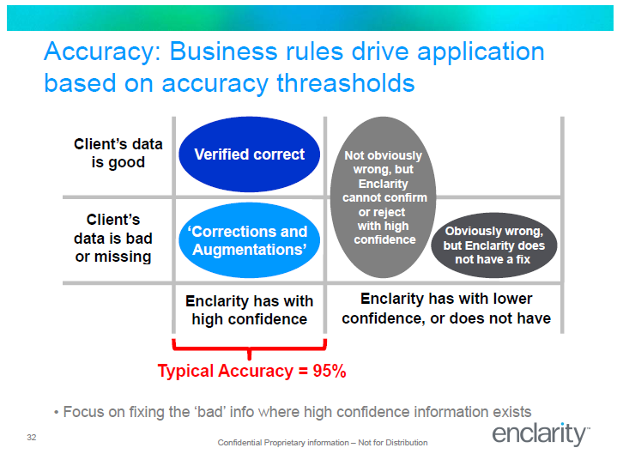

**Use of Enclarity Data within EPDS v2**

* **Batch Mode**
  + Enclarity Cleansed/Augmented data files can be leveraged from the current EDWARD process and loaded into the EPDS v2 Staging Database. EDWARD currently receives Enclarity Extract from Enclarity Vendor – Same Files should be consumed by this project
  + EDWARD to Enclarity cross-reference file from EDWARD to be loaded into the EPDS v2 staging database which has all the mapping from regional provider Id’s to the corresponding Enclarity Id
* **Real-time Mode**
  + New WLP Re-usable Java Services should be implemented to invoke real-time Enclarity service for cleansing provider data. These services can be used by the batch and real-time implementations to cleanse provider data

**Integration Option 1 – Recommended for Batch & Real-Time Operations**

Leverage Enclarity Data currently EDWARD received and stage within EPDS v2 Staging Database through Capability 1 and establish direct connectivity with Enclarity through Capability 2 prior to decommissioning of EDWARD/Enclarity process. Also establish real-time connectivity with Enclarity through Capability 2 to be used by EPDS v2 implementations. Non WLP Providers would also be registered in the EPDS v2 as Enclarity Source to align with Commercialization initiative.



**Integration Option 2**

Establish real-time connectivity with Enclarity through Capability 1 and use it for Batch and Real-Time operations through EPDS v2 implementation. Accept additional Non WLP Provider Data through Capability 2 to be used within EPDS v2 as public data operations. All the Enclarity Data received through real-time hits to Enclarity System will be staged within EPDS v2 staging database.

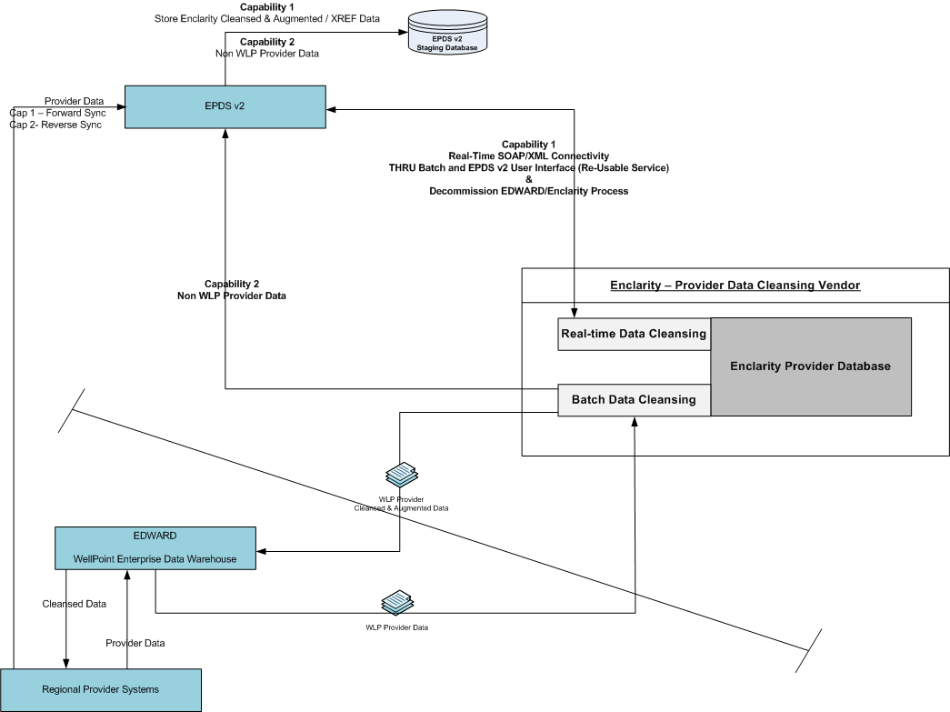

**Integration Option 3**

Establish direct connectivity with Enclarity through Capability 1 by sending provider data feed from EPDS v2 to Enclarity and receive data files back from Enclarity. Also through Capability 2 establish real-time connectivity with Enclarity.



**Enterprise Hierarchy from current state:**

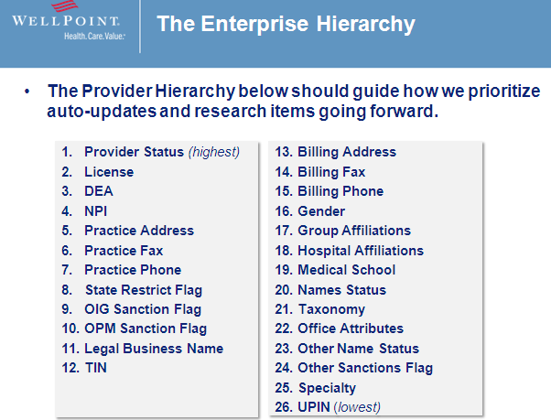

## Central Region Facets – Inbound/Outbound Data Feeds

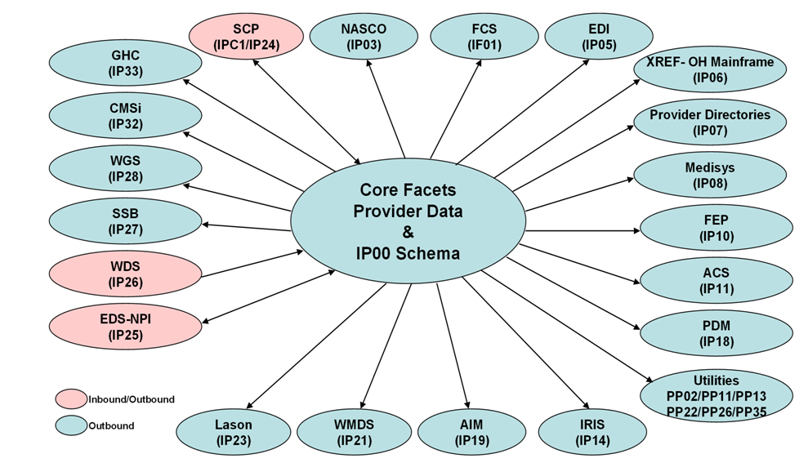

## CPF – CS90 Inbound/Outbound Data Feeds

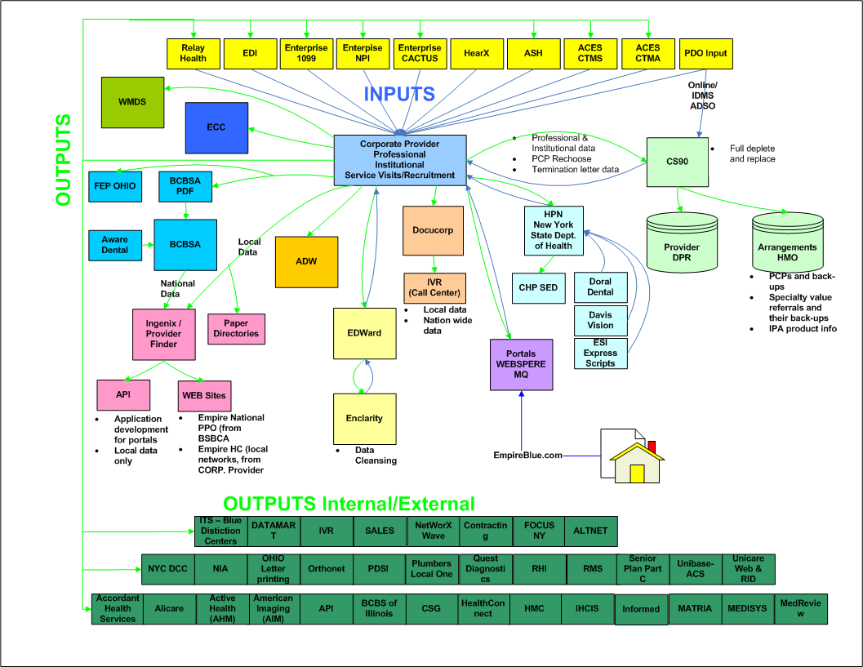

## ACES – Inbound/Outbound Data Feeds

